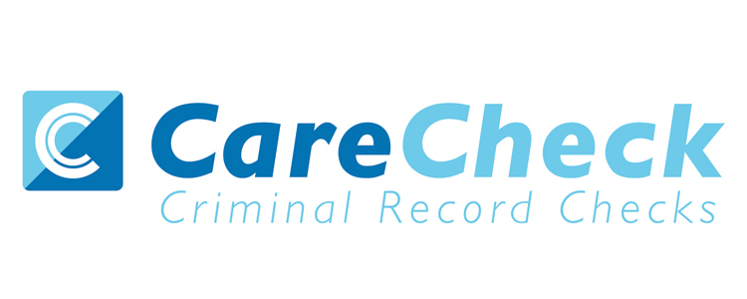

1st Floor
Orchard House
Crab Apple Way
Evesham
Worcestershire
WR11 1GE
0333 777 8575
info@carecheck.co.uk

Care Check Terms of Service

Our client organisations must adhere to the following conditions when applying for, receiving, holding and disposing of Criminal Disclosures via the e-Bulk Online application channel or Paper Route.

- The Client must nominate a designated individual(s) who will act as the clients contact point for all DBS matters and receive Disclosure information.
- The client organisation will provide details of the person(s) who will verify the identity of the applicant, and that identity validation will be done in accordance with DBS guidelines using only original documents, and ensure that all applicant details are checked in the same manner.
- The client organisation must inform Care Check immediately in writing should the person(s) checking the identity of the applicants change.
- The client organisation will observe and fully adhere to the DBS (CRB) code of practice.
- The client organisation is likely and will remain likely to genuinely ask an exempted question.
- The client organisation will make all disclosure applicants aware of the Code of Practice when recruiting and will make a copy available to all disclosure applicants upon request.
- The client organisation has a satisfactory written policy on the recruitment of ex offenders and issues a copy of the policy to all disclosure applicants at the start of the recruitment process.
- The client organisation is aware that a statement must be included on its application forms or accompanying documentation, that a disclosure will be requested in the event of an applicant being offered a position.
- The client organisation is aware that it must include a statement on its application forms, or accompanying documentation, that a criminal record will not necessarily be a bar to obtaining a position.
- The client organisation must provide a statement in all employment advertisements that Disclosure will be required in the event that a post is offered.
- The client organisation has a written policy on the secure storage, handling, retention and disposal of disclosure information.
- The client organisation will not retain disclosures or a record of the information contained within them for longer than is required for the particular purpose. This should be no longer than 6 months after the date on which the recruitment or other relevant decisions have been taken, or after the date on which any dispute about the accuracy of the disclosure information has been resolved. The period should only be exceeded in very exceptional circumstances, which justify retention for a longer period. (Disclosure information may be retained for longer than 6 months for the purpose of audit where organisations are regulated by CQC or OFSTED)
- All Disclosure certificates will be destroyed in accordance with the DBS (CRB) Code of Practice by shredding, pulping or burning.
- The client organisation will keep all Disclosure information kept securely, in accordance with the DBS (CRB) Code of practice, separate from their staff members files and within a locked storage unit that cannot be moved by less than 2 persons.
- The client organisation is aware of what additional information is, and that under no circumstances can this information be divulged to an applicant (or person who is not authorised to have access to this information) and that to do so would constitute a criminal offence.
- Additional information is very sensitive and must be treated with the utmost caution. Should the client organisation be informed of additional information then they should be careful to base their withdrawal of an offer on employment on pre employment checks, and avoid letting the applicant know that there is “additional information”
- Client organisations should discuss any matters revealed in the disclosure with the applicant before withdrawing the offer of employment.
Information provided on the disclosure is confidential, and as such should only be available to those persons named in the client contract.
(Unless the person is a registered inspector with the CQC, CSCIW or OFSTED)
- Care Check reserves the right to make assurance visits to our client organisations to ensure that they are fully complying with the terms and conditions of our contract and the DBS (CRB) Code of Practice.
- Should Care Check find that any part of this contract is being breached, it reserves the right to withdraw its service with immediate effect.
- It is the client organisations responsibility to state the level of check they require and if the applicant is working with Children, Vulnerable Adults or both.
- Care Check shall have no liability for defective services where the defect has been caused or contributed by the client organisation
- Care Check shall have no liability for defective services where the defect has been caused or contributed by DBS (CRB).
- Care Check shall have no liability to the client organisation for services if invoice payments have not been received by the due dates of payment.
- Care Check have no liability for additional damage, loss, liability, claims or expenses caused or contributed to by the Client’s continued use of services or the continued engagement of an Applicant once an error or defect in the relevant Disclosure has become apparent.
- Care Check shall have no liability for any matters which are outside its reasonable control.
- Care Check shall have no liability to the client for any consequential losses, loss or profits and/or damage to goodwill, economic losses, special damages and indirect losses or business interruption, loss of business, contracts, opportunity and production.
- Invoiced Clients shall pay Care Check for all invoices within 15 days of receipt. invoices are raised and sent upon receipt of application. Invoices will be raised for the application if completed correctly or if in need of amendment.
- Unpaid invoices that are over 90 days old will be passed to an independent debt collection agency. The agenc will add their own charges when collecting the overdue invoice.
- Clients using the e-Bulk online channel will ensure that all passwords and log on details are kept private and are under no circumstances passed on to any other person.
- Clients using the e-Bulk system will change their passwords on a regular basis, preferably every month not rotating the same password within a three month period.
- Clients using the e-Bulk system shall take reasonable care to ensure that no person is within distance to take note of log on details or disclosure information when accessing the e-Bulk system.
- ID Checkers using the e-Bulk system shall always check original ID, no photocopies at the time that the information is imputed into the e-Bulk system.
- Clients using the e-Bulk system shall keep the information held securely on it, unless it needs to be printed for the purposes of audit.
- Clients using the e-Bulk system who print disclosures for the purpose of audit shall only print them once and shall keep them in accordance with the DBS (CRB) Code of Practice and their policy on the secure storage, retention and disposal of disclosure information.
- Responsible persons using the e-Bulk system, or the responsible persons Employers shall inform Care Check immediately if they are to leave the client organisation or cease using the system so their log on details can be deleted immediately.
- ID Checkers, using the e-Bulk system, or the ID Checker employers shall inform Care Check immediately if they are to cease being employed by the client organisation or cease using the system so their log on details can be deleted immediately.
- Disclosure certificates shall not be passed on to persons not named in the service contract without the written consent of the applicant.

