Primary Applicant Manager Guidance Notes

DBS Online Disclosure Guide (eBulkPlus)

Contents
Primary Applicant Manager Guidance Notes 1
Logging onto the System 2-5
Inviting applicants to submit their application 6-9
How to complete ID & Section Y 10-15
Tracking an application 16
Viewing completed results 17-20
How to find an application 21
Reports 22-23
DBS List of Acceptable Identification 24-25

Primary Applicant Manager Guidance Notes

An online DBS check can be completed by accessing the internet from any device that has this facility. This includes a smart phone, tablet, laptop or PC. It is supported on the latest versions of all modern browsers; however, we do not recommend access via Internet Explorer as this browser is unsupported both by our technology and soon by Microsoft also. The software is simplistic and easy to use. You can gain access to the system within minutes.

You have been granted access to eBulkPlus in the role of a Primary Applicant Manager. A Primary Applicant Manager can view and edit all applications created under the organisation or specific division they have been created under. A Primary Applicant Manager can stipulate what ID has been seen in relation to an applicant and complete Section Y details. After an applicant’s ID has been verified and Section Y completed, a Primary Applicant Manager has the authority to approve an application for countersigning.

Logging onto the System

Please enter the following address into your web browser:

WWW.CARECHECK.CO.UK and click on `Manage Your DBS Checks’

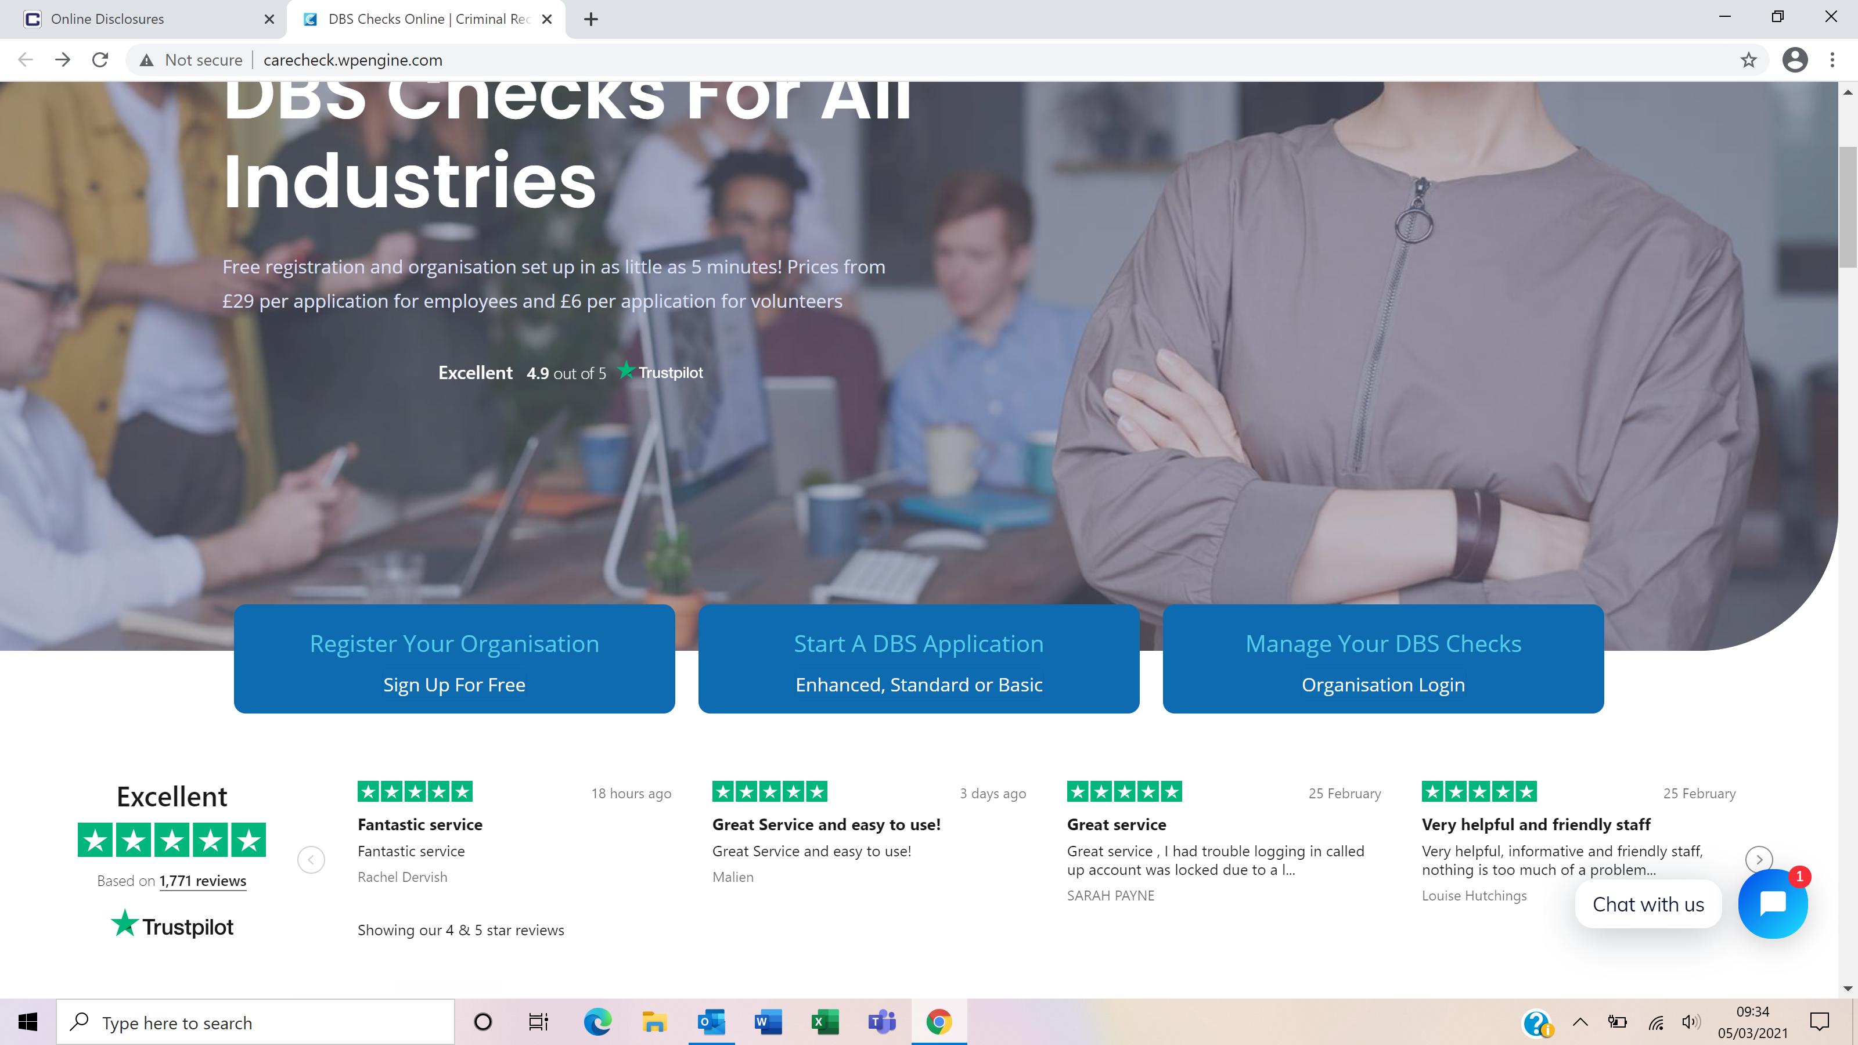

You will now be on the main login page that shows three coloured boxes. Please note at this stage of the process, your login details are case sensitive.

- Click on ‘Application Management’.
- Enter your company Organisation Reference - this will have been supplied to you in an automated email (if you cannot remember this please click on the ‘Forgotten your login details?’ icon at the bottom of the screen to be sent a reminder).
- Enter your Username.
- Enter your Date of Birth (for first initial login please ensure you enter the default date of birth 01 Jan 1998. Failure to do so will deny you access to the system).

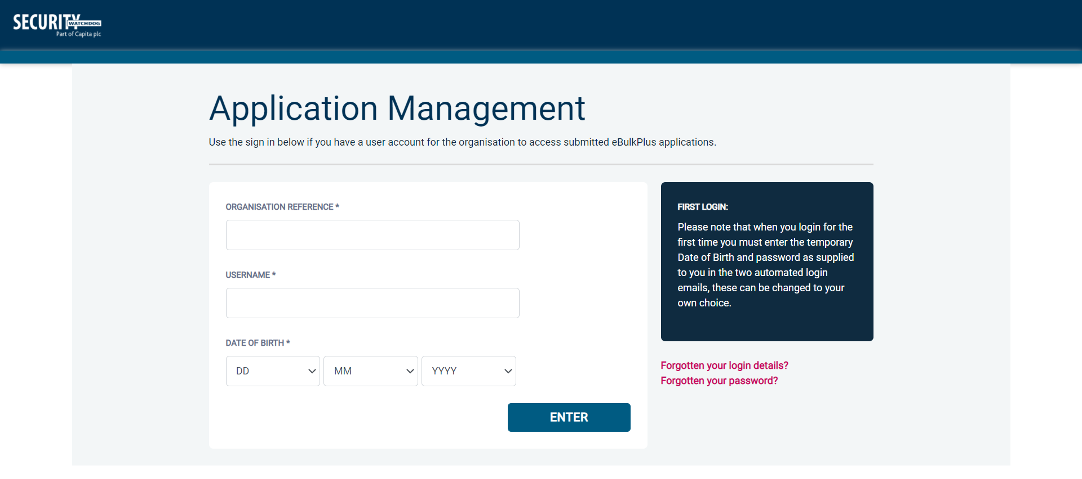
Screen Shot 1

- Once you have completed this section click ‘Enter’.

- Enter your password (this will be supplied to you in an automated email) – see screen shot 2 below (If you cannot remember this please click on the ‘Forgotten your password?’ icon at the bottom of the screen to be sent a new one-time password).

If you have difficulty gaining access to the system, please contact Care Check on 0333 777 8575, however please ensure the first time you login that you have not been denied access because of entering your own date of birth. The first time you login you must enter the temporary default date of birth 01 Jan 1998.

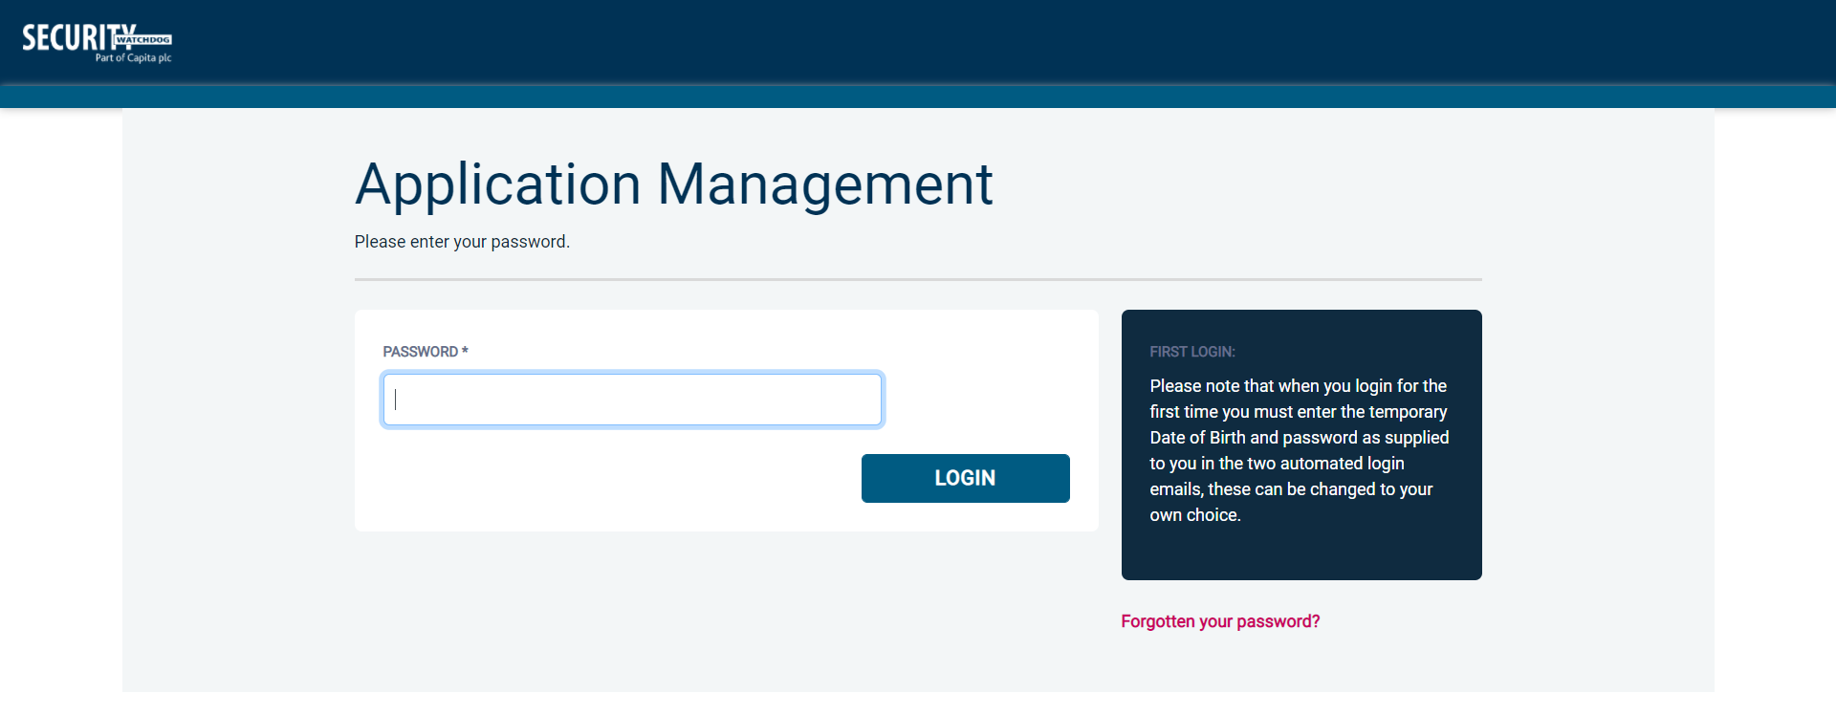
Screen Shot 2

- Please note, after initial login you will be required to set your own password and enter your own date of birth for future login purposes.
- Please re-enter into the ‘Current Password’ field the temporary password you received in your initial e-mail and then create your own unique password (see screen shot 3 below).
- The password you create must be between 8 & 30 characters containing at least one upper case letter, one lower case letter, one special character and at least one number.
- Please then enter a date of birth of your choice for future login purposes.
- Please then click ‘Update’.

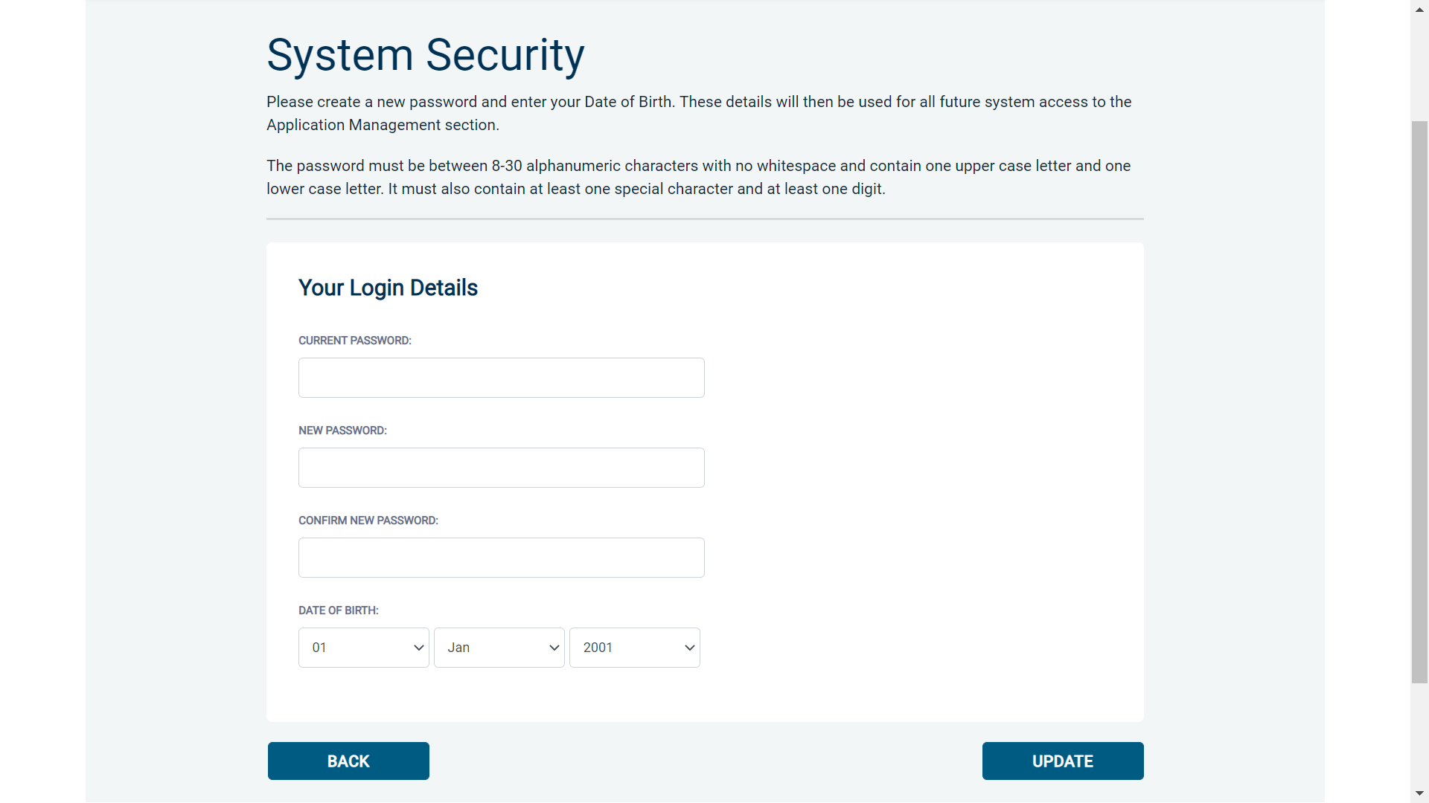
Screen Shot 3

- If you have successfully created your own password, you will now be able to enter the system by clicking the ‘Click here to enter System’ icon in the green box (please note you do not need to re-enter your password details once the green box has appeared).

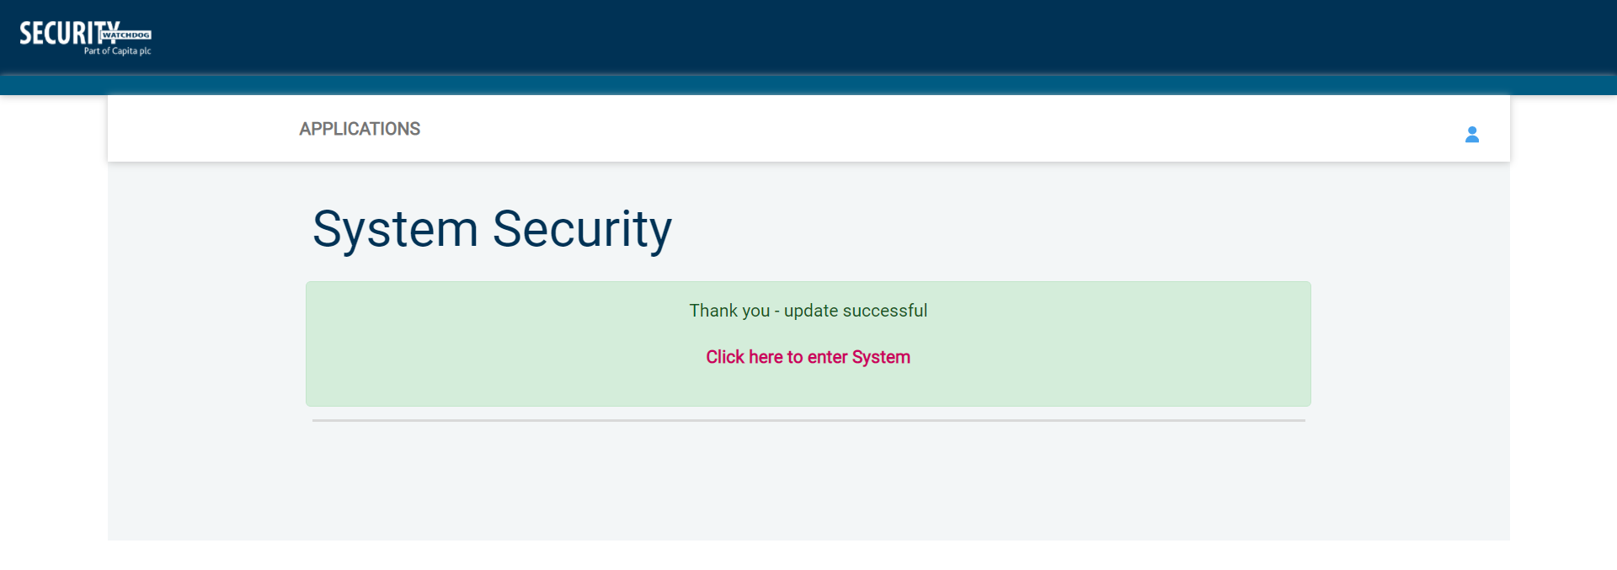
Screen Shot 4

- This will now take you to the main eBulkPlus Home Page called the ‘Dashboard’ (see screen shot 5 below).

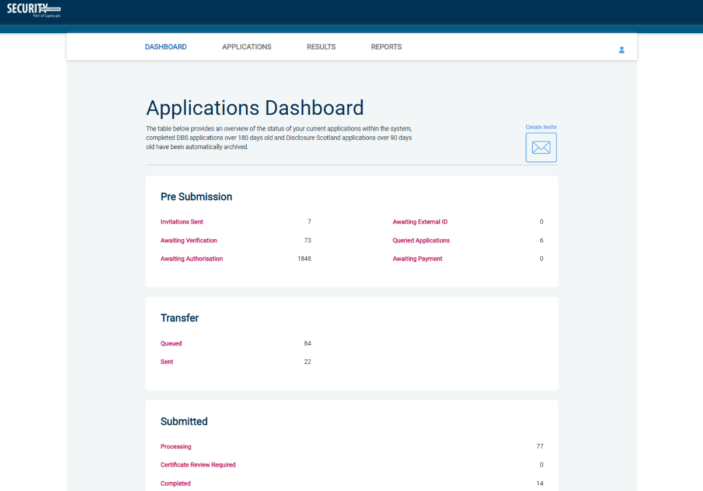
Screen Shot 5

Inviting an applicant to submit their application

You can generate an email invite to an applicant(s) inviting them to submit their application, from within the eBulk dashboard. This can be done by clicking the ‘Create Invite’ button at the top of the dashboard.

You will be taken to the invitation page where you can generate your invite (screenshot 6 below).

- You will need to select the ‘Organisation’ that you wish the applicant to create their application under, you will be able to select any organisations that you are linked to. You will then need to select the level of check that you require the applicant to submit from the ‘Channel’ drop-down field below.
- You are then required to enter the applicant’s forename, surname and email address into the boxes provided. If you wish to invite more than one applicant to create this specific level of check for this specific organisation you can click the ‘Add Candidate’ button as many times as required to invite multiple applicants.

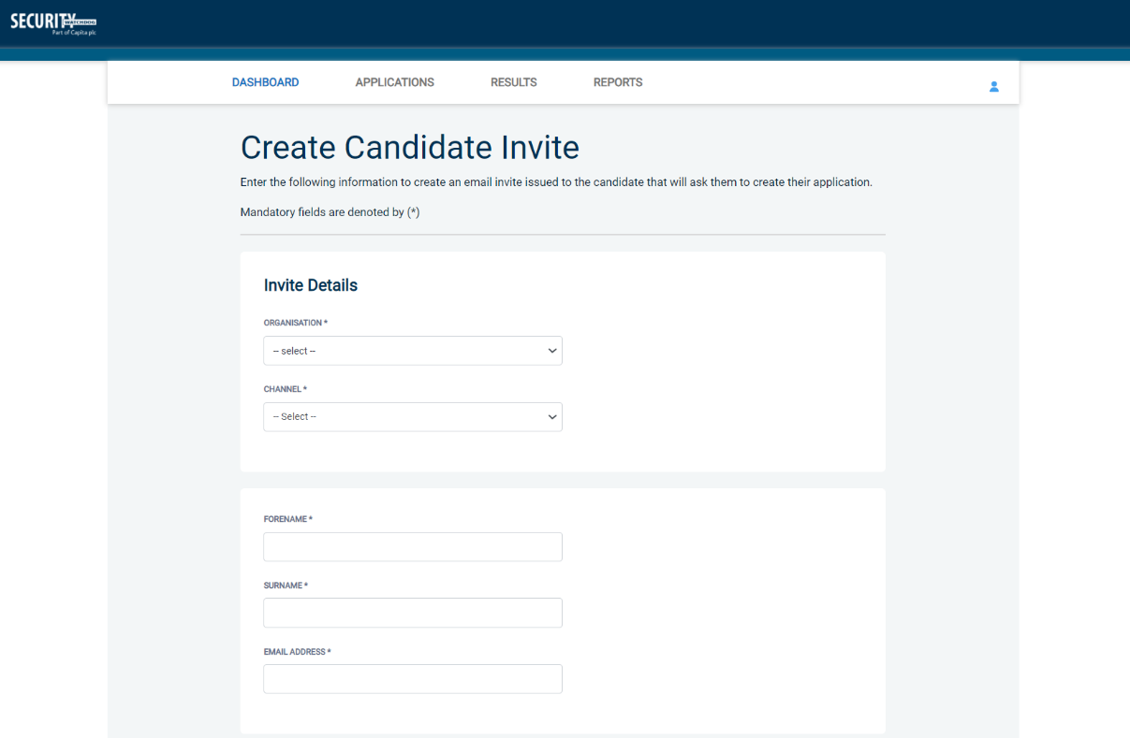
Screen Shot 6

- If you need to invite a large list of individuals, you can use the ‘Bulk Upload’ feature instead allowing you to upload a spreadsheet of applicants to be invited (screenshot 7 below). If you wish to use this feature, please leave the forename, surname, and email address fields blank and instead upload a pre-created spreadsheet. A blank template is provided in the eBulk footer if required. The spreadsheet must contain 3 columns only (Forename, Surname, Email address), any invalid data contained in the spreadsheet when uploaded will fail validation and be highlighted to you at the top of the screen.

Screen Shot 7
- Next, you are required to select a template from the ‘Email Template’ drop-down field (screenshot 8 below). You will be able to choose from either a ‘New Starter Invite Email’ or a ‘Renewal Invite Email’. Selecting one of these will populate the content of the invite email on-screen for you to review and amend if required. The pre-populated wording of these templates will either be the default wording coded into our system or a bespoke template for your organisation.
- Finally, click ‘Send’ to generate the invite to issue the invite to the applicant(s) entered.

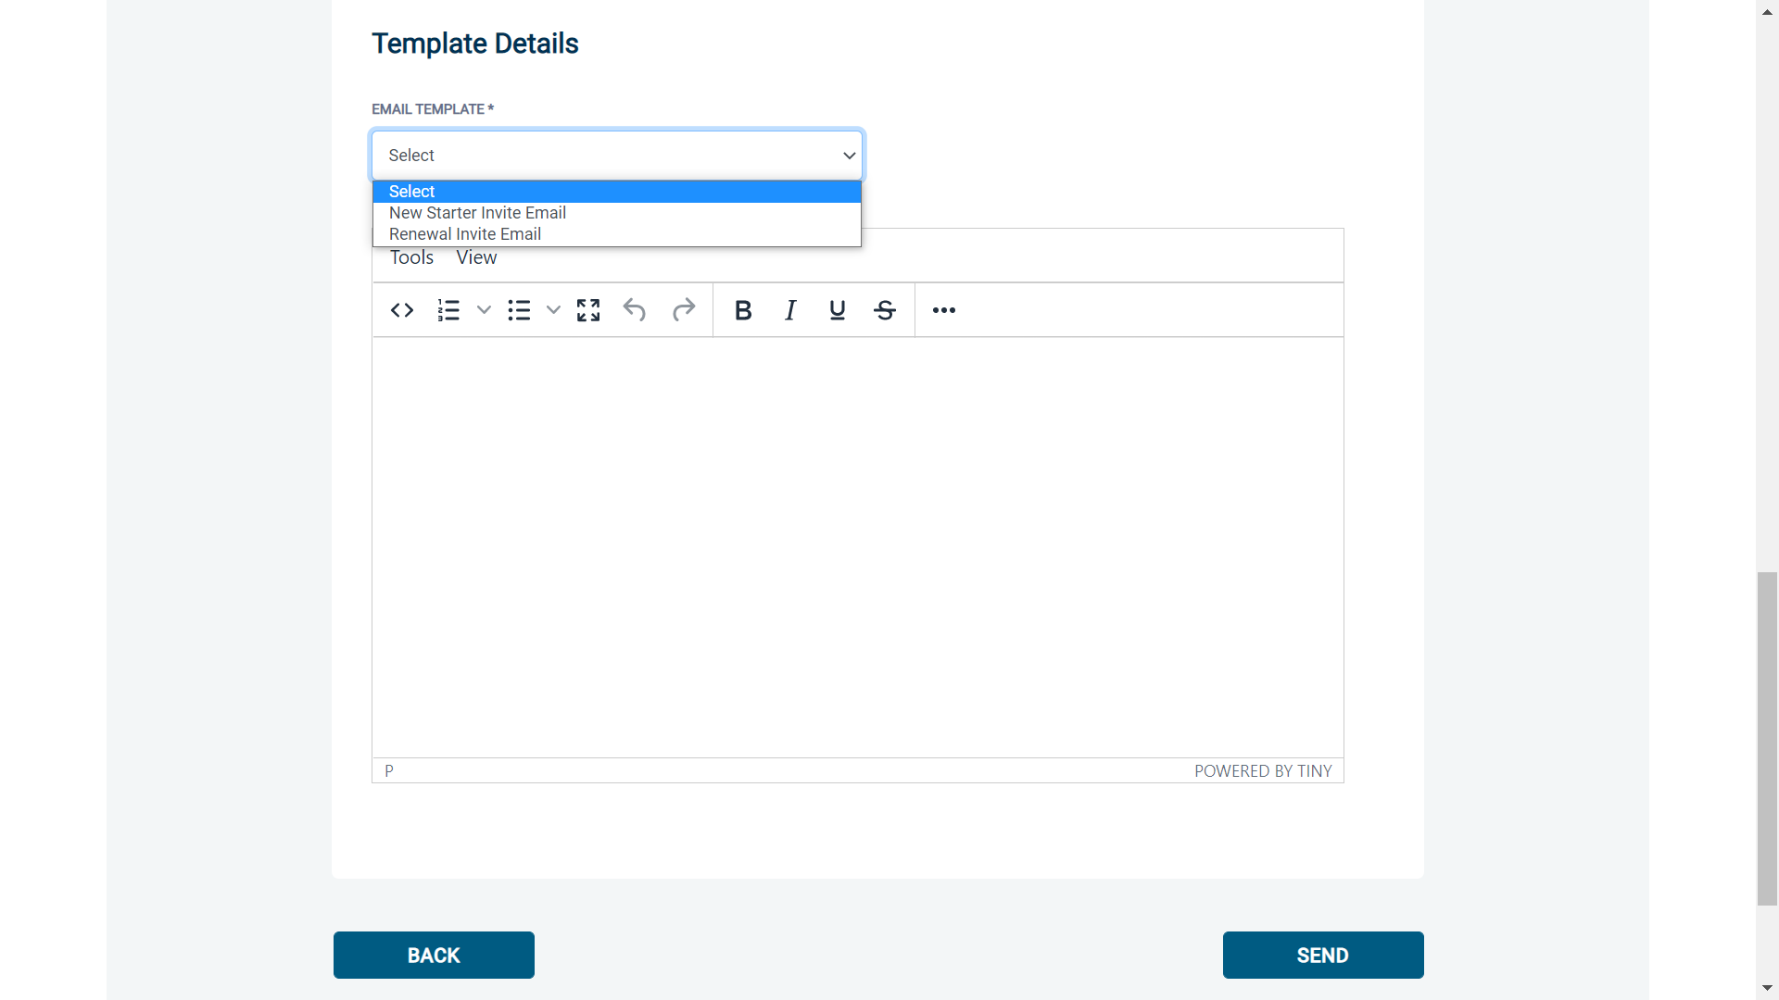
Screen Shot 8

How to track/chase invitations

Step 1 - Once invitations have been generated and sent, they are stored in the system until the applicant creates their application from the invite they have been sent. On the Dashboard page (see screen shot 5 above), in the top box entitled Pre-Submission, click on ‘Invitations Sent’.

You will be able to see the invitations that have been sent, waiting for the applicant to create their application. Please note, when an applicant has created their application from the invite they have received, it will move from this dashboard folder and into the ‘Awaiting Verification’ folder.

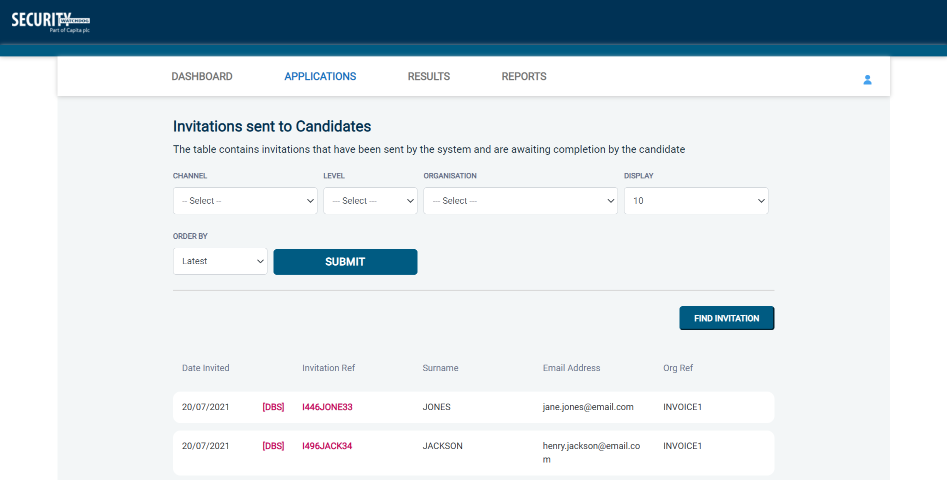
Screen Shot 9

Step 2 - Opening an invite: Click on an applicant’s reference number to open their invitation (see screen shot 9 above)

Step 3 – Overview, you will now see two tabs of the invitation (see screen shots 10 & 11 below)

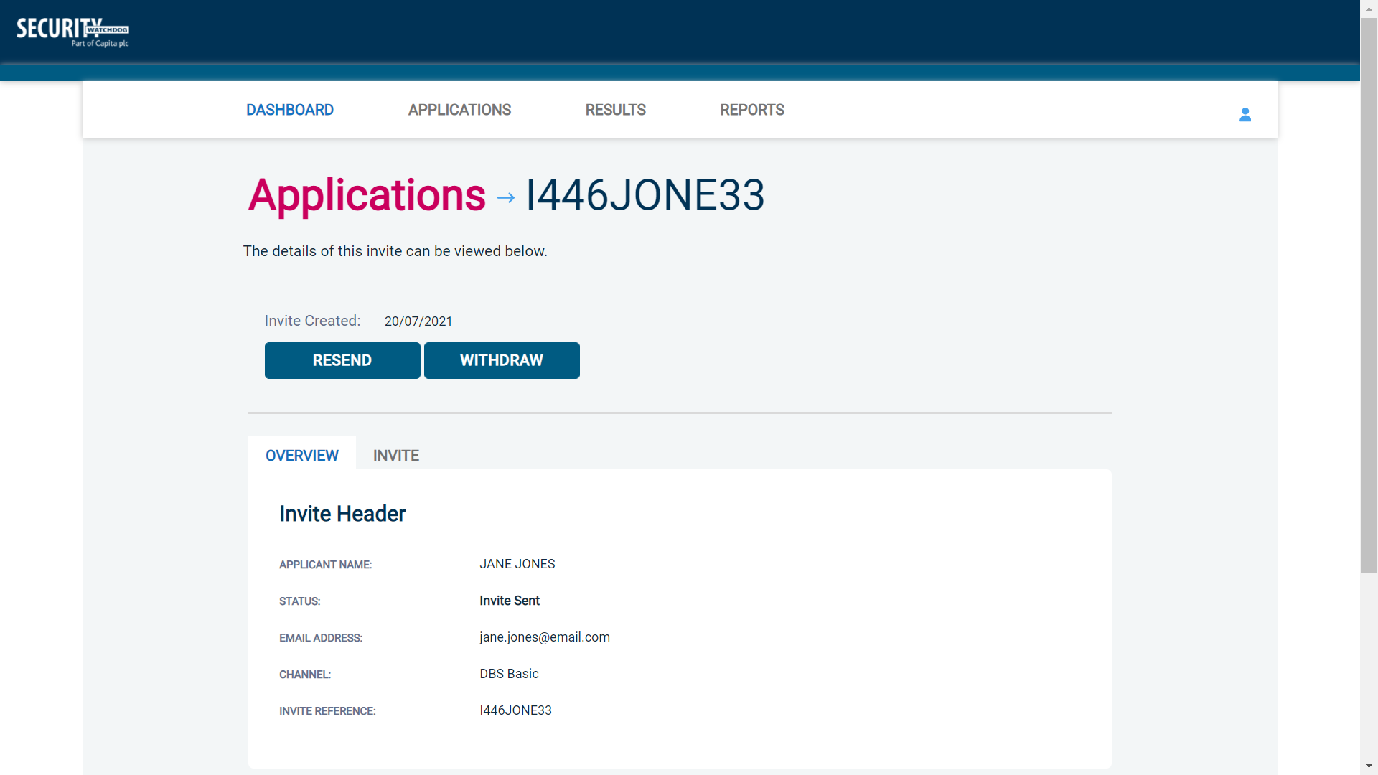
Screen Shot 10
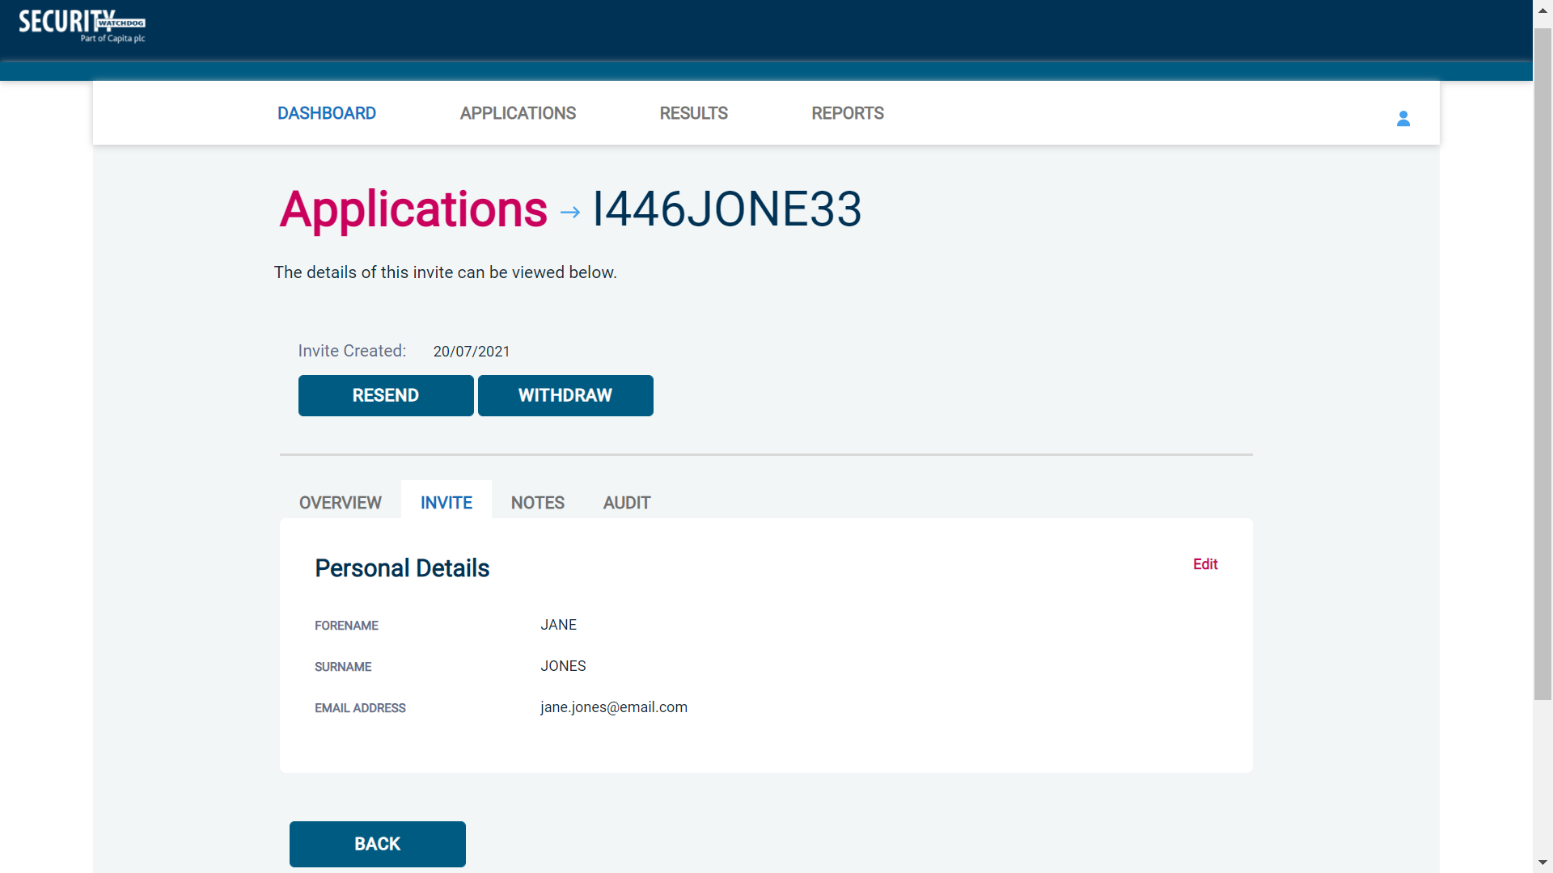
Screen Shot 11

Step 4 – Invitation, to view the details entered for the invitation click the ‘Invite’ tab. If these details are incorrect, these can be amended by clicking the ‘Edit’ button and updating the information (see screen shot 11).

Step 5 – Chasing an invitation

- If you wish to resend the invitation, please click the ‘Resend’ button at the top of the page. This will resend the original invitation email to the email address detailed on the ‘Invite’ tab.
- Invitations will be automatically chased by the system at a default chase pattern of 3 times every 3 days unless a different chase pattern has been configured for your organisation. After the final chase, the applicant will then have a further 30 days to create their application until the invitation is automatically withdrawn by the system.
- If the invitation is no longer required, it can be withdrawn at any time using the ‘Withdraw’ button at the top of the page. This will remove the invite from the ‘Invitations Sent’ folder.

How to verify ID & Complete Section Y

Step 1 – On the Dashboard page (see screen shot 5 above), in the top box entitled Pre-Submission, click on ‘Awaiting Verification’. Please note that you will be able to see the total number of application forms you have awaiting ID verification and Section Y to be completed.

The DBS applications in this folder can be filtered using the ‘ID Check’ and ‘Section Y’ drop-down menus from the grey toolbar. These can be used to only see applications awaiting just the ID Check, just Section Y, or both. It can also be used to filter out applications that have had both the ID Check and Section Y completed, but that are just awaiting approval (see screen shot 12 below)

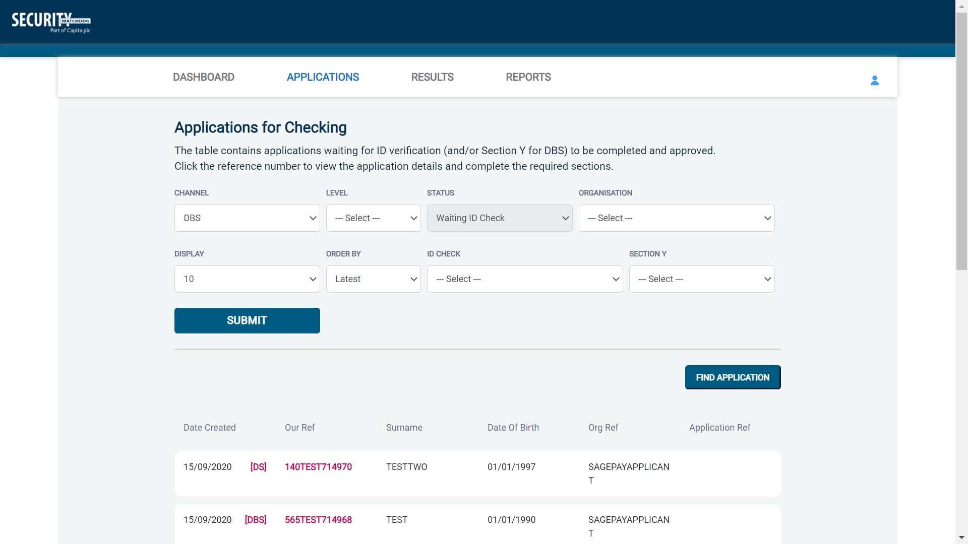
Screen Shot 12

Step 2 - Opening an application form:

Click on an applicant’s reference number to open their application form (see screen shot 13 below)

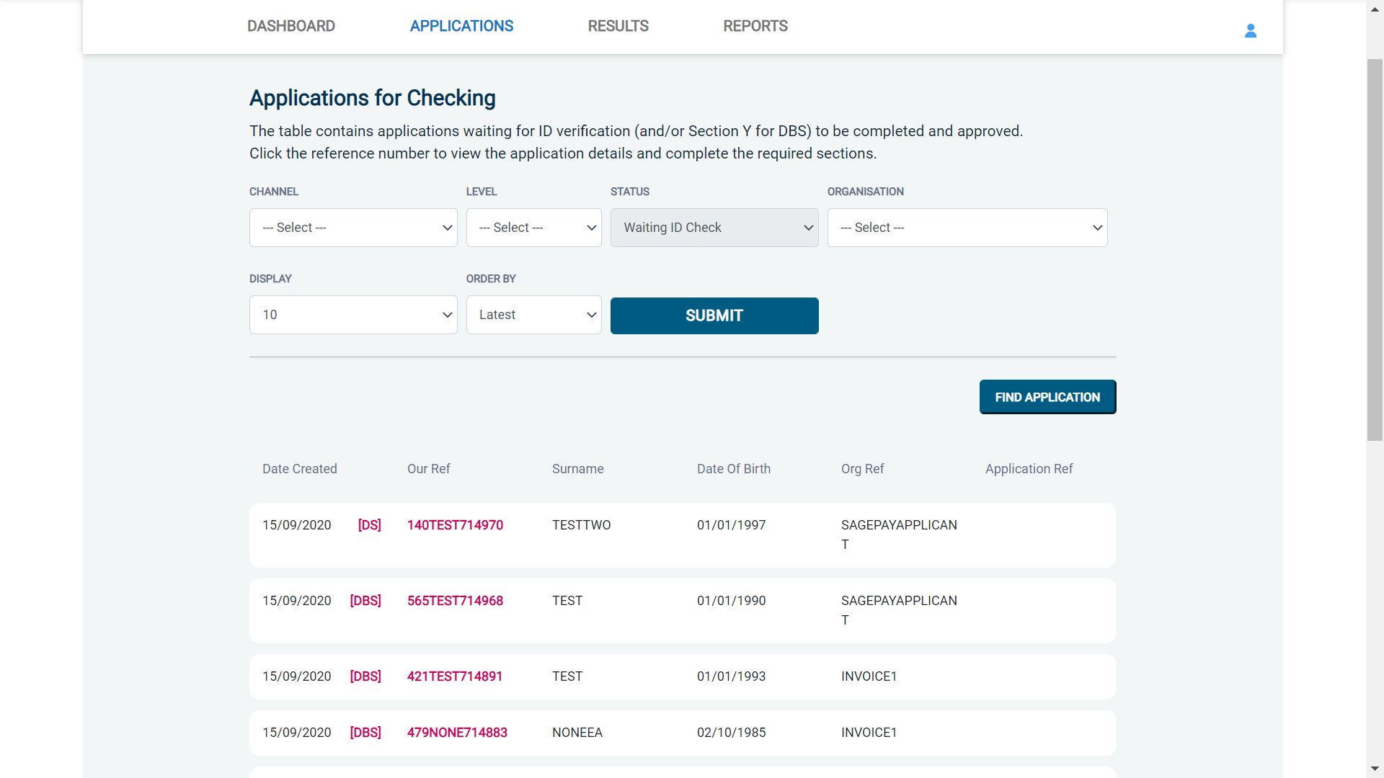
Screen Shot 13

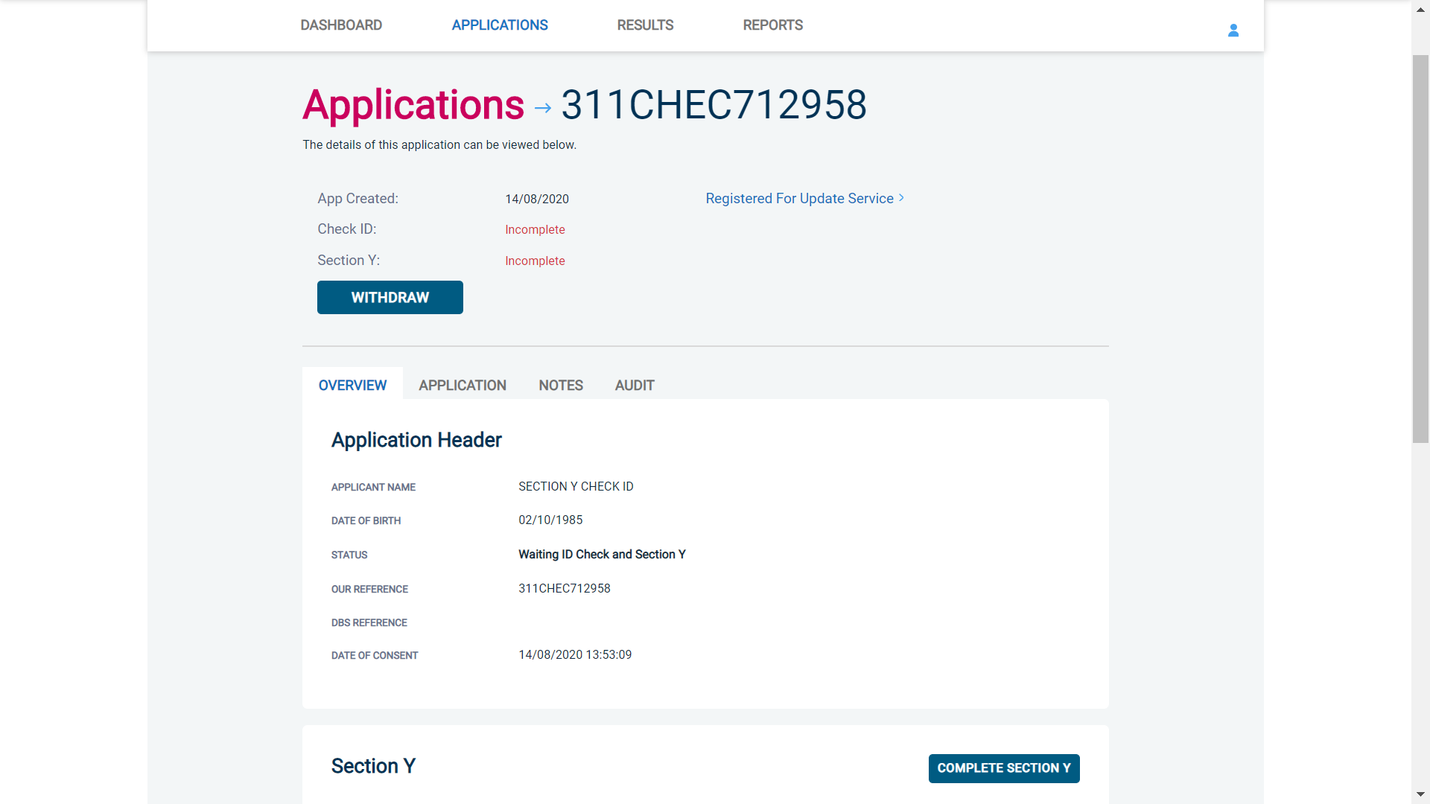
Screen Shot 14

Step 3 – You will now see an overview of the applicant’s completed form with 3 other available tabs, Application, Notes and Audit (see screen shot 14).

- Notes tab – this provides the facility to add any notes relating to an application for other Primary Applicant Managers to see. To add a note, click the ‘Notes’ tab then click the ‘Add Note’ button. After entering the note, select ‘Save’.
- Audit tab – this provides a real-time audit trail of any activity relating to an application. This will show the date and time when a user views or edits an application as well as when the ID Check/Section Y was completed.

Step 4 – Application, to view the application details entered by the applicant, click on the ‘Application’ tab. Here you can see the entire application submitted by the applicant, this can be used to ensure the correct job role has been entered and to verify any ID given by the applicant in a previous surname or previous address (see screen shots 15 & 16).

If any of the information stated on the application is incorrect this can be amended. To edit any part of the application, click ‘Edit’ against that section of the application. Once you have amended the information on the application, click the ‘Next’ button at the bottom of the page to go back to the overview screen. A Primary Applicant Manager can amend any part of the application up until it has been countersigned by us; once the application has been countersigned it can no longer be edited.

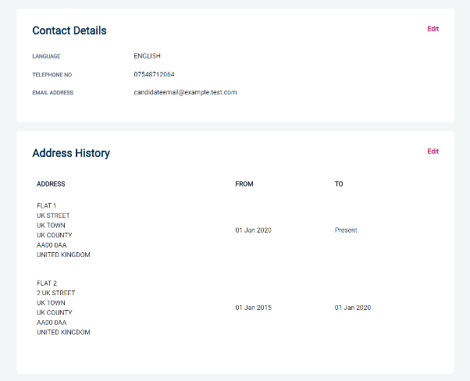
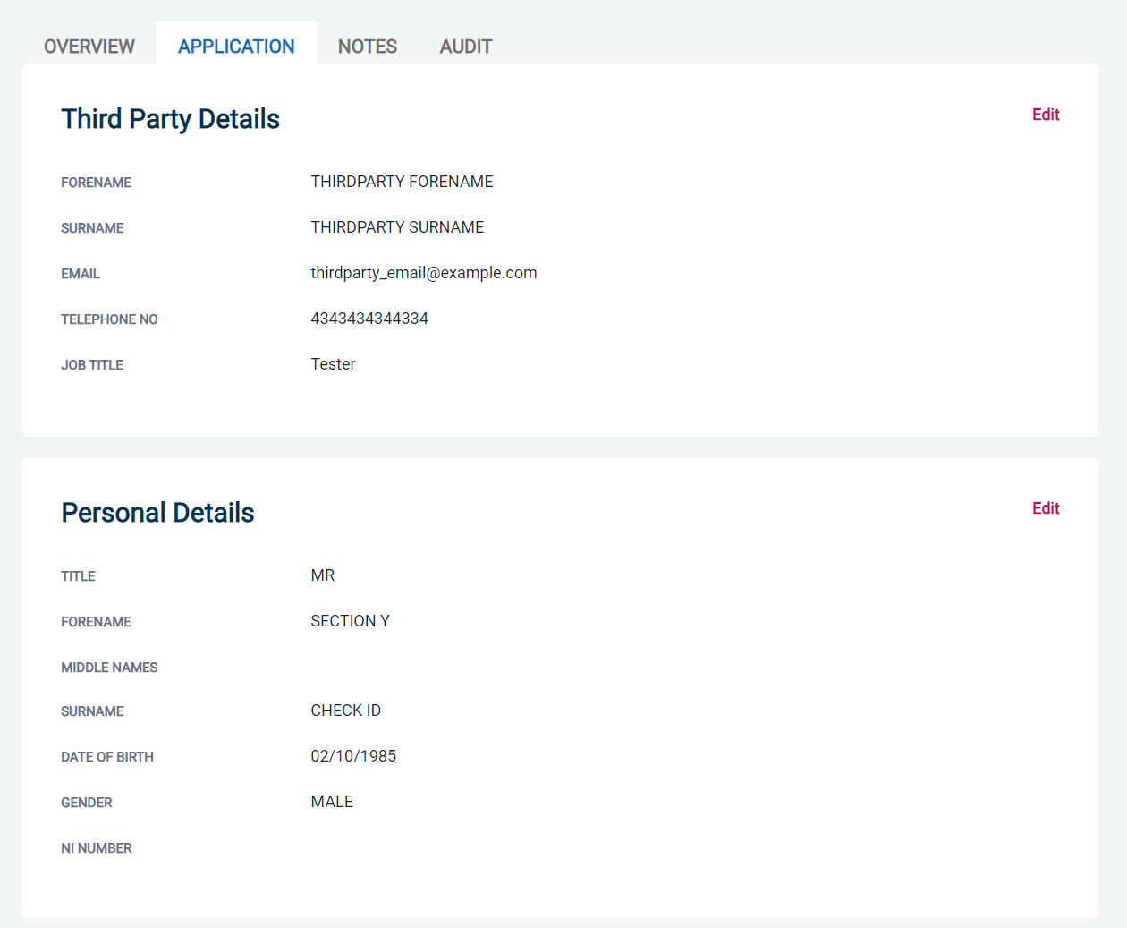
Screen Shot 15
Screen Shot 16

- To complete the ID verification section, click on ‘Complete ID Check’ (see screen shot 14 above), access to this section is located in two places – at the top of the screen or on the overview of the actual form itself. You will now be on the ID screen (see screen shot 17 below).

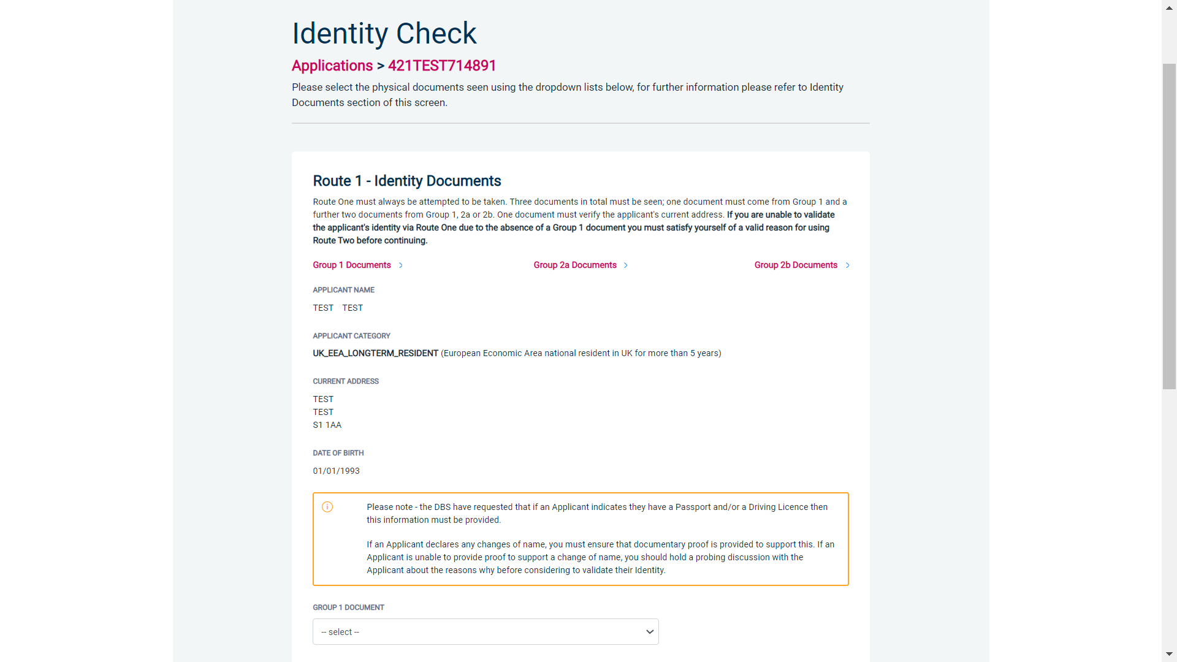
Screen Shot 17

eBulkPlus will automatically ascertain the route that should (or must) be taken based on the nationality and country of birth stated by an applicant within their application form. If an applicant does not hold sufficient ID to be able to go through Route 1, you will then be required to click the ‘Unable to verify ID via Route 1 – proceed to Route 2’ button at the bottom of the screen.

- Please select the ID the applicant has provided for you from the drop-down boxes. Guidance notes can be found on the right-hand side of the screen and are in accordance with the DBS Code of Practice. Please always ensure that you follow the ID checking rules e.g. do not accept a utility bill if it is more than 3 months old or do not accept an out of date passport.
- Ensure that you confirm from the drop-down boxes that you have verified a document showing the applicant’s address and also that you have verified their date of birth.
- If a Cost Code or Personnel Number is required to be assigned to the specific application, this can be entered in the Cost Code / Personnel Number field.
- Now click ‘Save’ and then click the ‘Return to Application’ icon in the green box located at the top of the screen. Now you are ready to complete Section Y of the form (this is the equivalent to Section X on the new lilac paper DBS application forms).
- Once the ID Check has been saved, if you realise that it has been completed incorrectly or through the wrong route, you can reset the ID Check section and complete it again if required. Please note, you will only be able to do this if you have been assigned the appropriate user privilege to do so. To do this, go back into the ID Check screen and click the ‘Reset ID Check’ button found at the bottom of the screen.

Please note, that if an applicant cannot verify their identity via Routes 1, 2 or 3 they will not be able to process their application through eBulk and will need to complete a paper application stating ‘NO’ in section W59. Fingerprints will need to be taken and consent will be required by the applicant. An applicant who is a non-UK national seeking paid employment cannot go through its appropriate route; they will be unable to submit a DBS application.

*A full list of DBS acceptable ID for each route can be found at the end of this guide*

What you must do as part of the ID Checking process

The applicant must provide a range of ID documents as part of the DBS check application process. As an employer you must:
- follow the ID checking process routes as outlined
- check and validate the information provided by the applicant on the application form
- establish the true identity of the applicant through the examination of a range of documents as set out in this guidance
- make sure the applicant provides details of all names by which they have been known
- make sure the applicant provides details of all addresses where they have lived in the last five years
- check that the online application is fully completed and the information it contains is accurate.
- you must only accept valid, current and original documentation
- you must not accept photocopies
- you must not accept documentation printed from the internet e.g. internet bank statements
- identity information for the applicant’s name, date of birth and address recorded on the online application form must be validated
- you should in the first instance, seek documents with photographic identity (e.g. passport, new style driving licence, etc.) and for this to be compared against the applicant’s likeness
- all documents must be in the applicant’s current name
- one document must confirm the applicant’s date of birth
- you must ensure that the applicant declares all previous name changes and provides documentary proof to support the change of name. If the applicant is unable to provide proof to support the change of name, you should hold a probing discussion with the applicant about the reasons why before considering validating their identity
- you must see at least one document to confirm the applicant’s current address, in accordance with the guidance
- a document from each of the groups should be included only once in the document count e.g. don’t accept two bank statements as two of the required documents, if they are from the same bank
- you should not accept the foreign equivalent of an identity document if that document is listed as ‘(UK)’ on the list of valid identity documents

Step 6 - Completing Section Y

- To complete Section Y click on ‘Complete Section Y’ (please refer back to screen shot 14). Access to this section is located in two places – at the top of the screen or on the overview of the actual form itself. You will now be on the ‘Section Y’ screen – (see screen shot 18).
- If required, guidance can be read by clicking on the ‘i’ tooltip icons if you require any clarification regarding the application type required or any other drop-down boxes within Section Y.

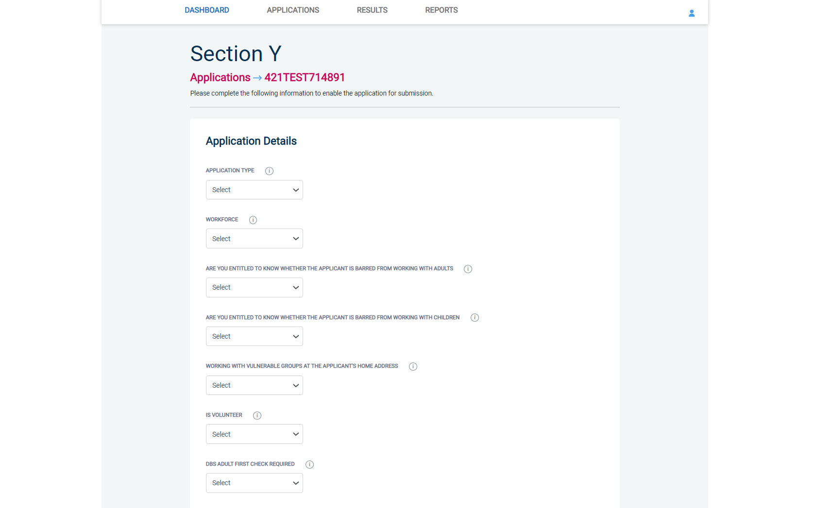
Screen Shot 18

- Please complete the application details by selecting Yes/No answers from each of the drop-down boxes. You can add additional information about an applicant and their job role if you wish in the box at the foot of this screen.

Workforce Categories

- Adult Workforce - use this for any position that involves working/volunteering with adults
- Child and Adult Workforce - use this for any position that involves working/volunteering with both children and adults
- Child Workforce - use this for any position that involves working/volunteering with children
- Other Workforce - use this for any position that does not involve working/volunteering with Children or Adults (e.g. security guard / electrician)

- Finally click ‘Save’ then scroll to the top of the screen to the green box and click ‘Approve’.

- Please ensure you click on ‘Approve’ – failure to do so will result in the form not being submitted for Countersignatory Authorisation.

- You have now completed this section; you will have no further action to take. The form will automatically transfer to us to be countersigned, ready for onwards transmission to the DBS.

- *If an application does require further clarification from us prior to submission to the DBS, a query will be flagged on the application and WE will contact you for clarification. During this time, a copy of the application record move into the ‘Queried Applications’ folder on the Dashboard (see Screen Shot 5). You can view the full information regarding the query by clicking on the ‘Notes’ tab of any application in the ‘Queried Applications’ folder (see Screen Shot 19 below)*

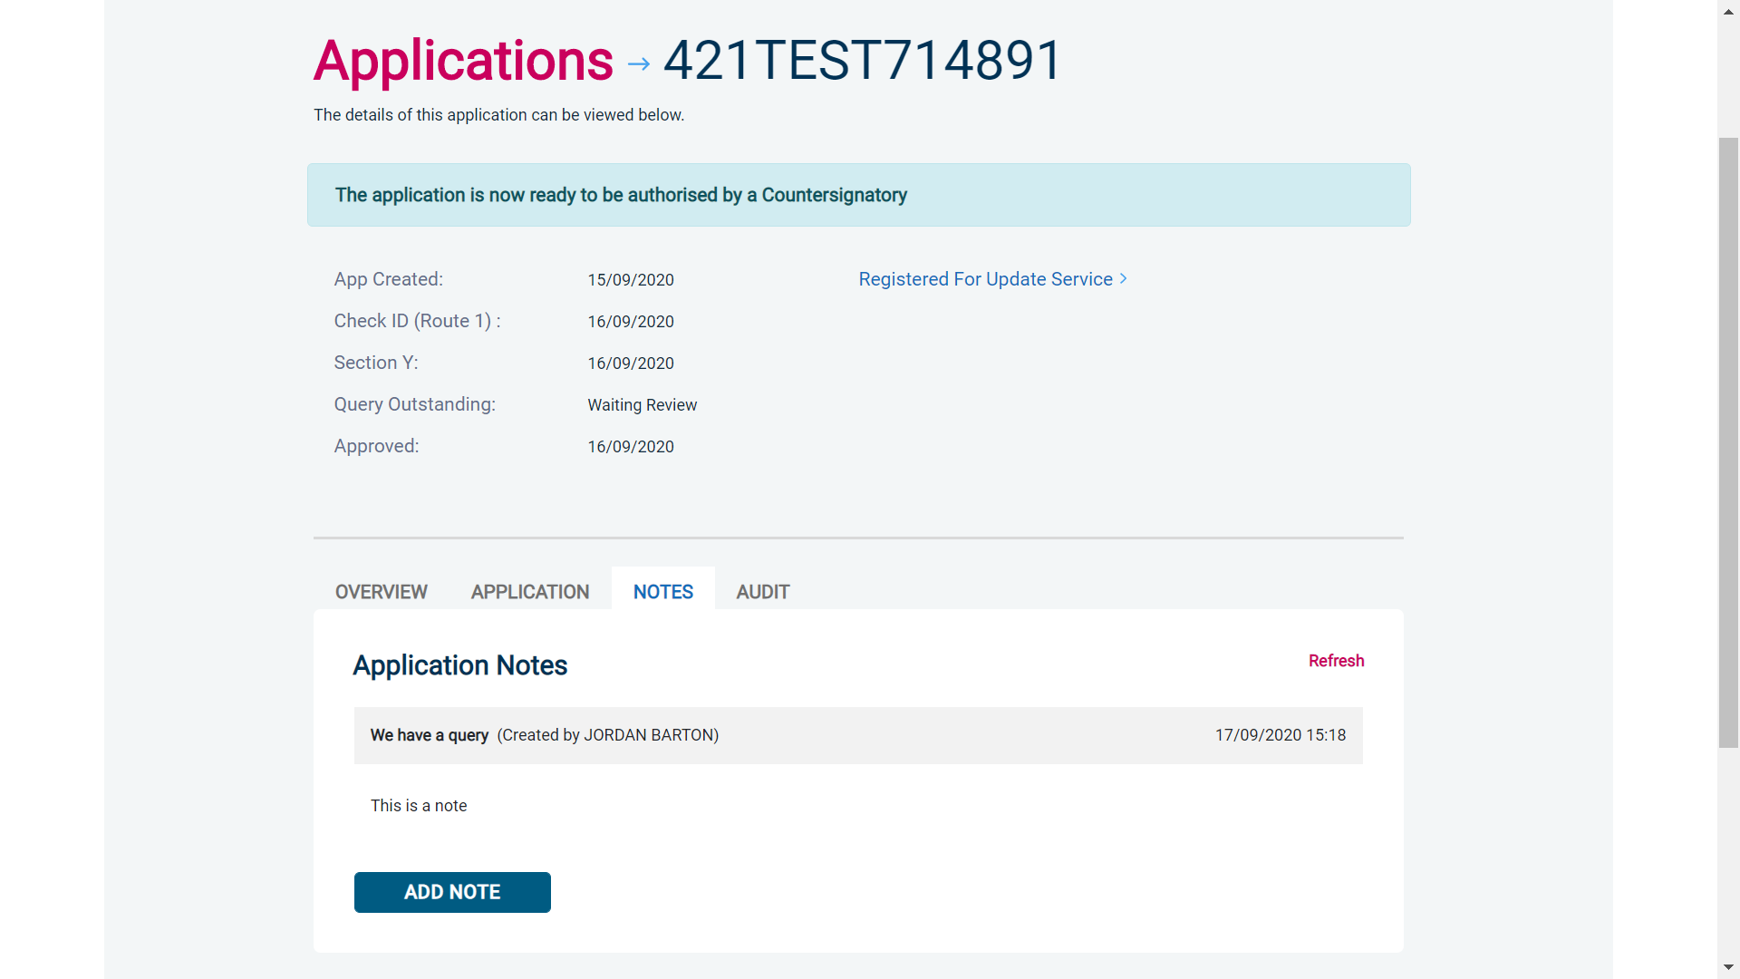
Screen Shot 19

- Once a form has been countersigned by your Registered Body, the application will be moved to the ‘Transfer’ section. Applications at this stage are awaiting collection by the DBS. Once the DBS have collected them they will move into the processing stage – please see below for further details.

NB. An application form can be withdrawn at any time up to and including Countersignatory stage. Once a form has been electronically transferred to the DBS, we cannot withdraw it without incurring the DBS charge. If you wish to withdraw an application at Countersignatory stage, please contact us immediately, to enable the process to be halted.

DBS Processing

Step 1 – Tracking an application – see screen shot 20.

- On the Dashboard you will see at the bottom of the page, a box called ‘Submitted’.

Screen Shot 20

- To track an application with the DBS, click on ‘Processing’, this will take you to a screen which will show all the applications for your company that are currently being processed by the DBS. To track an individual’s application, click on ‘Track’ next to their DBS reference number in the right-hand column (see screen shot 21). This will take you directly into the DBS’s tracking page for that applicant.

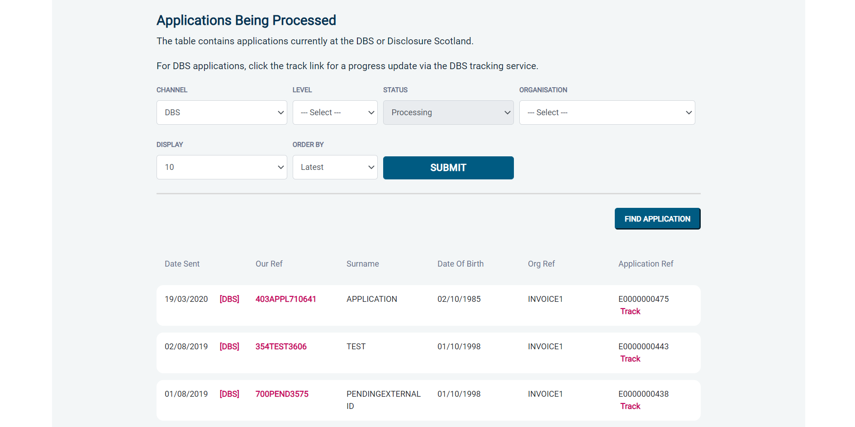
Screen Shot 21

Completed Results

Results with content

Step 1 - Notification – see screen shot 22.

- The DBS will send notification online once an application has been completed. To view a result please return to the Dashboard and click on ‘Completed’ in the Submitted section.

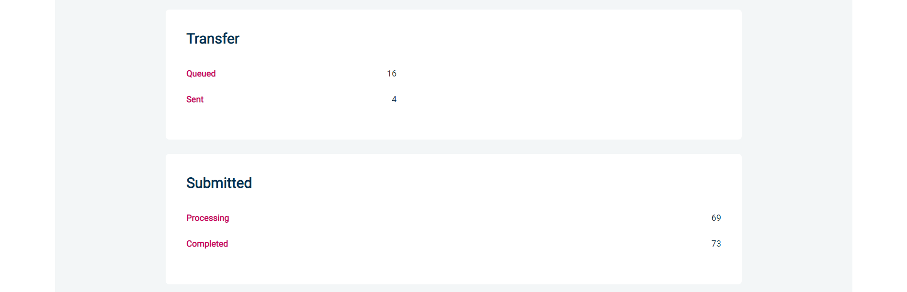
Screen Shot 22

Step 2 - Viewing a Certificate result with content – see screen shot 23.

- To view the information of a certificate e.g. certificate issue date, reference number and result status, click on the applicant’s reference number (see screen shot 23). This information will stay in the ‘Completed’ folder for 180 days from the issue date of the certificate.

- Certificate results with content will state “Please wait to view applicant certificate” in the Status column – This means the certificate contains information and you will have to view the applicant’s certificate to see this information.

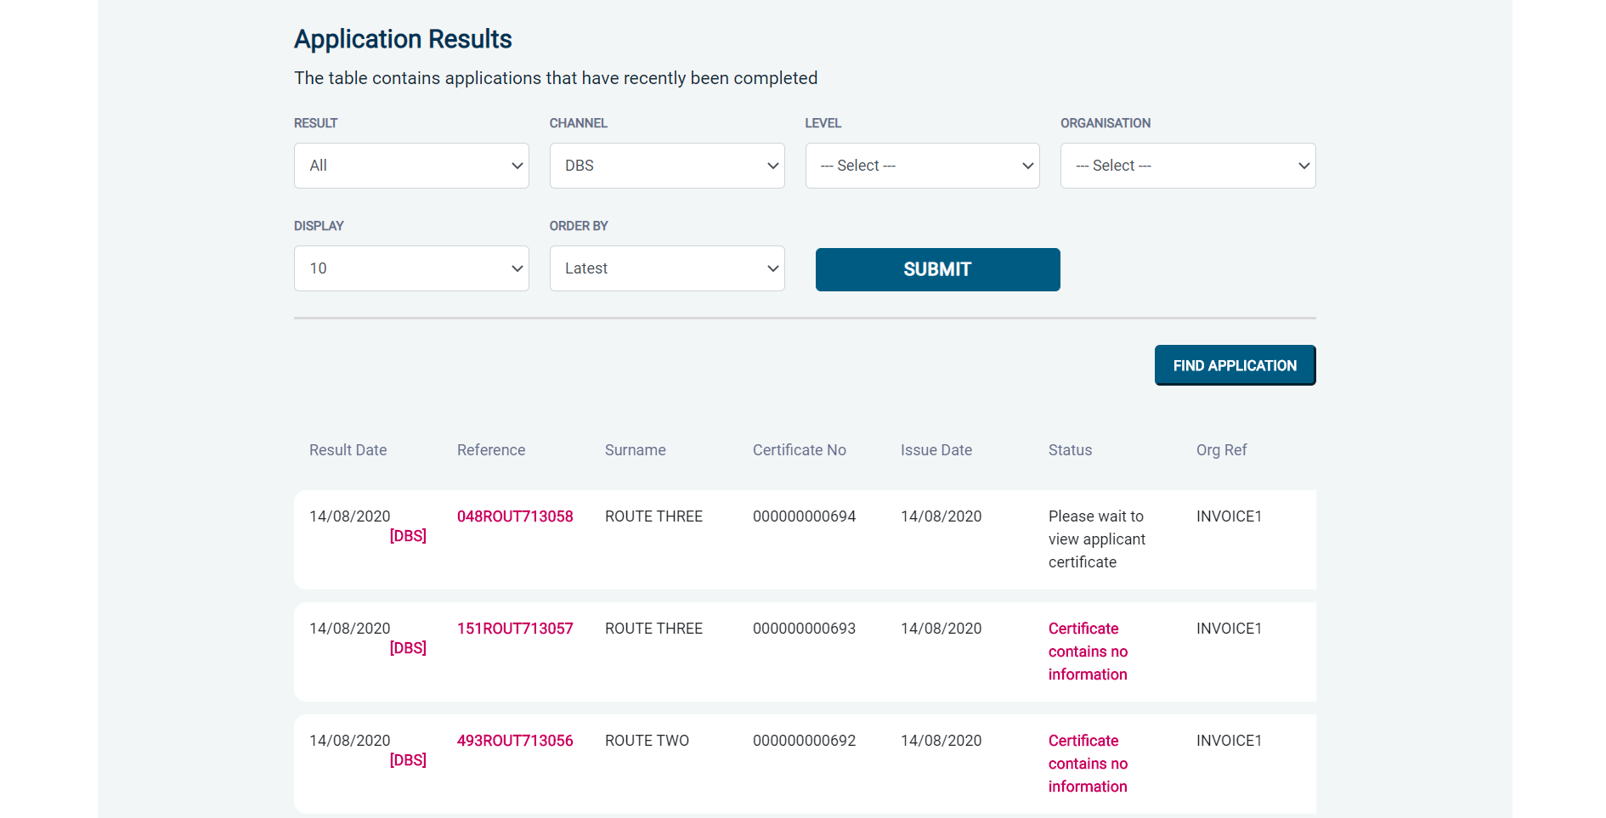

Screen Shot 23

Step 3 – Indicating sight of the applicant’s certificate – see screen shot 24.

To help an organisation keep track of which applicants have brought their certificate in and been viewed by the organisation, the system is able to record the date the applicant’s certificate has been seen by their organisation or whether sight is not required. As a Primary Applicant Manager, you can add this date on to an application to indicate that their certificate has been sighted.

To add the date or to view whether a date has been added, click on the reference number of the application from the ‘Completed’ folder (see screen shot 22 above). Once in the application, the date can be added in the ‘Applicant’s Certificate Seen’ section at the top of the screen (see screen shot 24 below).

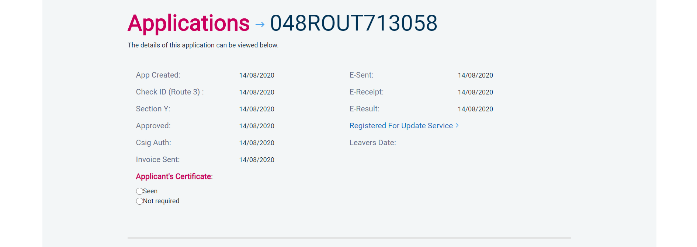
Screen Shot 24

Step 4 – Uploading a scanned copy of the applicant’s certificate – see screen shot 25.

As a Primary Applicant Manager, you may have been granted permission to upload and/or view uploaded certificates attached to results with content. If you have been granted the upload privilege, you are able to upload a scanned copy of the applicant’s certificate to their application as long as you obtain their consent. If you wish to use this facility, you will need to mark the ‘Written consent has been obtained from the applicant?’ box, once ticked you will have facility to select the required file to upload.

Once a file has been uploaded, you will be able to view this as many times as you wish by clicking the ‘Download Certificate’ button until the application is archived after 180 days (see screen shot 25 below). If you have been granted the appropriate privilege, you may also have the ability to remove the uploaded certificate by clicking the ‘Remove Certificate’ button. Please note a sample ‘Applicant Consent Form’ can be downloaded from the footer of eBulkPlus to use to obtain applicant’s consent.

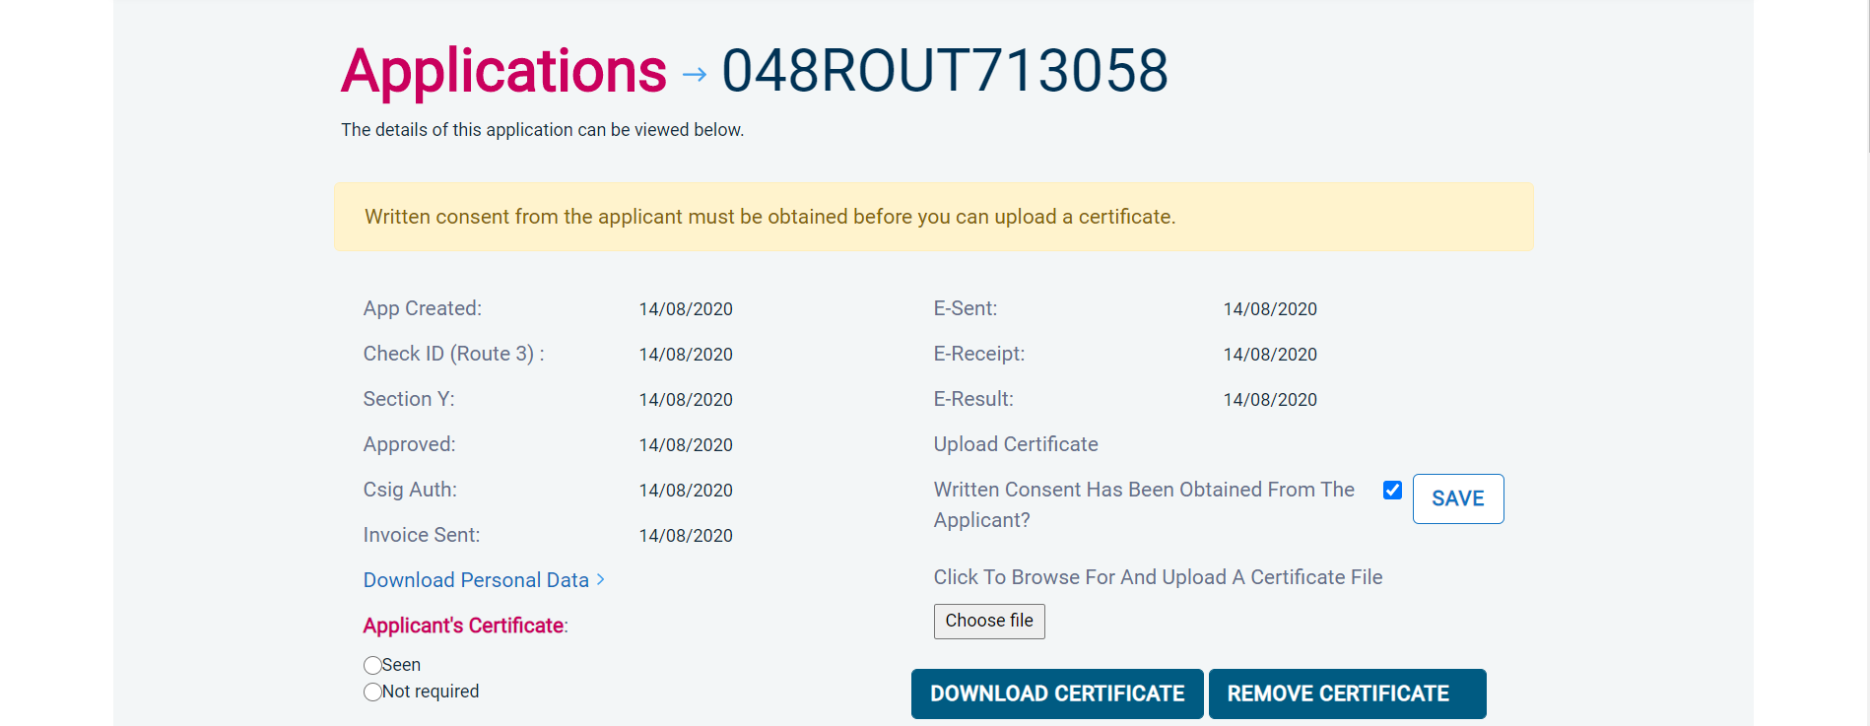
Screen Shot 25

Clear results

Step 1 - Notification – refer back to screen shot 22 above.

- The DBS will send notification online once an application has been completed. To view a result please return to the Dashboard and click on ‘Completed’ in the Submitted section.

Step 2 - Viewing a clear certificate result– see screen shot 26.

- To view the information of a certificate e.g. certificate issue date, reference number and result status, click on the applicant’s reference number (see screen shot 26). This information will stay in the ‘Completed’ folder for 180 days from the issue date of the certificate.

- Clear certificate results will state “Certificate contains no information” in the status column – This means the certificate contains no criminal convictions, cautions, warnings or reprimands.

Screen Shot 26

Step 2 - Viewing a Result Snapshot for clear applications – see screen shots 26 & 27.

- As an Applicant Manager you can click on the ‘Certificate contains no information’ wording in the status column to view a Result Snapshot for this application (see screen shot 27 below).

Please note that the Result Snapshot is for information purposes only, it does not represent a DBS certificate or act as a DBS certificate alternative. The information contained within the snapshot is not to be viewed by or passed to any individual who does not have the appropriate authority to view it.

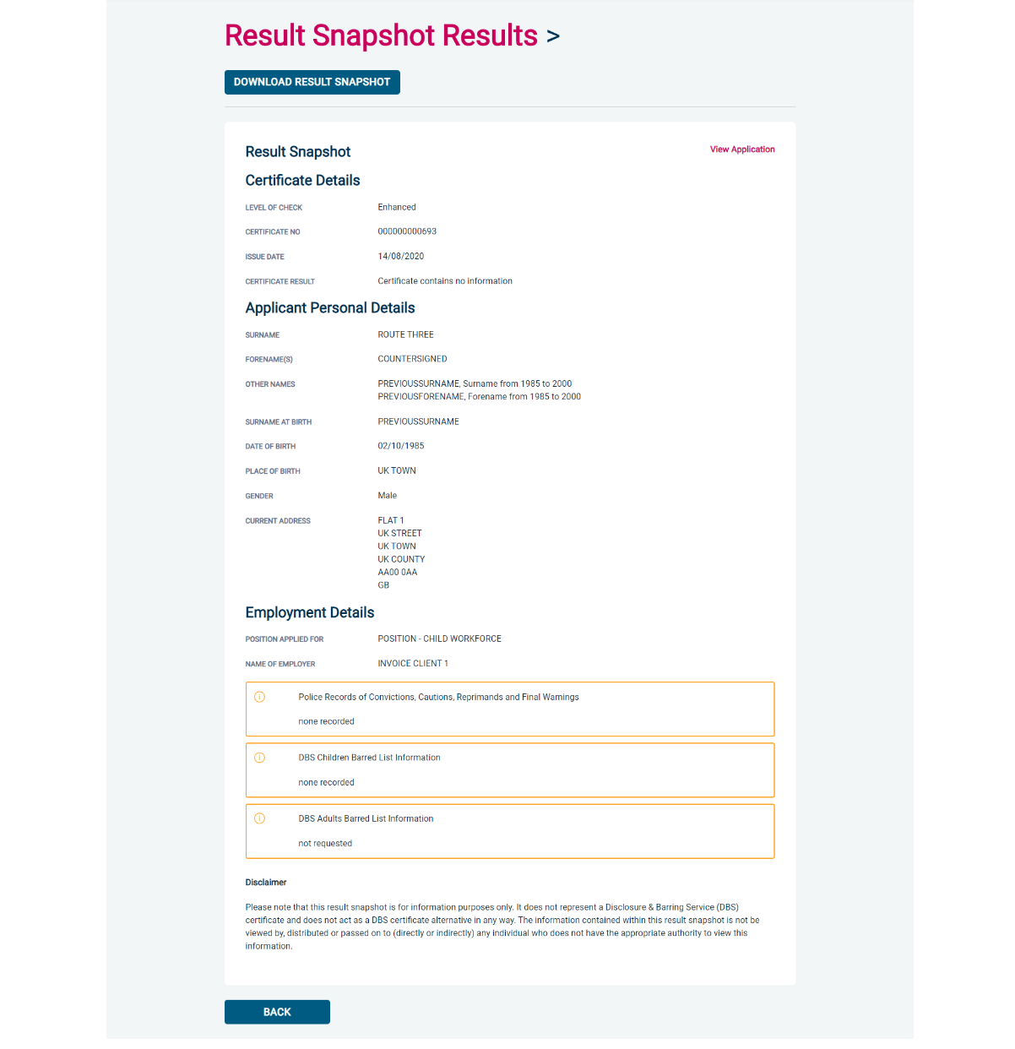
Screen Shot 27

As the Registered Body/Employer does not receive a copy of a completed DBS certificate, we advise that you have sight of the applicant’s certificate regardless of the status outcome on eBulkPlus; however this is for your organisation to decide based on your own internal policies. For completed applications with a result status of “Please wait to view applicant’s certificate” you must view the applicant’s certificate before making a recruitment decision.

Find an Application

Step 1 - Finding an individual application – see screen shots 28 & 29.

- To find an individual application pre or post DBS processing or that has been archived, select from the Dashboard the Applications tab and then click on ‘Find Application’.

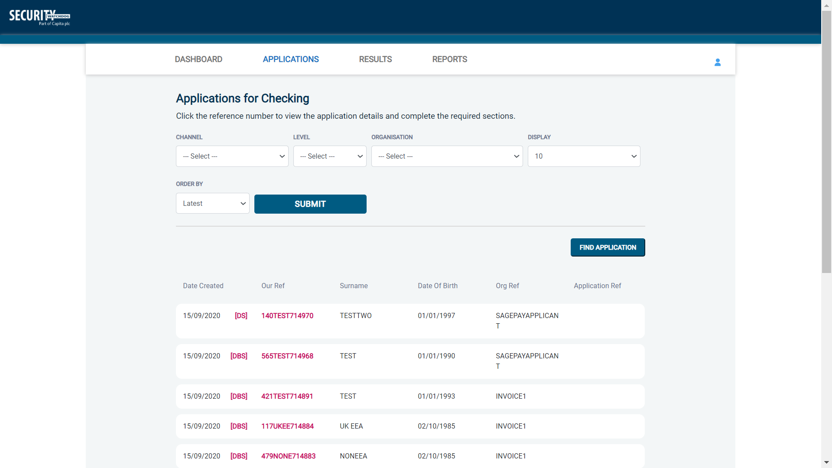
Screen Shot 28

- The following box will appear for you to enter as much of the applicant’s details as you have available. E.g. if you only enter the surname without date of birth or DBS reference, it will bring up a list of every applicant with that surname. However, if you enter their date of birth as well, then this will define the search results accordingly. If you tick the ‘Search Archived’ button, this will display applications that have been archived from the system.

Screen Shot 29

Reports

Step 1 - Running a report – see screen shot 30.

- To run a report, you need to return to the Dashboard and select the tab ‘Reports’ and then select the report you wish to run. There are currently a number of standard reports that you can choose from, however it is also possible to run a customised report (please note that as you only process Standard/Enhanced DBS checks, you can ignore the right-hand section of the reports screen containing Basic Disclosure report information).

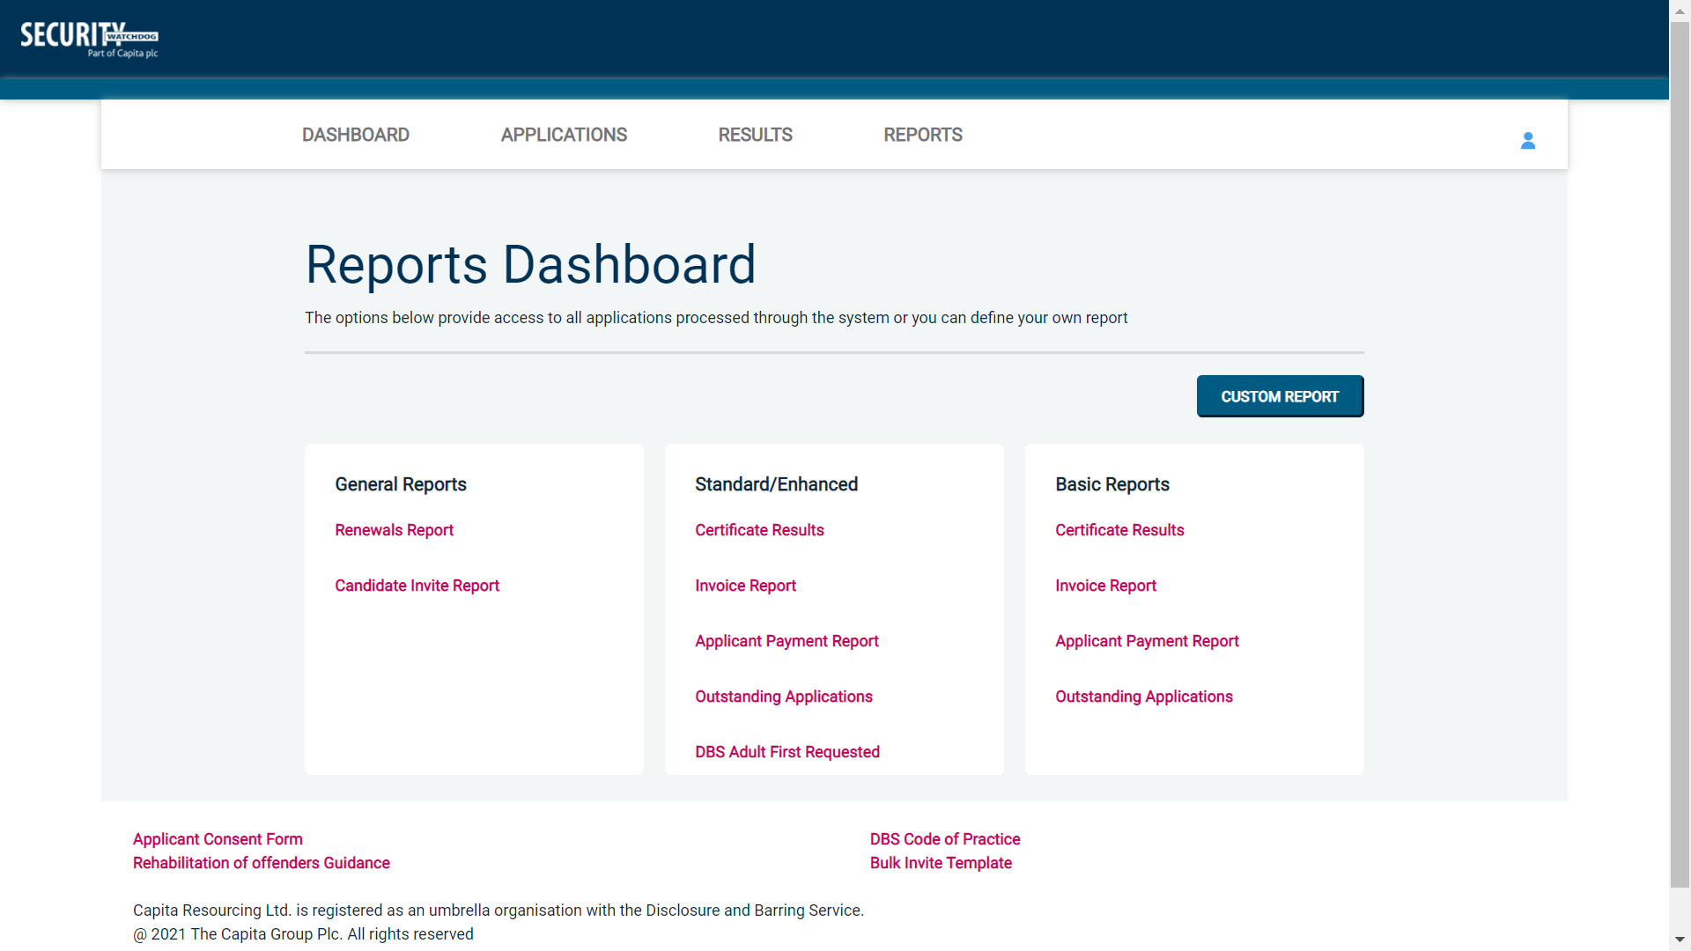
Screen Shot 30

Stage 2 – Invoice Report – see screen shot 30 above.

This report can be used to produce an electronic version of the invoice you will receive from us or for you to calculate the company budget required in relation to DBS costs. This can be filtered by a specific division or can be run on all divisions within your organisation. The report captures applicant and organisation data with the addition of;

- Basic, Standard or Enhanced Fee
- Cost Code
- Organisation Postcode
- Admin Fee (referred to as Base Fee on the system)
- VAT
- Total application price

.

Stage 3 - Customised Reports and selecting field headings – see screen shot 31.

- To run a customised report, you can select the field headings and date criteria that you wish the report to contain. For example, this is an ideal opportunity to run a report when carrying out re-checks on your staff or for capturing cost codes for invoicing purposes. All reports can be printed or saved into an Excel spreadsheet (.CSV file) or PDF document.

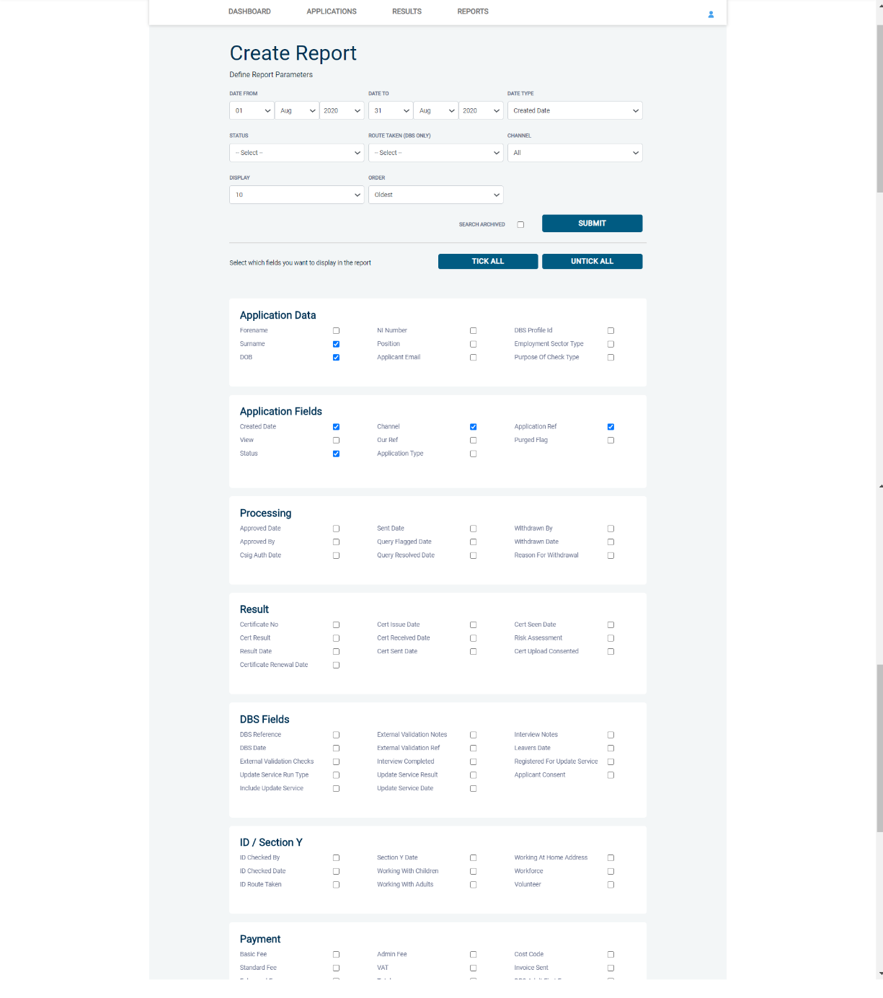
Screen Shot 31

ALL USERS – PLEASE LOG OFF AT THE END OF YOUR SESSION. IF A SESSION IS INACTIVE FOR MORE THAN TEN MINUTES YOU WILL BE AUTOMATICALLY LOGGED OFF FOR SECURITY REASONS.

CONTACT DETAILS

If you experience any technical issues with the online system, please contact Care Check on 0333 777 8575. Alternatively, you can contact us by e-mail at info@carecheck.co.uk

DBS List of Acceptable Identification

For paid non-UK nationals only

(3 documents to be seen)

1 Primary Document
2 Supporting Documents from Group 1, 2a or 2b.

Combination of documents must confirm name, DOB & current address.

If unable to satisfy this route, DBS check cannot be submitted.

Route 2 – UK applicants only
(3 documents to be seen plus an External ID Check)

1 document from Group 2a.
2 further documents from Group 2a or 2b.

Combination of documents must confirm name, DOB & current address.

If unable to satisfy Route 2, proceed to Route 3/Fingerprints.

Route 1 – For all applicants except paid non-UK nationals
(3 documents to be seen

1 document from Group 1.
2 further documents from Group 1, 2a or 2b

Combination of documents must confirm name, DOB & current address.

If unable to satisfy Route 1, proceed to Route 2/Fingerprints.

Fingerprints

Paper application form required (unable to process online).

Attendance at a local Police Station for fingerprints to be taken.
Route 3 – For UK applicants only
(5 documents to be seen)

A UK Birth Certificate issued after birth.
4 further documents, 1 from Group 2a, 3 from 2a or 2b.

At least one of the documents must show the applicant’s current address.

If unable to satisfy Route 3, proceed to Fingerprints.

Group 1
Primary Identity Documents
- Current valid Passport
- Biometric Residence Permit (UK)
- Current Driving Licence – photo card (UK / Isle of Man / Channel Islands) (Full or Provisional)
- Birth Certificate (UK / Isle of Man / Channel Islands) (Issued within 12 months of birth)
Full or short form acceptable including those issued by UK authorities overseas, such as Embassies, High Commissions & HM Forces. (Photocopies are not acceptable)
- Adoption Certificate (UK / Channel Islands)

Paid Non-UK Nationals
Primary Documents
- A current passport or passport card showing that the holder is a national of the Republic of Ireland.
- A current document issued by the Home Office to a family member of an EEA or Swiss citizen, and which indicates that the holder is permitted to stay in the United Kingdom indefinitely.
- A current Biometric Immigration Document (Biometric Residence Permit) issued by the Home Office to the holder indicating that the person named is allowed to stay indefinitely in the UK or has no time limit on their stay in the UK.
- Online evidence of immigration status. Either via the View and Prove service or using the BRP or BRC online service. Issued by the Home Office to the employer or prospective employer, which indicates that the named person may stay in the UK and is permitted to do the work in question. Must be valid. Note: this includes the EUSS digital status confirmation.
- A current passport endorsed to show that the holder is exempt from immigration control, is allowed to stay indefinitely in the UK, has the right of abode in the UK, or has no time limit on their stay in the UK.
- A current Immigration Status Document issued by the Home Office to the holder with an endorsement indicating that the named person is allowed to stay indefinitely in the UK or has no time limit on their stay in the UK, together with an official document giving the person’s permanent National Insurance number and their name issued by a government agency or a previous employer.
- A current passport endorsed to show that the holder is allowed to stay in the UK and is currently allowed to do the type of work in question.
- A current Biometric Immigration Document (Biometric Residence Permit) issued by the Home Office to the holder which indicates that the named person can currently stay in the UK and is allowed to do the work in question.
- A current document issued by the Home Office to a family member of an EEA or Swiss citizen, and which indicates that the holder is permitted to stay in the United Kingdom for a time limited period and to do the type of work in question.
- A frontier worker permit issued under regulation 8 of the Citizens’ Rights (Frontier Workers) (EU Exit) Regulations 2020.
- A current Immigration Status Document containing a photograph issued by the Home Office to the holder with a valid endorsement indicating that the named person may stay in the UK, and is allowed to do the type of work in question, together with an official document giving the person’s permanent National Insurance number and their name issued by a government agency or a previous employer.
- A document issued by the Home Office showing that the holder has made an application for leave to enter or remain under Appendix EU to the immigration rules on or before 30 June 2021 together with a Positive Verification Notice from the Home Office Employer Checking Service.
- An Application Registration Card issued by the Home Office stating that the holder is permitted to take the employment in question, together with a Positive Verification Notice from the Home Office Employer Checking Service.
- A Positive Verification Notice issued by the Home Office Employer Checking Service to the employer or prospective employer, which indicates that the named person may stay in the UK and is permitted to do the work in question.

Group 2a  Trusted Government Documents | Group 2b  Financial & Social History Documents
- Current Driving Licence – photo card only (All Countries except Group 1) (Full or Provisional)  - Current Driving Licence – paper version (UK / Isle of Man / Channel Islands) (Full or Provisional)  - Birth Certificate (UK / Isle of Man / Channel Islands) (Issued after the time of birth)  - Marriage / Civil Partnership Certificate (UK / Channel Islands)  - HM Forces ID Card (UK)  - Fire Arms Licence (UK / Isle of Man / Channel Islands)  - Immigration document, work permit or VISA (Issued outside of UK) (Valid only for roles whereby applicant is living and working outside of UK.) | - Mortgage Statement (UK) **  - Bank/Building Society Statement (UK / Channel Islands) *  Monzo statements or statements printed from the internet are not acceptable  - Bank/Building Society Account Opening Confirmation Letter (UK) *  - Credit Card Statement (UK) *  - Financial Statement e.g. pension, endowment, ISA (UK) **  - P45/P60 Statement (UK / Channel Islands) **  - Council Tax Statement (UK / Channel Islands) **  - Utility Bill (UK) - Not Mobile Phone *  - Benefit Statement (UK) e.g. Child Allowance, Pension *  - Document from Central/ Local Government/ Government Agency/ Local Authority (UK / Channel Islands) *  e.g. DWP, Employment Service, HMRC, Job Centre, Social Security  - EEA National ID Card – must be valid  - Cards carrying the PASS accreditation logo (UK / Isle of Man / Channel Islands) – must be valid  - Irish Passport Card – must be valid (Cannot be used with an Irish Passport)  - Letter from Head Teacher or College Principal (16-19 year olds in full time education in the UK)  - Non-UK Bank/Building Society Statement *  Branch must be located in the country in which the applicant lives and works  - Letter of Sponsorship from future employer  Non-UK only – valid only for applicants residing outside UK at time of application
Please note if a document in the List of Valid Identity Documents is:
- Denoted with * - issued in the last 3 months
- Denoted with ** - issued in the last 12 months

