Primary Applicant Manager Guidance Notes

Basic Online Disclosure Guide (eBulkPlus)

Contents
Primary Applicant Manager Guidance Notes 1
Logging onto the System 2-5
Inviting applicants to submit their application 6-9
How to complete ID Verification 10-15
Tracking an application 16
Viewing completed results 17-21
How to find an application 22
Reports 23-24
DBS List of Acceptable Identification 25-27

Primary Applicant Manager Guidance Notes - Basic

An online DBS check can be completed by accessing the internet from any device that has this facility. This includes a smart phone, tablet, laptop or PC. It is supported on the latest versions of all modern browsers; however, we do not recommend access via Internet Explorer as this browser is unsupported both by our technology and soon by Microsoft also. The software is simplistic and easy to use. You can gain access to the system within minutes.

You have been granted access to eBulkPlus in the role of a Primary Applicant Manager. A Primary Applicant Manager can view and edit all applications created under the organisation or specific division they have been created under. A Primary Applicant Manager can stipulate what ID has been seen in relation to an applicant. After an applicant’s ID has been verified a Primary Applicant Manager has the authority to approve an application for submission.

Logging onto the System

Please enter the following address into your web browser:

www.carecheck.co.uk

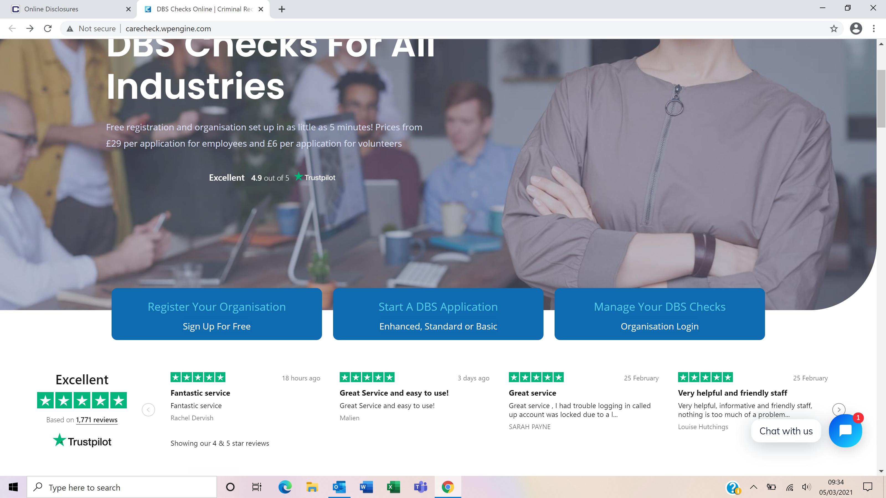

Now click on the box that says `Manage Your DBS Checks’

You will now be on the main login page that shows three boxes. Please note at this stage of the process, your login details are case sensitive.

- Click on ‘Application Management’.
- Enter your company Organisation Reference - this will have been supplied to you in an automated email (if you cannot remember this please click on the ‘Forgotten your login details?’ icon at the bottom of the screen to be sent a reminder).
- Enter your Username.
- Enter your Date of Birth (for first initial login please ensure you enter the default date of birth 01 Jan 1998. Failure to do so will deny you access to the system).

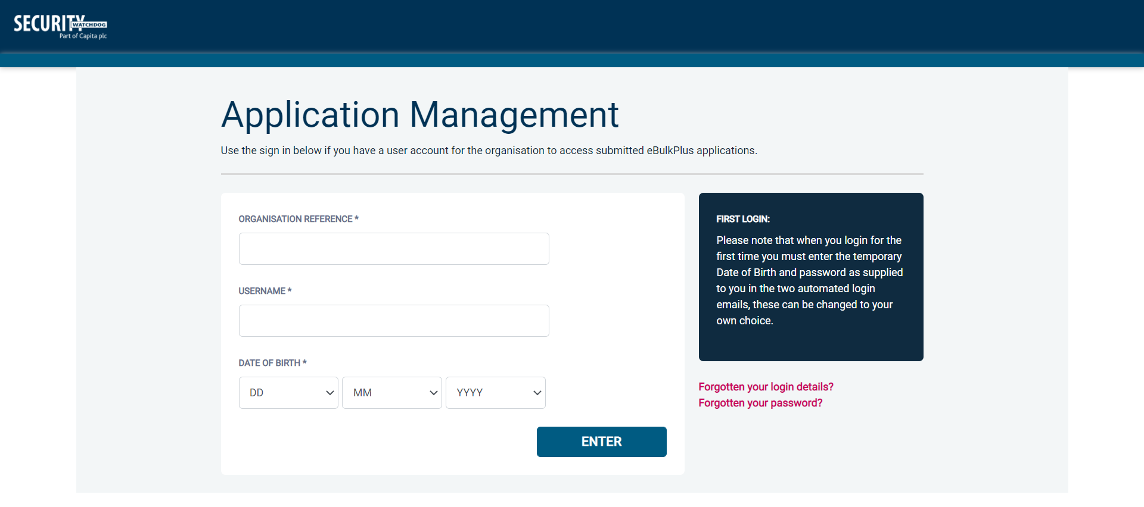
Screen Shot 1

- Once you have completed this section click ‘Enter’.

- Enter your password (this will be supplied to you in an automated email) – see screen shot 2 below (If you cannot remember this please click on the ‘Forgotten your password?’ icon at the bottom of the screen to be sent a new one-time password).

If you have difficulty gaining access to the system, please contact XXX, however please ensure the first time you login that you have not been denied access because of entering your own date of birth. The first time you login you must enter the temporary default date of birth 01 Jan 1998.

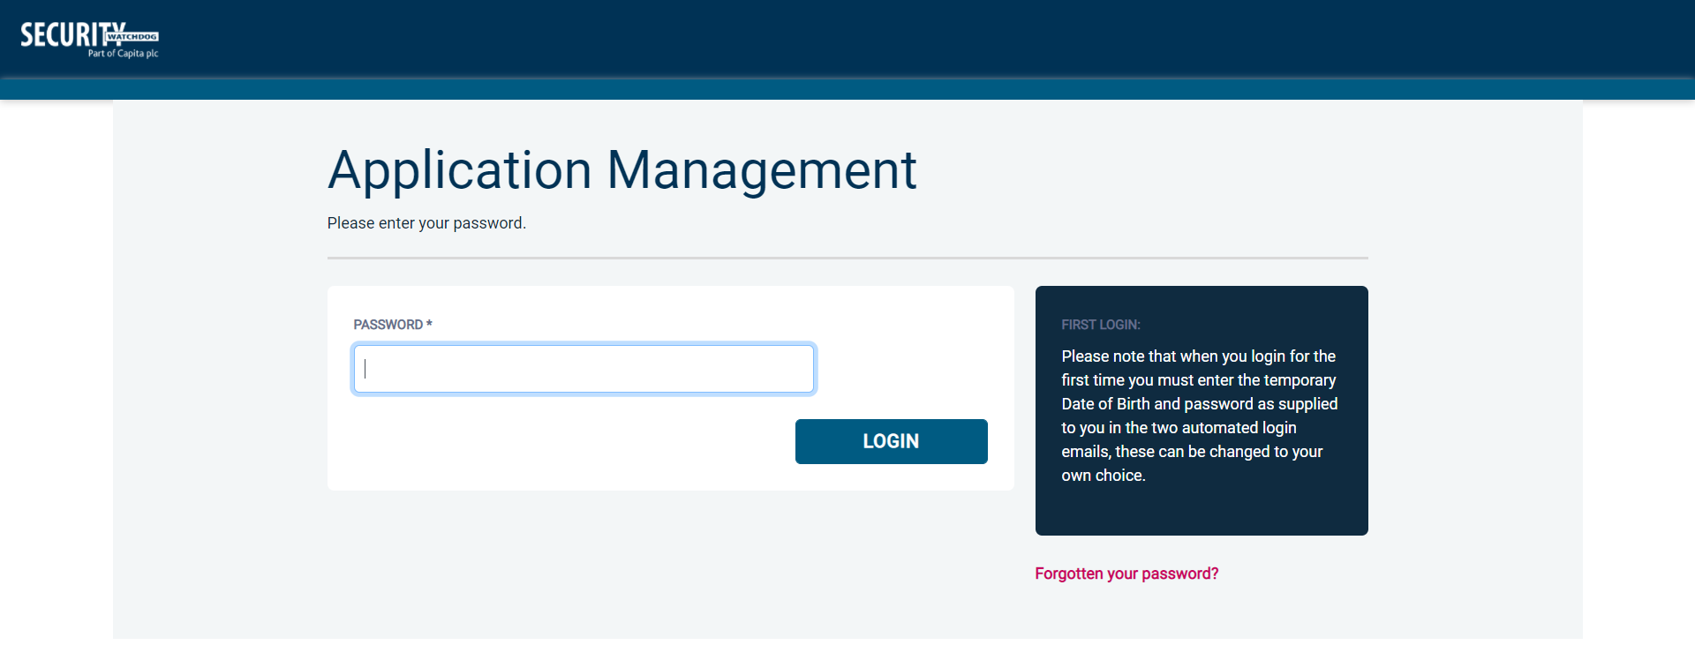
Screen Shot 2

- Please note, after initial login you will be required to set your own password and enter your own date of birth for future login purposes.
- Please re-enter into the ‘Current Password’ field the temporary password you received in your initial e-mail and then create your own unique password (see screen shot 3 below).
- The password you create must be between 8 & 30 characters containing at least one upper case letter, one lower case letter, one special character and at least one number.
- Please then enter a date of birth of your choice for future login purposes.
- Please then click ‘Update’.

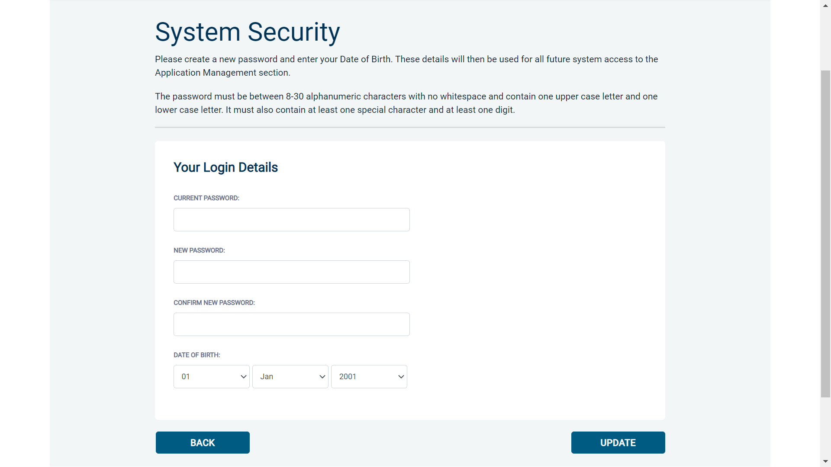
Screen Shot 3

- If you have successfully created your own password, you will now be able to enter the system by clicking the ‘Click here to enter System’ icon in the green box (please note you do not need to re-enter your password details once the green box has appeared).

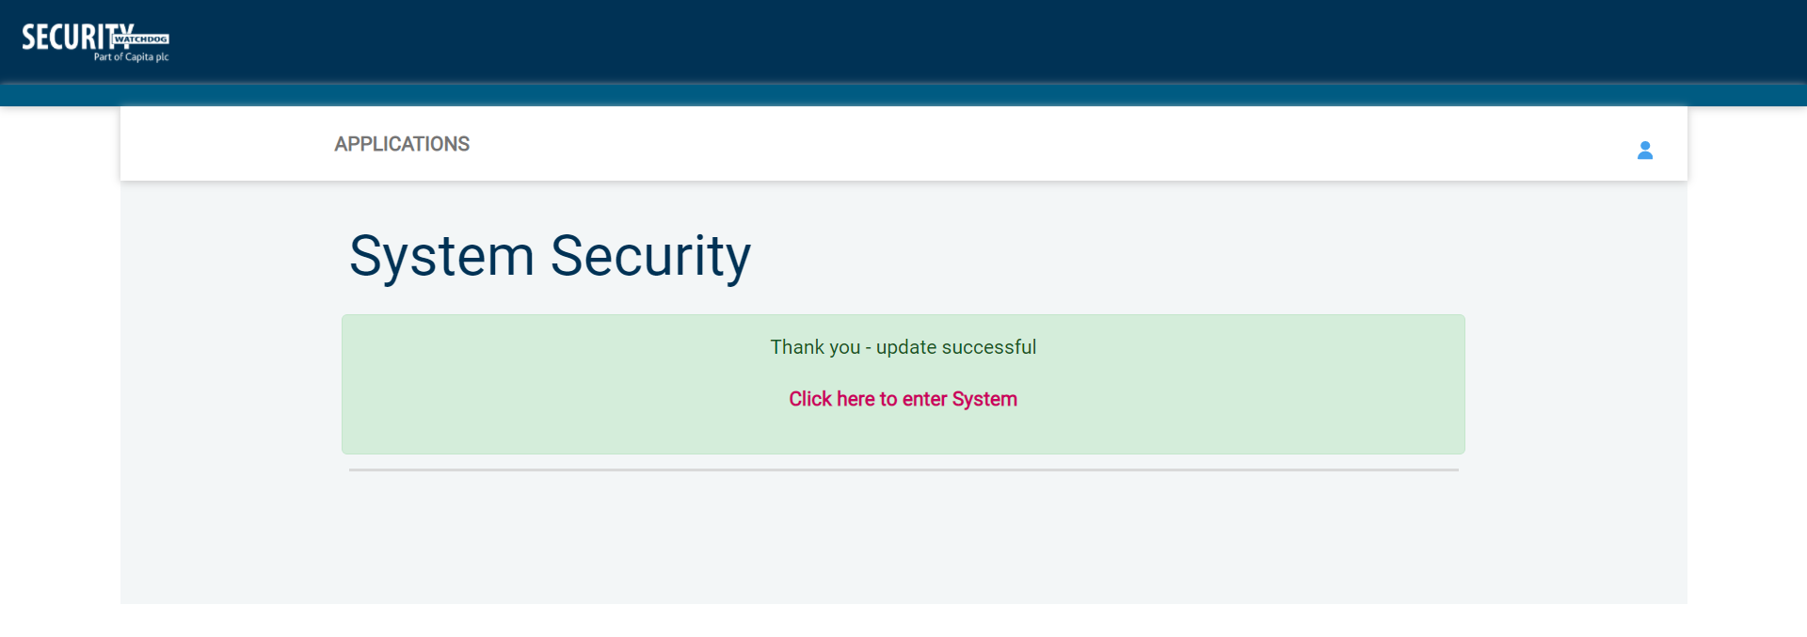
Screen Shot 4

- This will now take you to the main eBulkPlus Home Page called the ‘Dashboard’ (see screen shot 5 below).

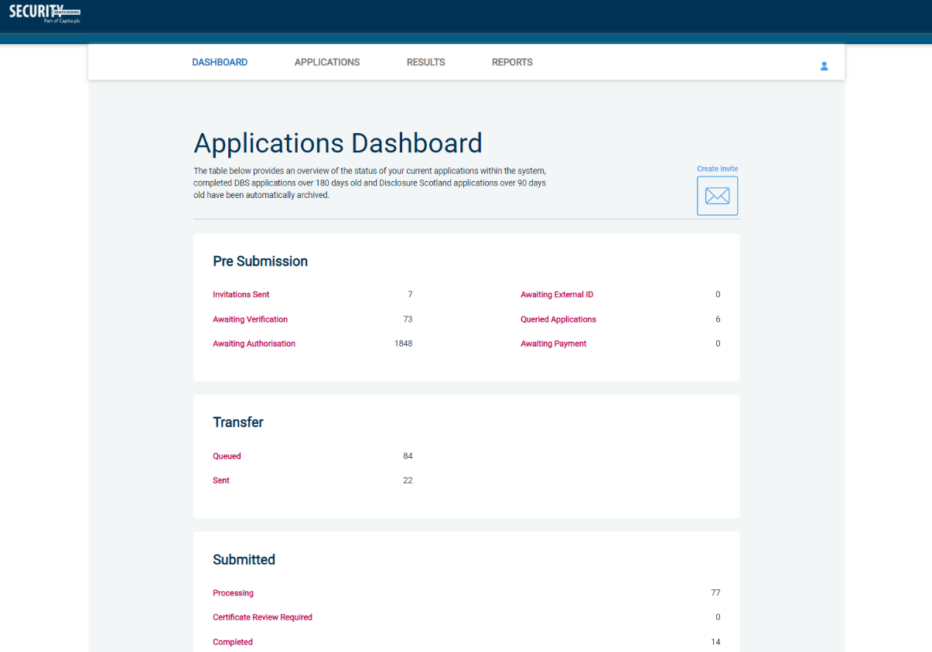
Screen Shot 5

Inviting an applicant to submit their application

You can generate an email invite to an applicant(s) inviting them to submit their application, from within the eBulk dashboard. This can be done by clicking the ‘Create Invite’ button at the top of the dashboard.

You will be taken to the invitation page where you can generate your invite (screenshot 6 below).

- You will need to select the ‘Organisation’ that you wish the applicant to create their application under, you will be able to select any organisations that you are linked to. You will then need to select the level of check that you require the applicant to submit from the ‘Channel’ drop-down field below.
- You are then required to enter the applicant’s forename, surname and email address into the boxes provided. If you wish to invite more than one applicant to create this specific level of check for this specific organisation you can click the ‘Add Candidate’ button as many times as required to invite multiple applicants.

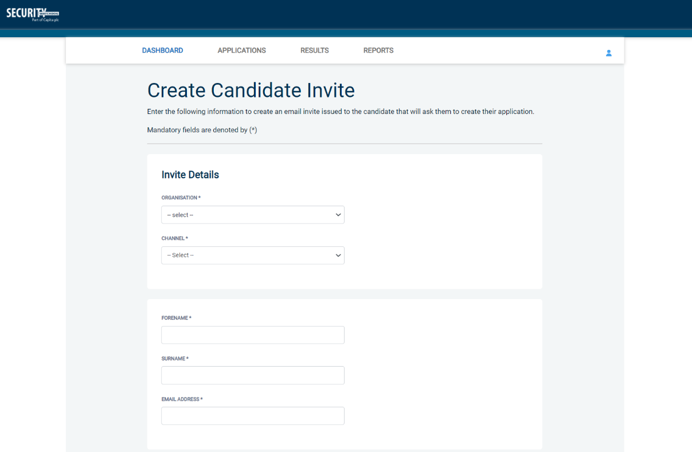
Screen Shot 6

- If you need to invite a large list of individuals, you can use the ‘Bulk Upload’ feature instead allowing you to upload a spreadsheet of applicants to be invited (screenshot 7 below). If you wish to use this feature, please leave the forename, surname, and email address fields blank and instead upload a pre-created spreadsheet. A blank template is provided in the eBulk footer if required. The spreadsheet must contain 3 columns only (Forename, Surname, Email address), any invalid data contained in the spreadsheet when uploaded will fail validation and be highlighted to you at the top of the screen.

Screen Shot 7
- Next, you are required to select a template from the ‘Email Template’ drop-down field (screenshot 8 below). You will be able to choose from either a ‘New Starter Invite Email’ or a ‘Renewal Invite Email’. Selecting one of these will populate the content of the invite email on-screen for you to review and amend if required. The pre-populated wording of these templates will either be the default wording coded into our system or a bespoke template for your organisation.
- Finally, click ‘Send’ to generate the invite to issue the invite to the applicant(s) entered.

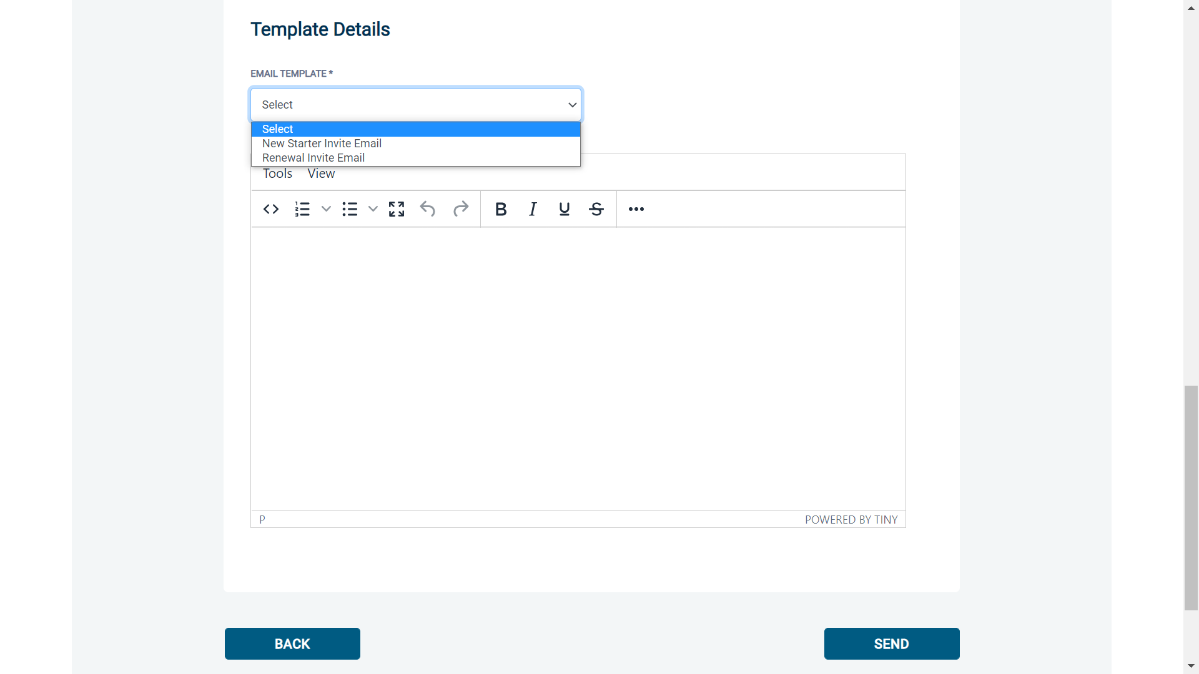
Screen Shot 8

How to track/chase invitations

Step 1 - Once invitations have been generated and sent, they are stored in the system until the applicant creates their application from the invite they have been sent. On the Dashboard page (see screen shot 5 above), in the top box entitled Pre-Submission, click on ‘Invitations Sent’.

You will be able to see the invitations that have been sent, waiting for the applicant to create their application. Please note, when an applicant has created their application from the invite they have received, it will move from this dashboard folder and into the ‘Awaiting Verification’ folder.

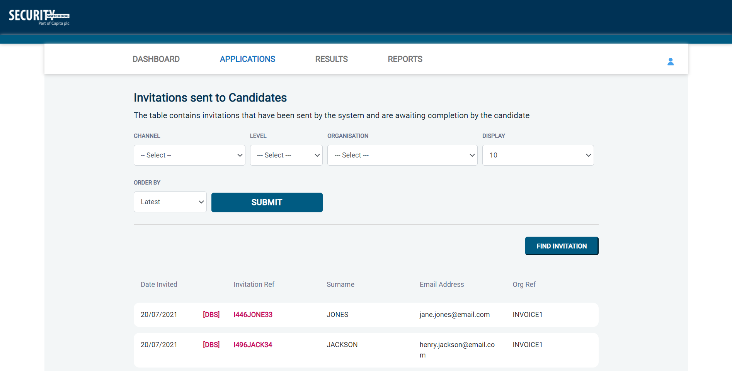
Screen Shot 9

Step 2 - Opening an invite: Click on an applicant’s reference number to open their invitation (see screen shot 9 above)

Step 3 – Overview, you will now see two tabs of the invitation (see screen shots 10 & 11 below)

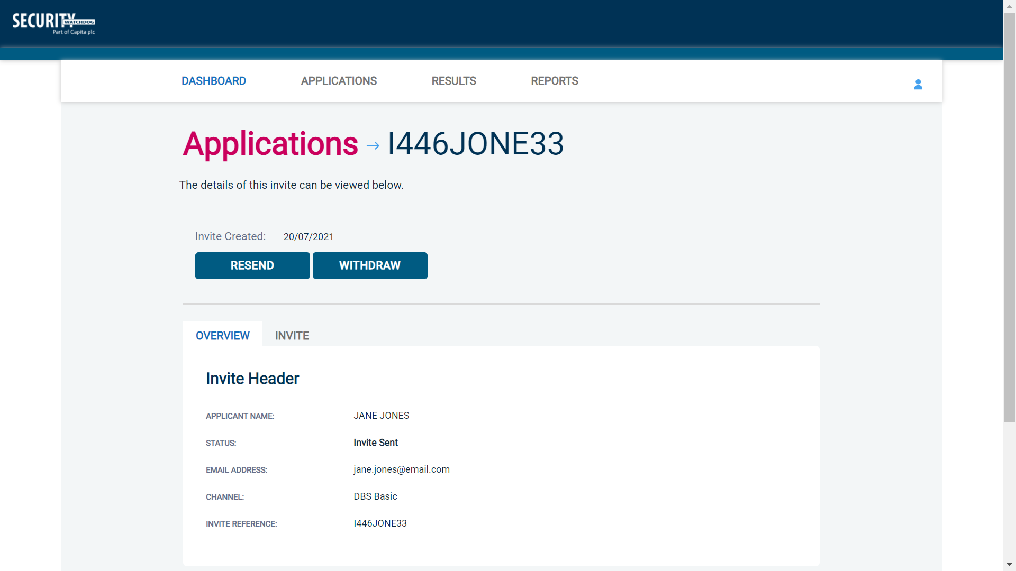
Screen Shot 10
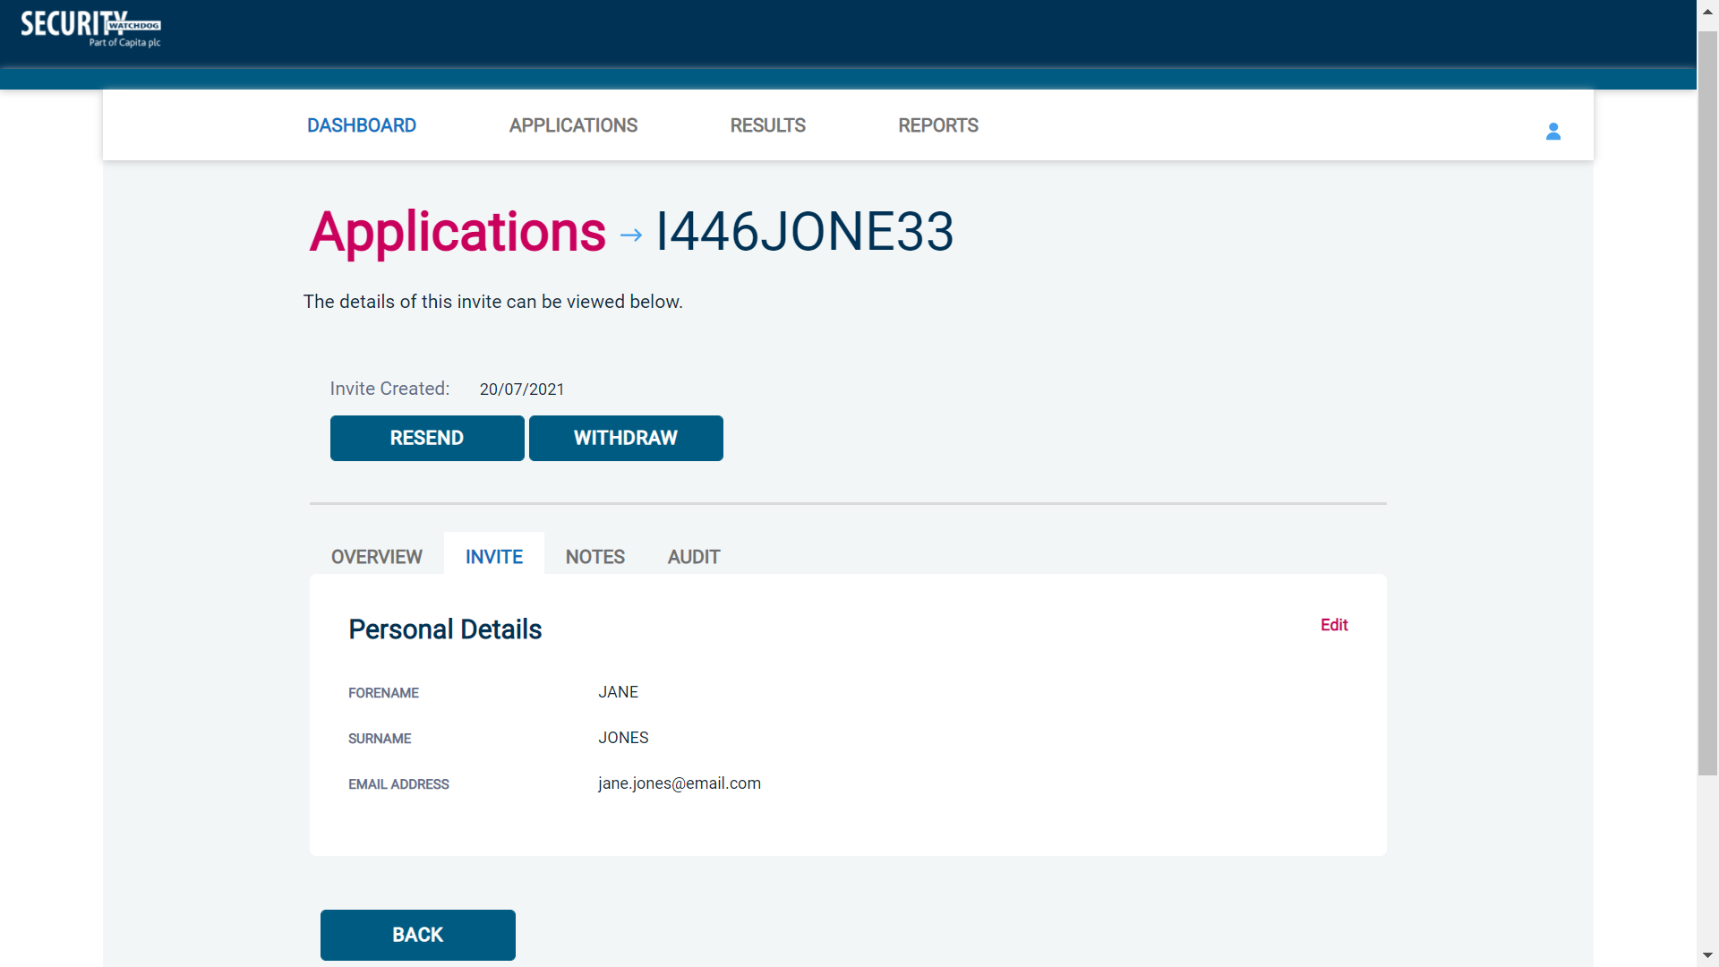
Screen Shot 11

Step 4 – Invitation, to view the details entered for the invitation click the ‘Invite’ tab. If these details are incorrect, these can be amended by clicking the ‘Edit’ button and updating the information (see screen shot 11).

Step 5 – Chasing an invitation

- If you wish to resend the invitation, please click the ‘Resend’ button at the top of the page. This will resend the original invitation email to the email address detailed on the ‘Invite’ tab.
- Invitations will be automatically chased by the system at a default chase pattern of 3 times every 3 days unless a different chase pattern has been configured for your organisation. After the final chase, the applicant will then have a further 30 days to create their application until the invitation is automatically withdrawn by the system.
- If the invitation is no longer required, it can be withdrawn at any time using the ‘Withdraw’ button at the top of the page. This will remove the invite from the ‘Invitations Sent’ folder.

How to verify ID – Basic Disclosures

Step 1 – On the Dashboard page (see screen shot 5 above), in the top left-hand box entitled Pre-Submission, click on ‘Awaiting Verification’. Please note that you will be able to see the total number of DBS and/or Disclosure Scotland basic application forms you have awaiting ID verification.

The applications in this folder can be filtered using the ‘Channel’ and ‘Level’ drop-down menus from the grey toolbar. These can be used to only see DBS basic applications, or only Disclosure Scotland basic applications.

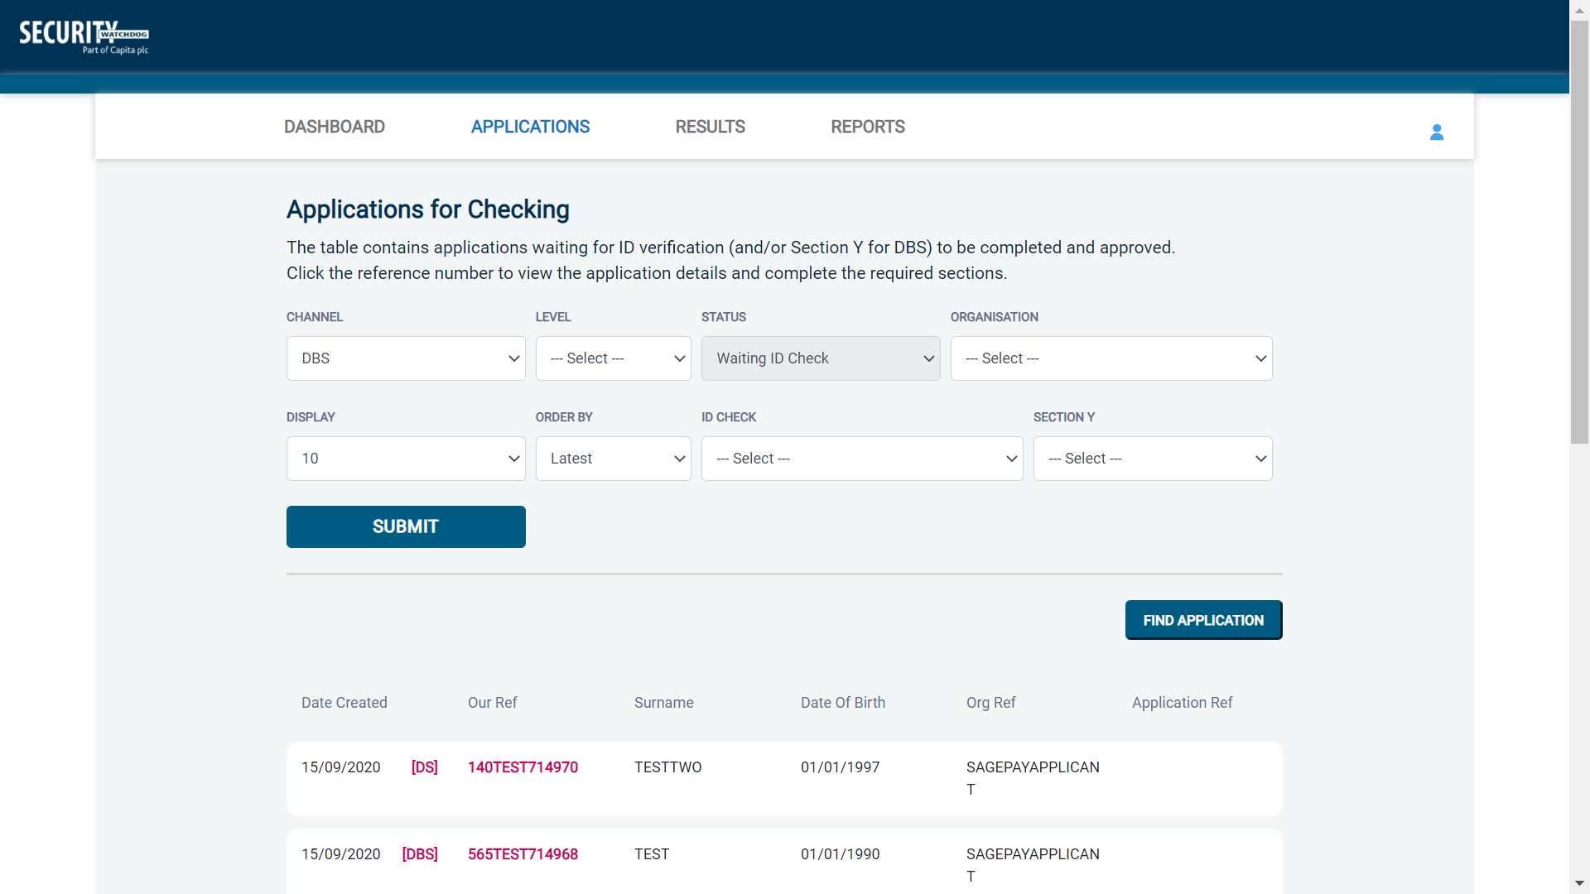
Screen Shot 12

Step 2 - Opening an application form:

Click on an applicant’s reference number to open up their application form (see screen shot 13 below)

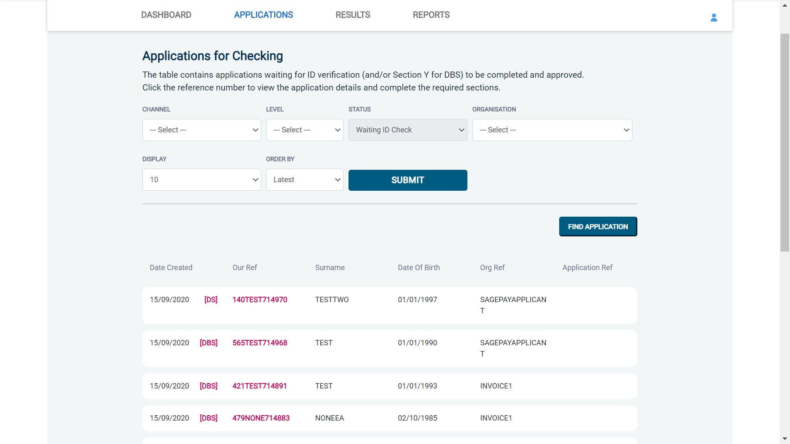
Screen Shot 13

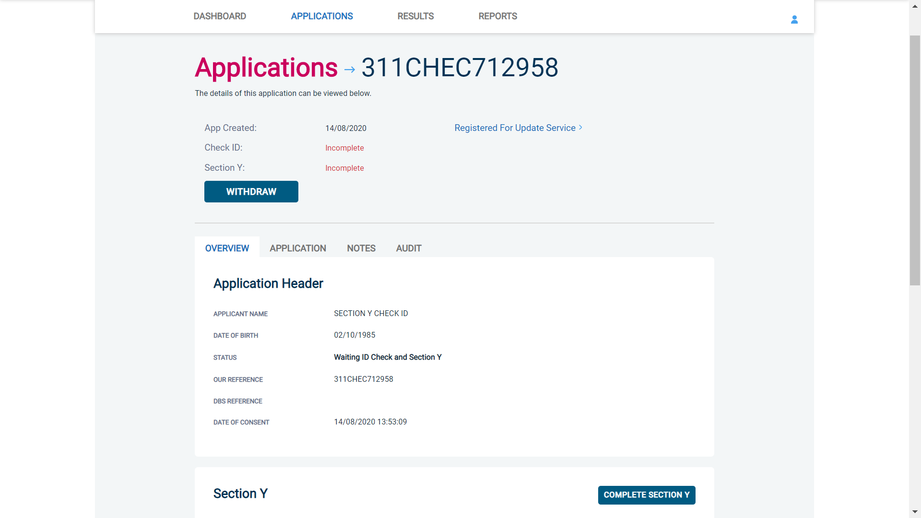
Screen Shot 14

Step 3 – You will now see an overview of the applicant’s completed form with 3 other available tabs, Application, Notes and Audit (see screen shot 14).

- Notes tab – this provides the facility to add any notes relating to an application for other Primary Applicant Managers to see. To add a note, click the ‘Notes’ tab then select ‘Add Note’ button. After entering the note you wish select ‘Save’.
- Audit tab – this provides a real-time audit trail of any activity relating to an application. This will show the date and time when a user views or edits an application as well as when the ID Check/Section Y was completed.

Step 4 – Application, to view the application details entered by the applicant, click on the ‘Application’ tab. Here you can see the entire application submitted by the applicant, this can be used to ensure the correct job role has been entered or to verify any ID given by the applicant in a previous surname or previous address (see screen shots 9 & 10).

If any of the information stated on the application is incorrect this can be amended. To edit any part of the application, click ‘Edit’ against that section of the application. Once you have amended the information on the application, click the blue ‘Save & Return’ button on the right-hand side to go back to the overview screen. A Primary Applicant Manager can amend any part of the application up until it has been countersigned by us; once the application has been countersigned it can no longer be edited.

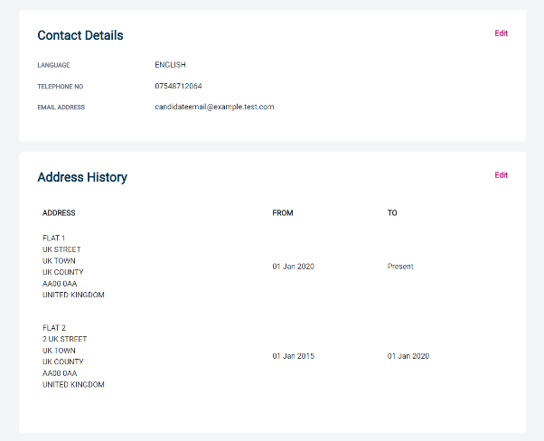
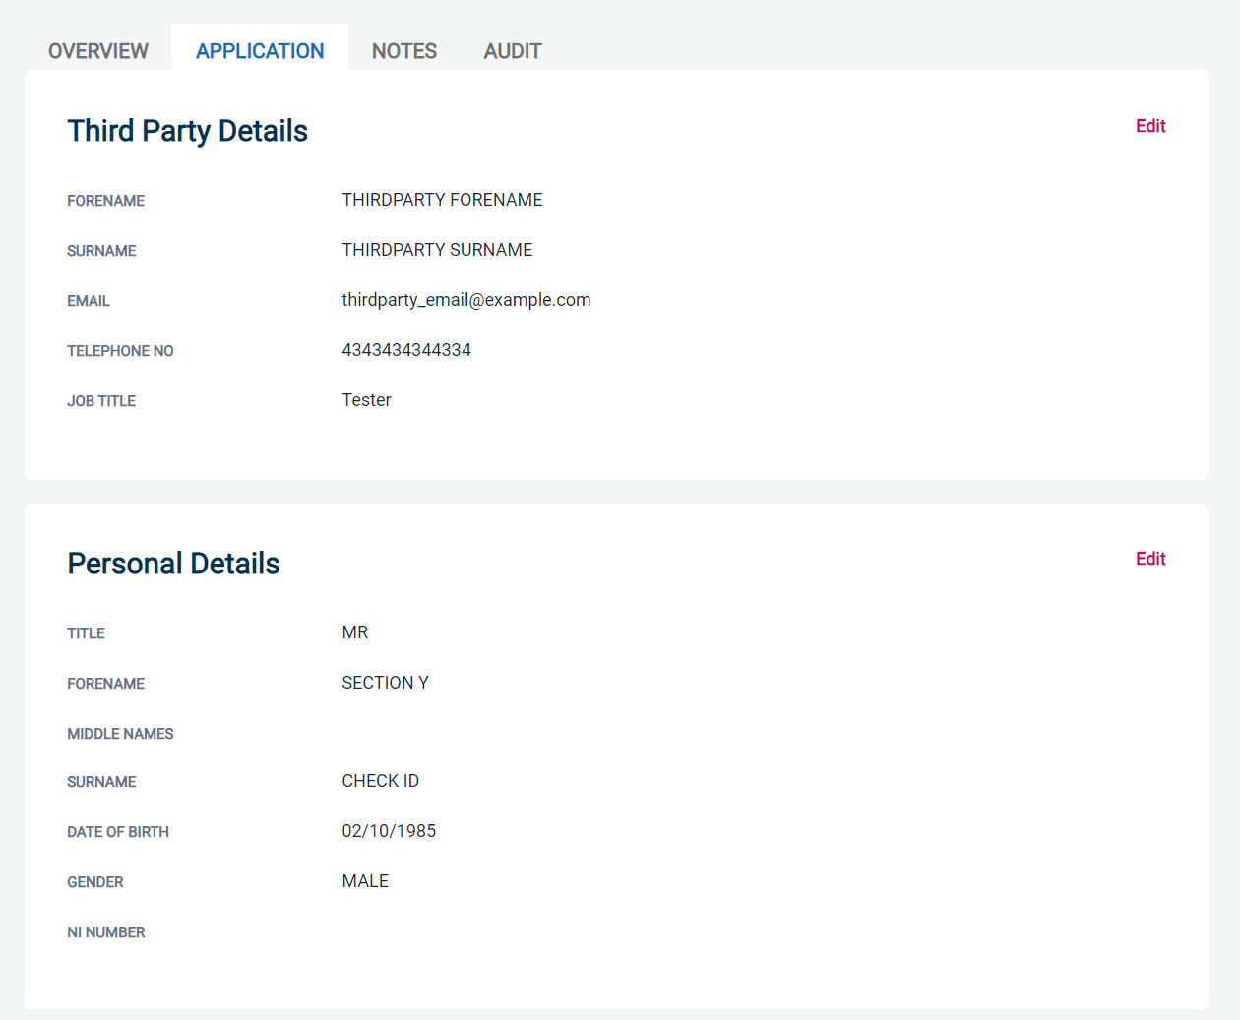

Screen Shot 15 Screen Shot 16

Step 5 - Verifying ID

- You will notice at the top of the screen a box which highlights if the ID has been verified or not (see screen shot 14 above), with a section completion date. It will say in red ‘Incomplete’ if the section has not been completed. If there is a date entered it means that this action has been completed and will show the date that it was carried out on.

- To complete the ID verification section, click on ‘Complete ID Check’ (see screen shot 14 above), access to this section is located in two places – at the top of the screen or on the overview of the actual form itself. You will now be on the ID screen (see screen shots 17 & 18 below).

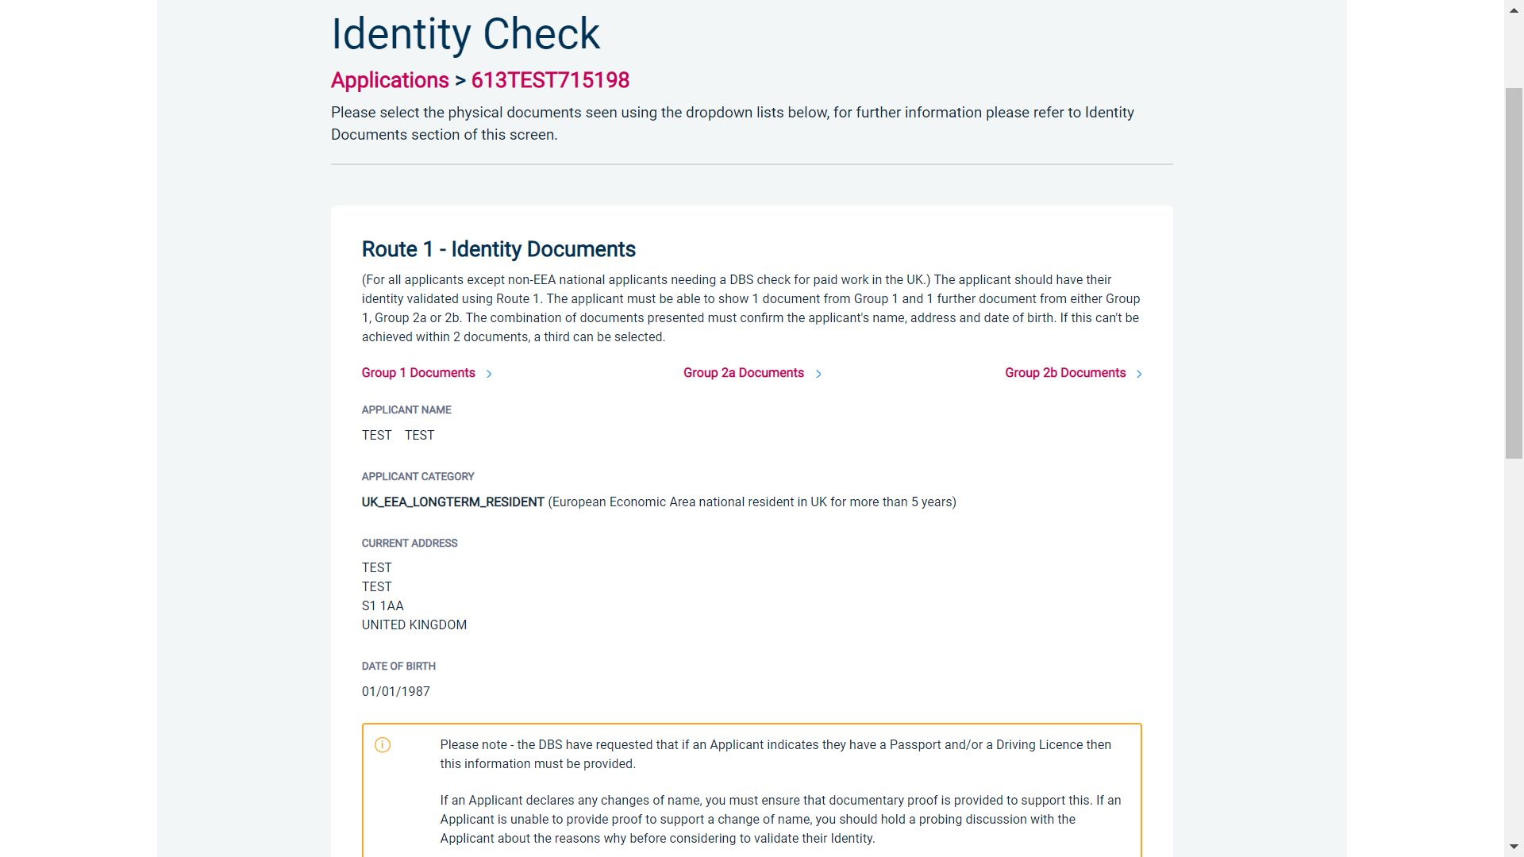
Screen Shot 17 – DBS Basic ID screen

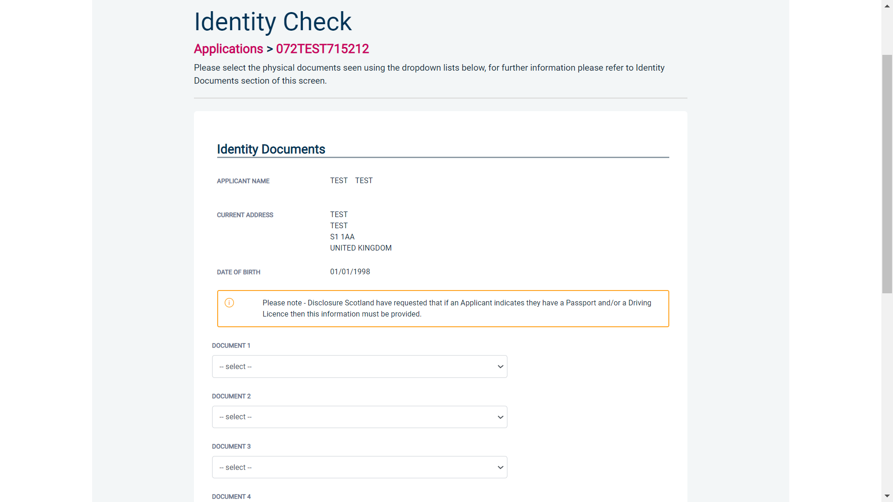
Screen Shot 18 – Disclosure Scotland Basic ID screen

For DBS basic applications, eBulkPlus will automatically ascertain the route that should (or must) be taken based on the nationality and country of birth stated by an applicant within their application form. If an applicant does not hold sufficient ID to be able to go through Route 1, you will then be required to click the ‘Next Route’ button at the bottom of the screen.

- Please select the ID the applicant has provided for you from the drop-down boxes. Guidance notes can be found on the right-hand side of the screen and are in accordance with the DBS or Disclosure Scotland Code of Practice. Please ensure at all times that you follow the ID checking rules e.g. do not accept a utility bill if it is more than 3 months old or do not accept an out of date passport.
- Ensure that you confirm from the drop-down boxes that you have verified a document showing the applicant’s address and also that you have verified their date of birth.
- If a Cost Code or Personnel Number is required to be assigned to the specific application, this can be entered in the Cost Code / Personnel Number field.
- Now click ‘Save’ and then click the ‘Return to Application’ icon in the green box located at the top of the screen.
- Once the ID Check has been saved, if you realise that it has been completed incorrectly or through the wrong route, you can reset the ID Check section and complete it again if required. Please note, you will only be able to do this if you have been assigned the appropriate user privilege to do so. To do this, go back into the ID Check screen and click the ‘Reset ID Check’ button found at the bottom of the screen.

Please note, that if an applicant cannot verify their identity via the routes available on screen, they will not be able to process their application through eBulk. If the identity cannot be satisfactorily verified, a basic application cannot be processed.

*A full list of acceptable ID for both the DBS and Disclosure Scotland can be found at the end of this guide*

What you must do as part of the ID Checking process

The applicant must provide a range of ID documents as part of the DBS check application process. As an employer you must:
- follow the ID checking process routes as outlined
- check and validate the information provided by the applicant on the application form
- establish the true identity of the applicant through the examination of a range of documents as set out in this guidance
- make sure the applicant provides details of all names by which they have been known
- make sure the applicant provides details of all addresses where they have lived in the last five years
- check that the online application is fully completed and the information it contains is accurate.
- you must only accept valid, current and original documentation
- you must not accept photocopies
- you must not accept documentation printed from the internet e.g. internet bank statements
- identity information for the applicant’s name, date of birth and address recorded on the online application form must be validated
- you should in the first instance, seek documents with photographic identity (e.g. passport, new style driving licence, etc.) and for this to be compared against the applicant’s likeness
- all documents must be in the applicant’s current name
- one document must confirm the applicant’s date of birth
- you must ensure that the applicant declares all previous name changes and provides documentary proof to support the change of name. If the applicant is unable to provide proof to support the change of name, you should hold a probing discussion with the applicant about the reasons why before considering validating their identity
- you must see at least one document to confirm the applicant’s current address, in accordance with the guidance
- a document from each of the groups should be included only once in the document count e.g. don’t accept two bank statements as two of the required documents, if they are from the same bank
- you should not accept the foreign equivalent of an identity document if that document is listed as ‘(UK)’ on the list of valid identity documents

- Finally scroll to the top of the screen to the green box and click ‘Approve’.

- Please ensure you click on ‘Approve’ – failure to do so will result in the form not being submitted for Countersignatory Authorisation.

- * If an application does require further clarification from us prior to submission to the DBS or Disclosure Scotland, a query will be flagged on the application and we will contact you for clarification. During this time, a copy of the application record move into the ‘Queried Applications’ folder on the Dashboard (see Screen Shot 5). You can view the full information regarding the query by clicking on the ‘Notes’ tab of any application in the ‘Queried Applications’ folder (see Screen Shot 19 below) *

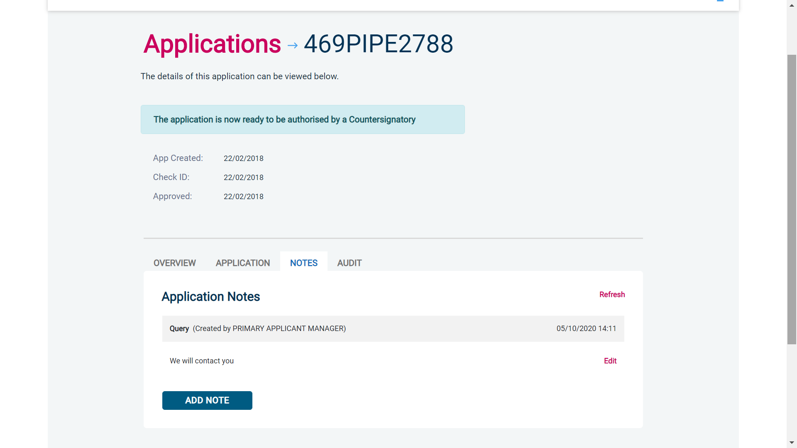
Screen Shot 19

- Once a form has been countersigned by your Registered Organisation, the application will be moved to the ‘Transfer’ section. Applications at this stage are awaiting collection by the DBS or Disclosure Scotland. Once they have collected them, they will move into the processing stage – please see below for further details.

NB. An application form can be withdrawn at any time up to and including Countersignatory stage. Once a form has been electronically transferred, we cannot withdraw it without incurring the DBS or Disclosure Scotland charge. If you wish to withdraw an application at Countersignatory stage, please contact us immediately, to enable the process to be halted

DBS Processing

Step 1 – Tracking an application – see screen shot 20.

- On the Dashboard you will see towards the bottom of the screen, a box called ‘Submitted’.

Screen Shot 20

- To view all applications currently being processed by DBS or Disclosure Scotland, click on ‘Processing’ (see screen shot 20). This will take you to a screen which will show all the applications for your company that are currently being processed. To view an individual’s application, click on their reference number - this will take you directly into the application form you wish to view (see screen shot 21).
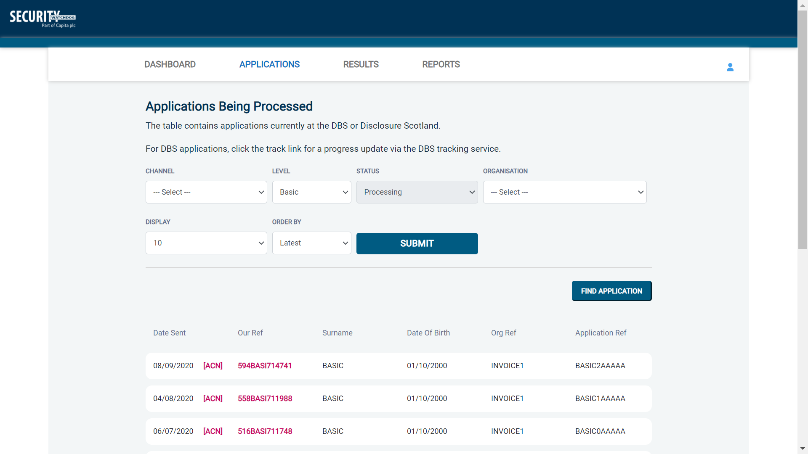
Screen Shot 21

Completed Results – Basic DBS

Results with content

Step 1 - Notification – see screen shot 22.

- The DBS will send notification online once an application has been completed. To view a result please return to the Dashboard and click on ‘Completed’ in the Submitted section.

Screen Shot 22

Step 2 - Viewing a Certificate result with content – see screen shot 23.

- To view the information of a certificate e.g. certificate issue date, reference number and result status, click on the applicant’s reference number (see screen shot 23). This information will stay in the ‘Completed’ folder for 180 days from the issue date of the certificate.

- Certificate results with content will state “Please wait to view applicant certificate” in the Status column – This means the certificate contains information and you will have to view the applicant’s certificate via the DBS portal to see this information.

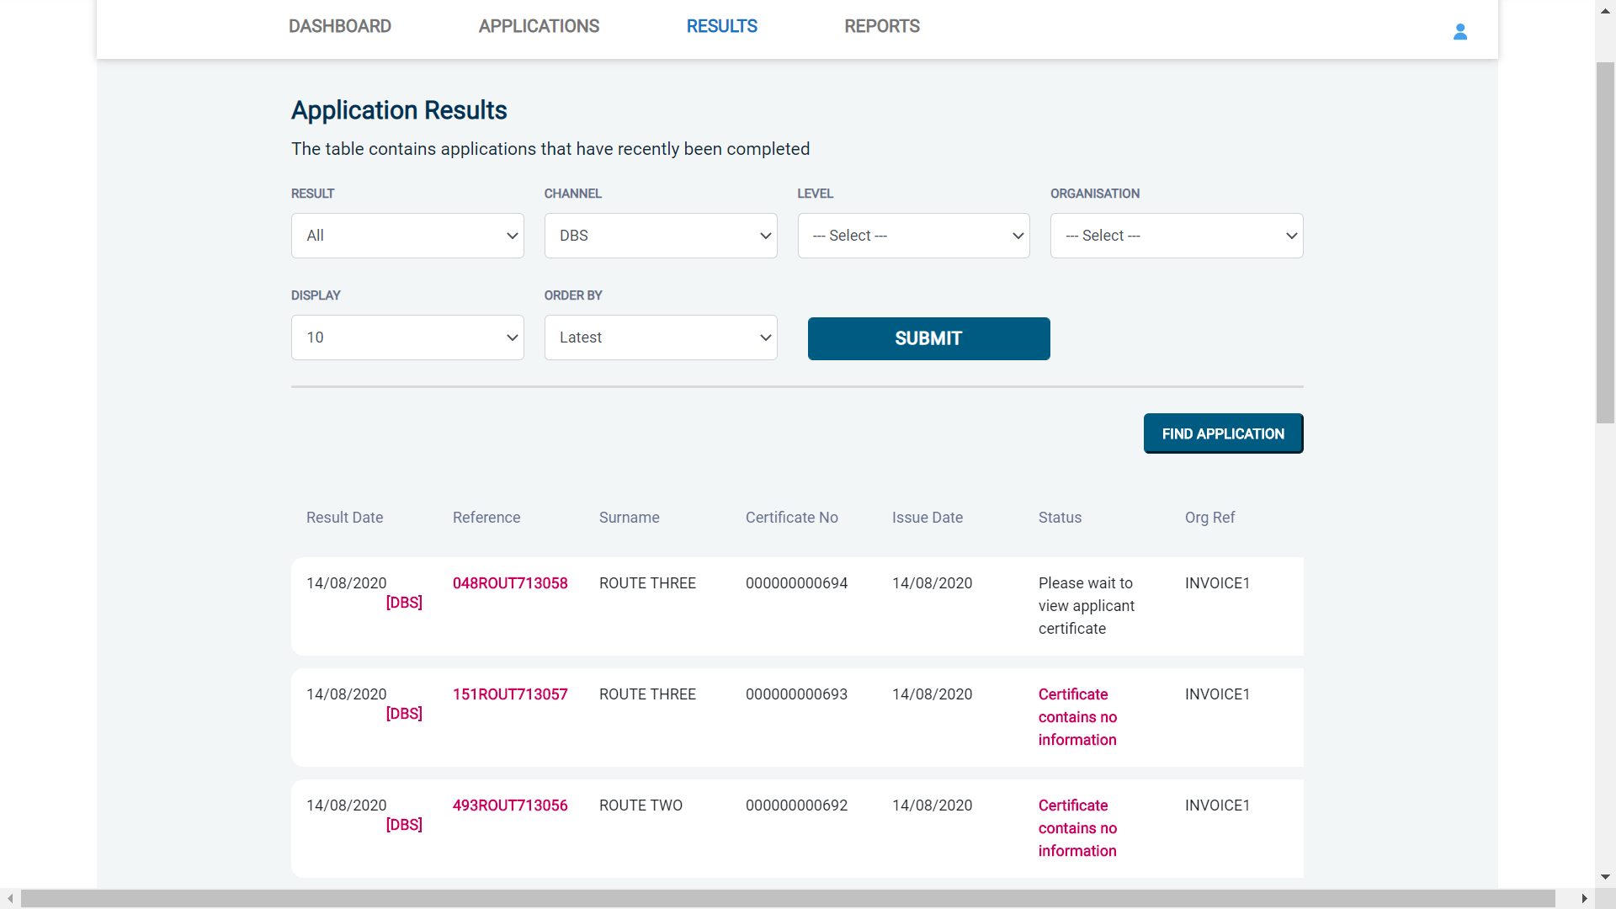

Screen Shot 23

Step 3 – Indicating sight of the applicant’s certificate – see screen shot 24.

To help an organisation keep track of which applicants have brought their certificate in and been viewed by the organisation, the system is able to record the date the applicant’s certificate has been seen by their organisation or whether sight is not required. As an Applicant Manager, you are able to add this date on to an application to indicate that their certificate has been sighted.

To add the date or to view whether a date has been added, click on the reference number of the application from the ‘Completed’ folder (see screen shot 22 above). Once in the application, the date can be added in the ‘Applicant’s Certificate Seen’ section of the Processing Details box on the right of the screen (see screen shot 18 below).

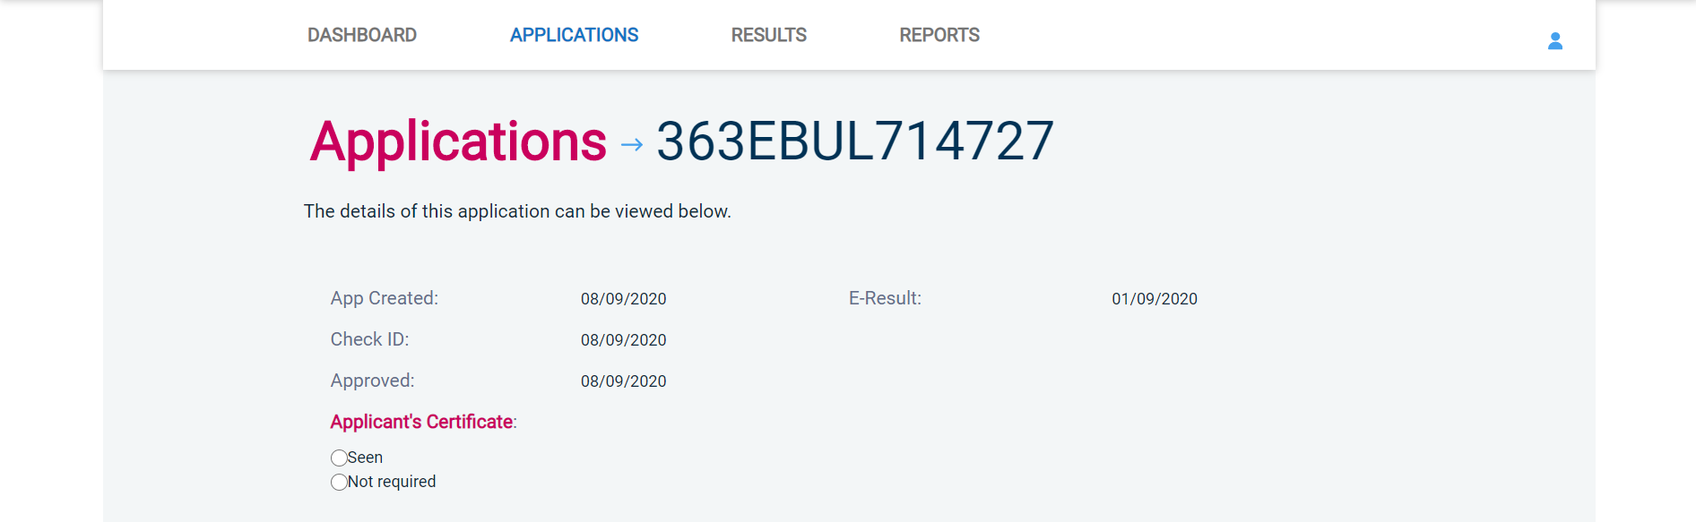
Screen Shot 24

Clear results

Step 1 - Notification – refer back to screen shot 22 above.

- The DBS will send notification online once an application has been completed. To view a result please return to the Dashboard and click on ‘Completed’ in the Submitted section.

Step 2 - Viewing a clear certificate result– see screen shot 25.

- To view the information of a certificate e.g. certificate issue date, reference number and result status, click on the applicant’s reference number (see screen shot 25). This information will stay in the ‘Completed’ folder for 180 days from the issue date of the certificate.
- Clear certificate results will state “Certificate contains no information” in the status column – This means the certificate contains no criminal convictions, cautions, warnings or reprimands.

Screen Shot 25

Step 2 - Viewing a Result Snapshot for clear applications – see screen shots 25 & 26.

- As an Applicant Manager you can click on the ‘Certificate contains no information’ wording in the status column to view a Result Snapshot for this application (see screen shot 26 below).

Please note that the Result Snapshot is for information purposes only, it does not represent a DBS certificate or act as a DBS certificate alternative. The information contained within the snapshot is not to be viewed by or passed to any individual who does not have the appropriate authority to view it.

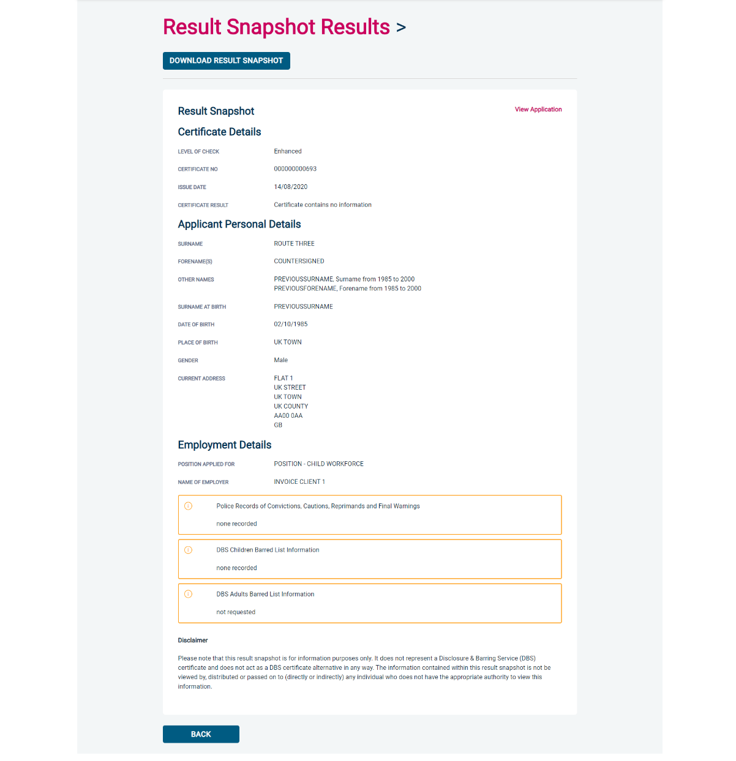
Screen Shot 26

As the Registered Organisation/Employer does not receive a copy of a completed DBS certificate, we advise that you have sight of the applicant’s certificate regardless of the status outcome on eBulkPlus; however this is for your organisation to decide based on your own internal policies. For completed applications with a result status of “Please wait to view applicant certificate” you must view the applicant’s certificate before making a recruitment decision.

Completed Results – Basic Disclosure Scotland

Notification and Viewing Disclosure Certificate Meta Data
Step 1 – Notification
- Security Watchdog will send you an email notification when an application form has been completed and a Disclosure Certificate has been completed. To view all disclosures that have been sent to you within the last 90 days, click on ‘Completed’ found on the Dashboard (see screen shot 20).

Step 2 – Viewing Disclosure Certificate Meta Data
- To view the disclosure Meta Data, for example disclosure issue date, reference number and disclosure status, click on the applicant’s reference number (see screen shots 27 & 28). This disclosure result will be retained on the system for 90 days, the rest of the metadata will be retained on the system, even after the disclosure has been archived until it has been purged or deleted.

Results with content:
Step 1 – Security Watchdog receives Disclosure Certificate with content
- Security Watchdog will update the ‘Disclosure Sent On’ date on the online system.
- The Disclosure Certificate will then be sent to you, the Applicant Manager, by post.

Step 2 – Applicant Manager receives Disclosure Certificate with content
- Please ensure that you follow the Disclosure Scotland Code of Practice – secure storage, handling, use, retention and disposal of disclosure information.

Results with no content:
Step 1 - Security Watchdog receives Disclosure Certificate with no content
- The Disclosure Certificate will not be sent to you, the Applicant Manager, by post. This will be securely shredded at our office by our document destruction contractors, Shred-It. Shred-It document destruction services were developed specifically to deal with the privacy and confidentiality requirements of the individuals and organisations. All documents are destroyed following Shred-It’s secure shredding process and we receive a Certificate of Destruction from Shred-It on every site visit.

Step 2 – Applicant Manager
- Applicant Manager can view Disclosure Certificate Meta Data from the Dashboard ‘Completed’ (see screen shots 20, 27 & 28).

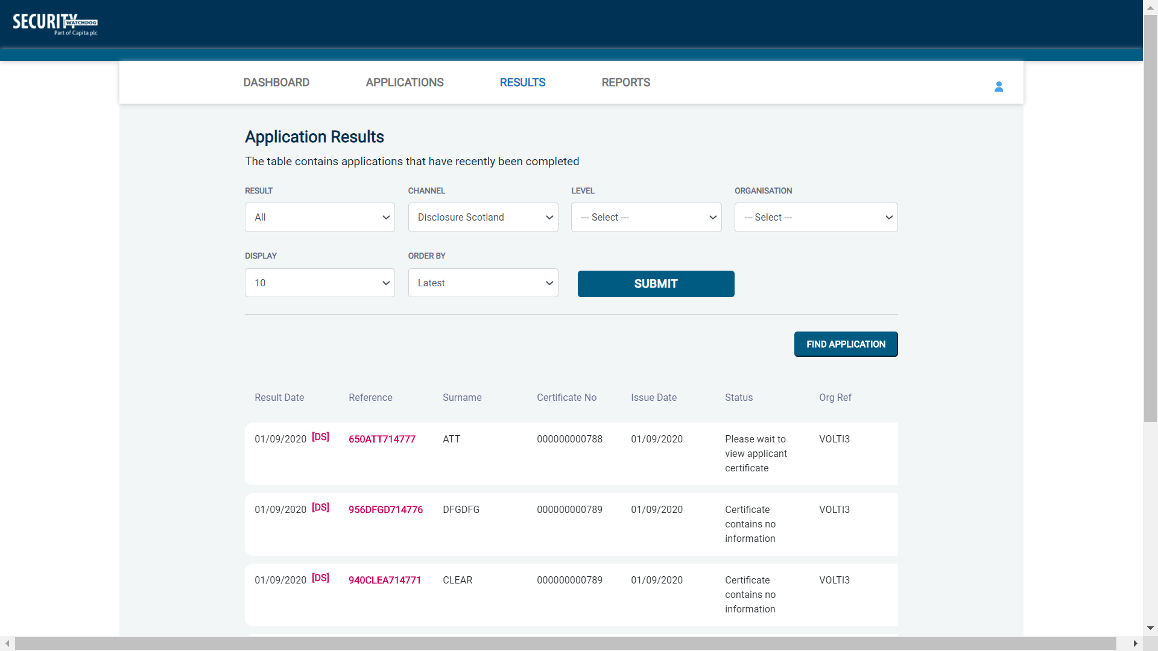
Screen Shot 27

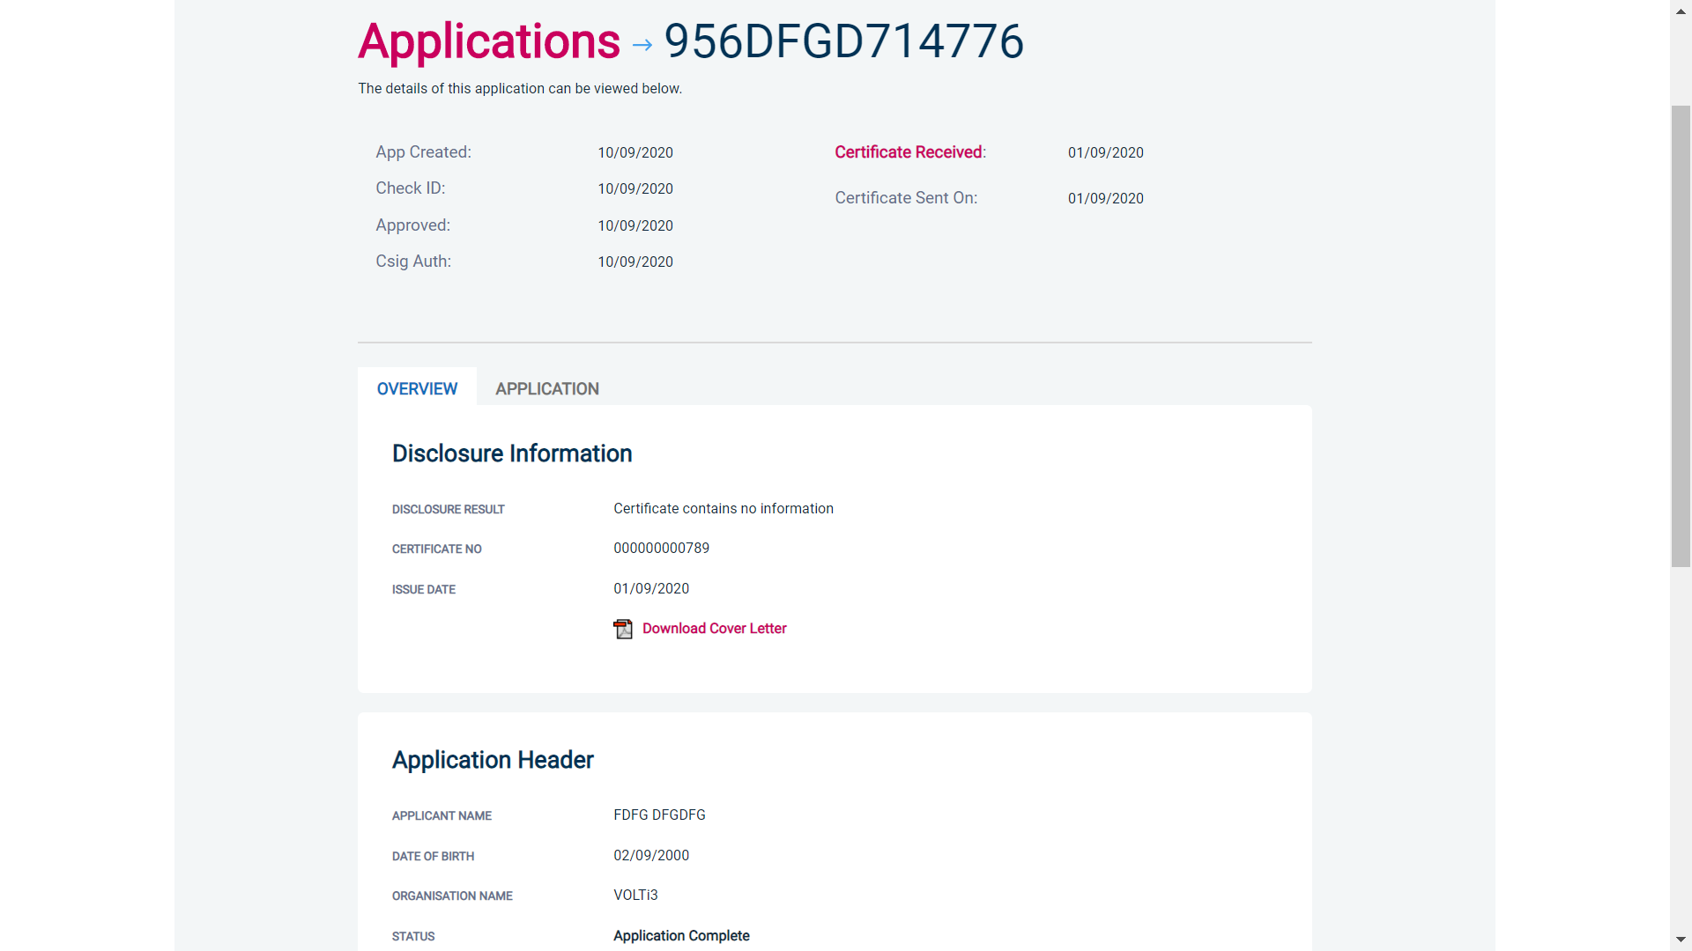
Screen Shot 28

Find an Application

Step 1 - Finding an individual application – see screen shots 29 & 30.

- To find an individual application pre or post processing or that has been archived, select from the Dashboard the Applications tab and then click on ‘Find Application’.

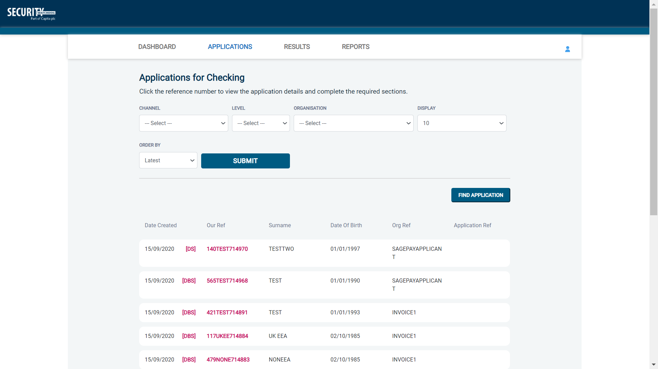
Screen Shot 29

- The following box will appear for you to enter as much of the applicant’s details as you have available. E.g. if you only enter the surname without date of birth or DBS/Disclosure Scotland reference, it will bring up a list of every applicant with that surname. However, if you enter their date of birth as well, then this will define the search results accordingly. If you tick the ‘Search Archived’ button, this will display applications that have been archived from the system.

Screen Shot 30

Reports

Step 1 - Running a report – see screen shot 31.

- To run a report, you need to return to the Dashboard and select the tab ‘Reports’ and then select the report you wish to run. There are currently a number of standard reports that you can choose from, however it is also possible to run a customised report (please note that if you only process Basic Disclosure checks, you can ignore the middle section of the reports screen containing Standard / Enhanced report information).

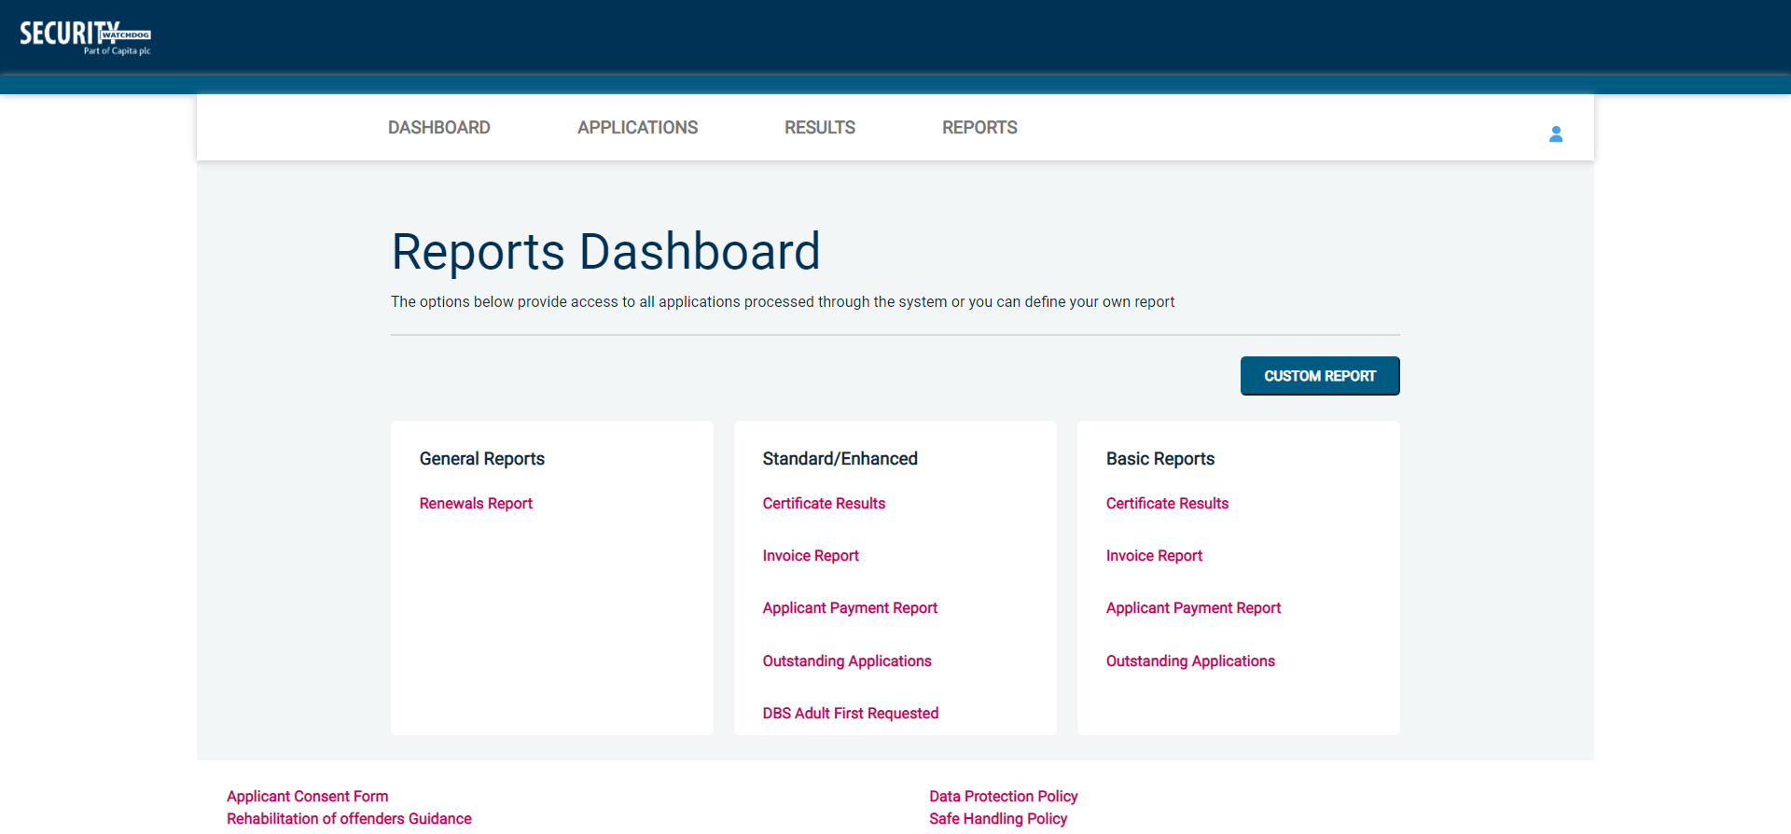
Screen Shot 31

Stage 2 – Invoice Report – see screen shot 31 above.

This report can be used to produce an electronic version of the invoice you will receive from us or for you to calculate the company budget required in relation to DBS costs. This can be filtered by a specific division or can be run on all divisions within your organisation. The report captures applicant and organisation data with the addition of;

- Basic, Standard or Enhanced Fee
- Cost Code
- Organisation Postcode
- Admin Fee (referred to as Base Fee on the system)
- VAT
- Total application price

Applications that were submitted before the system was capable to produce invoice reports will not be captured in the report. These will have a zero value against them.

Stage 3 - Customised Reports and selecting field headings – see screen shot 32.

- To run a customised report, you can select the field headings and date criteria that you wish the report to contain. For example, this is an ideal opportunity to run a report when carrying out re-checks on your staff or for capturing cost codes for invoicing purposes. All reports can be printed or saved into an Excel spreadsheet (.CSV file) or PDF document.

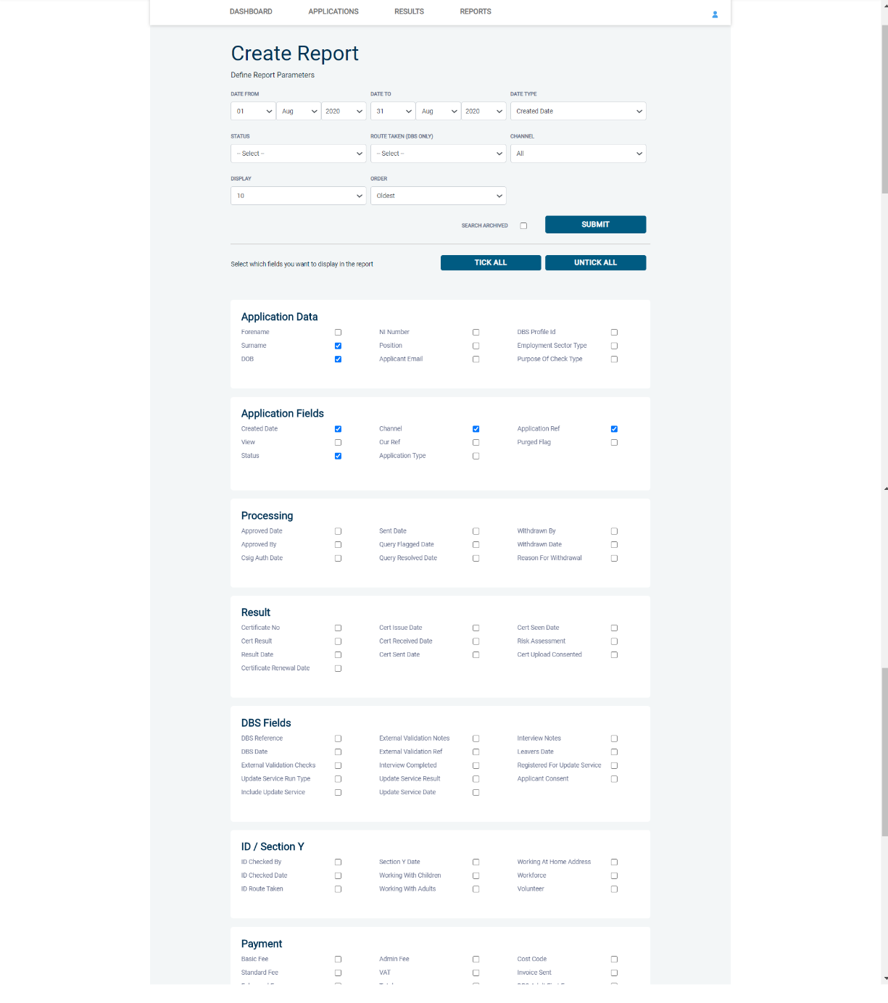
Screen Shot 32

ALL USERS – PLEASE LOG OFF AT THE END OF YOUR SESSION. IF A SESSION IS INACTIVE FOR MORE THAN TEN MINUTES YOU WILL BE AUTOMATICALLY LOGGED OFF FOR SECURITY REASONS.

CONTACT DETAILS

If you experience any technical issues with the online system, please contact Care Check on 0333 777 8575. Alternatively, you can contact us by e-mail at info@carecheck.co.uk

DBS List of Acceptable Identification

Route 1a – For paid non-UK nationals only
(2 documents to be seen)

1 document from Group 1a.
1 further document from Group 1, 2a or 2b

Combination of documents must confirm name, DOB & current address.

If unable to satisfy Route 1a, basic check cannot be submitted.

Route 2 – For all applicants except paid non-UK nationals
(3 documents to be seen)

1 document from Group 2a.
2 further documents from Group 2a or 2b.

Combination of documents must confirm name, DOB & current address.

If unable to satisfy Route 2, basic check cannot be submitted.

Route 1 – For all applicants except paid non-UK nationals
(2 documents to be seen)

1 document from Group 1.
1 further document from Group 1, 2a or 2b

Combination of documents must confirm name, DOB & current address.

If unable to satisfy Route 1, proceed to Route 2.

Group 1
Primary Identity Documents
- Current valid Passport
- Biometric Residence Permit (UK)
- Current Driving Licence – photo card (UK / Isle of Man / Channel Islands) (Full or Provisional)
- Birth Certificate (UK / Isle of Man / Channel Islands) (Issued within 12 months of birth)
Full or short form acceptable including those issued by UK authorities overseas, such as Embassies, High Commissions & HM Forces. (Photocopies are not acceptable)
- Adoption Certificate (UK / Channel Islands)

Group 1a
Primary Identity Documents for non-UK nationals
- A current passport or passport card showing that the holder is a national of the Republic of Ireland.
- A current document issued by the Home Office to a family member of an EEA or Swiss citizen, and which indicates that the holder is permitted to stay in the United Kingdom indefinitely.
- A current Biometric Immigration Document (Biometric Residence Permit) issued by the Home Office to the holder indicating that the person named is allowed to stay indefinitely in the UK or has no time limit on their stay in the UK.
- Online evidence of immigration status. Either via the View and Prove service or using the BRP or BRC online service. Issued by the Home Office to the employer or prospective employer, which indicates that the named person may stay in the UK and is permitted to do the work in question. Must be valid. Note: this includes the EUSS digital status confirmation.
- A current passport endorsed to show that the holder is exempt from immigration control, is allowed to stay indefinitely in the UK, has the right of abode in the UK, or has no time limit on their stay in the UK.
- A current Immigration Status Document issued by the Home Office to the holder with an endorsement indicating that the named person is allowed to stay indefinitely in the UK or has no time limit on their stay in the UK, together with an official document giving the person’s permanent National Insurance number and their name issued by a government agency or a previous employer.
- A current passport endorsed to show that the holder is allowed to stay in the UK and is currently allowed to do the type of work in question.
- A current Biometric Immigration Document (Biometric Residence Permit) issued by the Home Office to the holder which indicates that the named person can currently stay in the UK and is allowed to do the work in question.
- A current document issued by the Home Office to a family member of an EEA or Swiss citizen, and which indicates that the holder is permitted to stay in the United Kingdom for a time limited period and to do the type of work in question.
- A frontier worker permit issued under regulation 8 of the Citizens’ Rights (Frontier Workers) (EU Exit) Regulations 2020.
- A current Immigration Status Document containing a photograph issued by the Home Office to the holder with a valid endorsement indicating that the named person may stay in the UK, and is allowed to do the type of work in question, together with an official document giving the person’s permanent National Insurance number and their name issued by a government agency or a previous employer.
- A document issued by the Home Office showing that the holder has made an application for leave to enter or remain under Appendix EU to the immigration rules on or before 30 June 2021 together with a Positive Verification Notice from the Home Office Employer Checking Service.
- An Application Registration Card issued by the Home Office stating that the holder is permitted to take the employment in question, together with a Positive Verification Notice from the Home Office Employer Checking Service.
- A Positive Verification Notice issued by the Home Office Employer Checking Service to the employer or prospective employer, which indicates that the named person may stay in the UK and is permitted to do the work in question.

Group 2a
Trusted Government Documents
- Current Driving Licence – photo card only (All Countries except Group 1) (Full or Provisional)
- Current Driving Licence – paper version (UK / Isle of Man / Channel Islands) (Full or Provisional)
- Birth Certificate (UK / Isle of Man / Channel Islands) (Issued after the time of birth)
- Marriage / Civil Partnership Certificate (UK / Channel Islands)
- HM Forces ID Card (UK)
- Fire Arms Licence (UK / Isle of Man / Channel Islands)
- Immigration document, work permit or VISA (Issued outside of UK) (Valid only for roles whereby applicant is living and working outside of UK.)

Group 2b
Financial & Social History Documents
- Mortgage Statement (UK) **
- Bank/Building Society Statement (UK / Channel Islands) *
Monzo statements or statements printed from the internet are not acceptable
- Bank/Building Society Account Opening Confirmation Letter (UK) *
- Credit Card Statement (UK) *
- Financial Statement e.g. pension, endowment, ISA (UK) **
- P45/P60 Statement (UK / Channel Islands) **
- Council Tax Statement (UK / Channel Islands) **
- Utility Bill (UK) - Not Mobile Phone *
- Benefit Statement (UK) e.g. Child Allowance, Pension *
- Document from Central/ Local Government/ Government Agency/ Local Authority (UK / Channel Islands) *
e.g. DWP, Employment Service, HMRC, Job Centre, Social Security
- EEA National ID Card – must be valid
- Cards carrying the PASS accreditation logo (UK / Isle of Man / Channel Islands) – must be valid
- Irish Passport Card – must be valid (Cannot be used with an Irish Passport)
- Letter from Head Teacher or College Principal (16-19 year olds in full time education in the UK)
- Non-UK Bank/Building Society Statement *
Branch must be located in the country in which the applicant lives and works
- Letter of Sponsorship from future employer
Non-UK only – valid only for applicants residing outside UK at time of application

Please note if a document in the List of Valid Identity Documents is:
- Denoted with * - issued in the last 3 months
- Denoted with ** - issued in the last 12 months

Disclosure Scotland List of Acceptable Identification

Can you produce any document from Group 1?

NO
YES

3 documents
to be seen
One document from Group 1 plus any two others from Group 1 or 2
5 documents
to be seen

Five documents from Group 2

Document check complete

Group 1
Primary Identity Documents
- Current valid Passport (any nationality)
- Current UK Driving Licence – photo card or paper (England/Wales/Northern Ireland/Isle of Man) (Full or Provisional)
- Original UK Birth Certificate (Issued within 12 months of date of birth)
Full or short form acceptable including those issued by UK authorities overseas, such as Embassies, High Commissions & HM Forces.
- Adoption Certificate (UK)
- Valid photo identity card (EU countries only)
- UK Firearms licence
- HM Forces ID card (UK)
Group 2  Issued whenever | Issued within last 3 months | Issued within last 12 months
- Non-original UK Birth Certificate (Issued after 12 months of date of birth, full or short form)  - Marriage / Civil Partnership Certificate  - P45/P60 Statement  - Utility Bill (electricity, gas, water, telephone – including mobile phone contract/bill)  - Valid TV licence  - Credit card statement  - Store card statement  - Mortgage statement  - Valid insurance certificate  - Certificate of British nationality  - Asylum Registration Card  - Valid vehicle registration document  - Court summons  - Valid NHS card  - Court Claim Form  - National insurance number card  - Examination certificate (e.g. GCSE, NVQ)  - Child benefit book | - Personal correspondence or a document from a Government Department  - Mail order catalogue statement  - Addressed payslip  - Letter from a Head Teacher | - British work permit/visa  - Bank or Building Society Document  - Financial statement e.g. pension, endowment, ISA

