Basic DBS Online Disclosure Guide (eBulkPlus)

Applicant Guidance Notes

Contents
Applicant Guidance Notes 2
Logging onto the System 3
Statement of Fair Processing 5
Section 1 – About You 6
Section 2 – Address History 7
Section 3 – Additional Info 8
Section 4 – Employment Details 10
Section 5 – Confirmation and Consent 11
Complete Application 12
DBS List of Acceptable Identification 13

Applicant Guidance Notes

An online basic DBS check can be completed by accessing the internet from any device that has this facility. This includes a smart phone, tablet, laptop or PC. It is supported on the latest versions of all modern browsers; however, we do not recommend access via Internet Explorer as this browser is unsupported both by our technology and soon by Microsoft also. If you do not own your own computer, you can go to any internet café or local library. Please be aware that you must complete your application form in full as part completed applications form cannot be saved.

Starting your application

You can start your application one of two ways depending on how you have been invited by the employer requesting this check to be carried out on you.
Option 1 – via a direct link within an email invitation
If you have received an email invitation containing a direct link to completing your application, simply click the link contained in your email and skip to page 5 of this guide.

Option 2 – accessing our system through your browser
Please enter the following address in the web browser:
WWW.CARECHECK.CO.UK and then click on the `Start A DBS Check’ button in the centre of the page
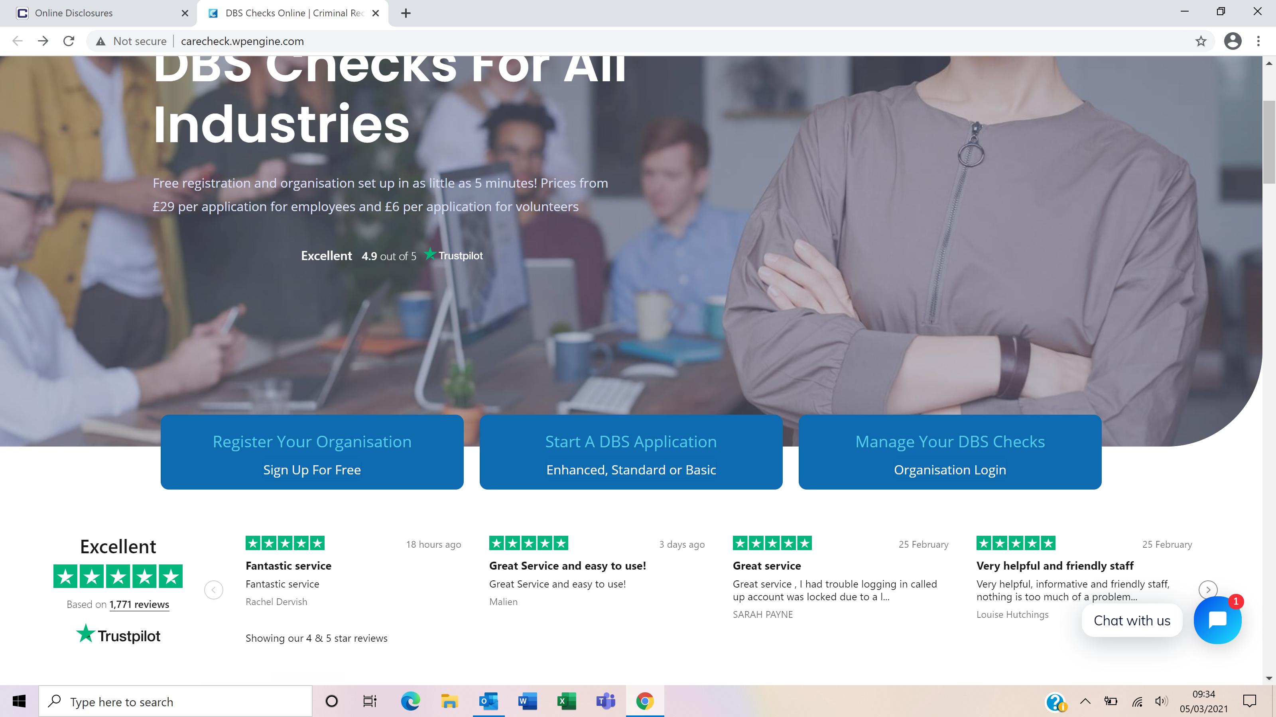

You will then be taken though a page where you are asked to acknowledge that you will not need a code when loggin in to the application unless you have bene provided with one by your employer. In most cases you just require the organisation reference they have provided you.
If you are not taken directly to the ‘Start New Application’ page, please click on ‘Start Application’ in the box entitled ‘Basic Disclosure Application’ to enter the system and start your application.
You will now be taken to the basic routing screen in order to determine whether your basic application needs to be processed by the DBS or Disclosure Scotland based on where you live/work.
For applicants based in England or Wales who require a basic DBS check, the answers to these questions will point to ‘England/Wales’.

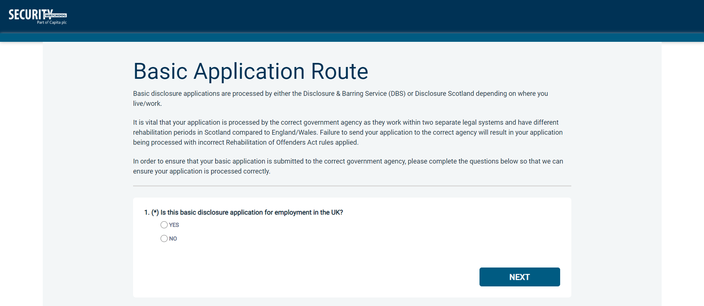
Once the questions have been answered, please click ‘Next’.
Please note at this stage of the process your login details are case sensitive.
- Enter the Organisation Reference that has been supplied to you by the company that you will be/are working for.
- Enter the Organisation Code that has been supplied to you by the company that you will be/are working for.

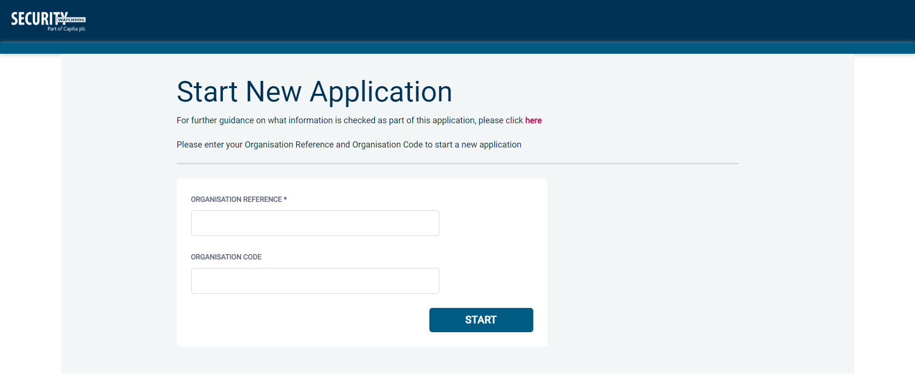

Once you have completed this section click ‘Enter’.

Statement of Fair Processing

You will now be taken to the ‘Security Watchdog Statement of Fair Processing’ outlining the terms and conditions. Please read the statement and tick the box to confirm this has been read and agreed to.

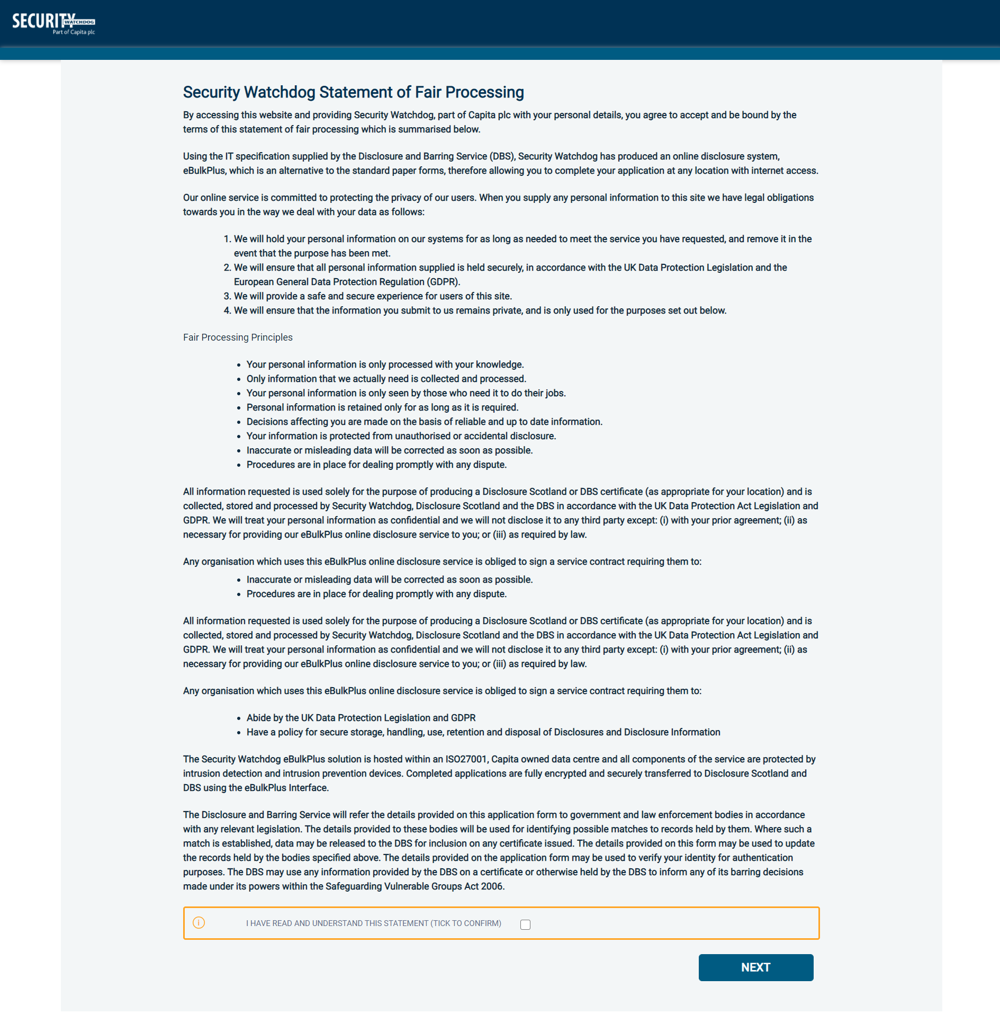

Once you have ticked the consent box please click ‘Next’
- The application form is a simple 5 step process. Please complete all fields.
- Mandatory fields are denoted by (*)

Mistakes on the application form will cause delays in processing.

Section 1 – About You

Third Party Details
If you are completing the application on behalf of someone else, please ensure you answer ‘Yes’ to the first question within the ‘Third Party Details’ section. Please then provide your personal details within the ‘Third Party Details’ section but the details of the person you are completing it on behalf of, for the rest of the application.

Personal Details
Please enter your personal details.
If you have any middle name(s) ensure that you enter these details, particularly those that appear on your identity documents, e.g. passport, driving licence, birth certificate, etc. Any missing information from this or any other section can severely delay the processing of your criminal record check.
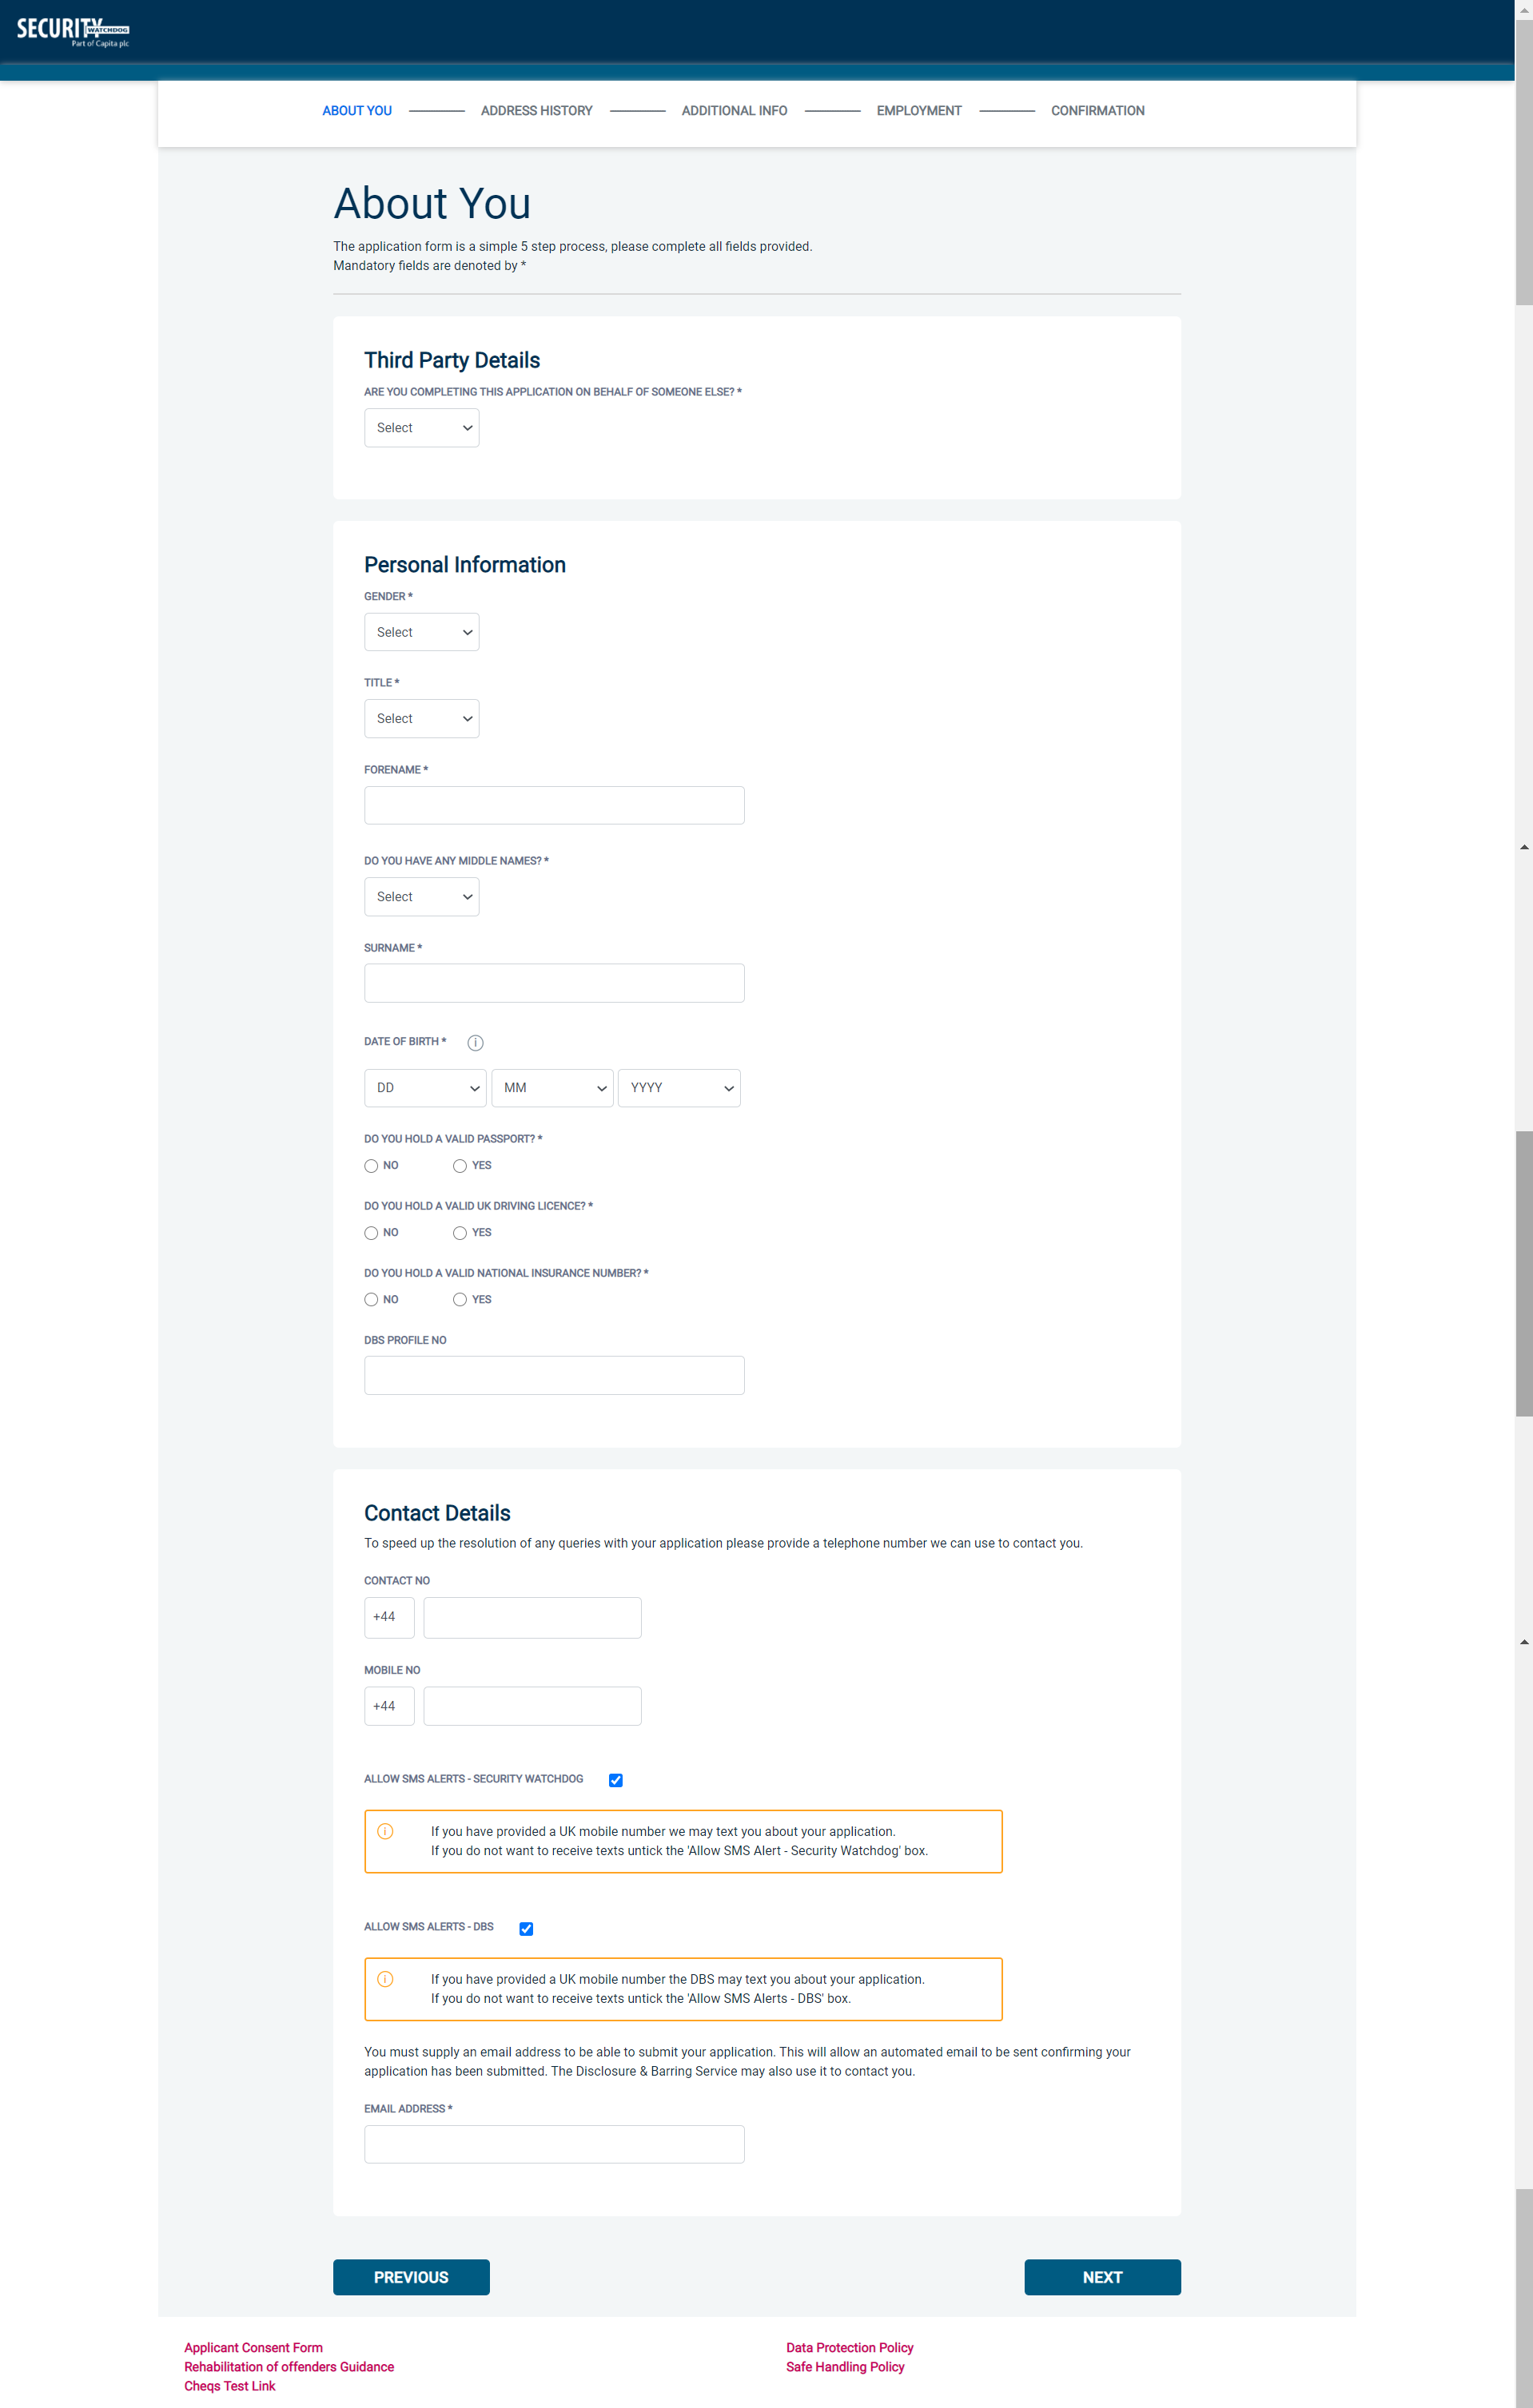

Once you have completed this section click ‘Next’

Section 2 – Address History

Please enter your current address. If you have not lived at this property for more than five years, you will be taken to another screen. Here you will be required to add any additional addresses to ensure your address history goes back the required five years. Please note if you do not provide a minimum of five years address history, you will not be able to proceed to the next stage of the application process.

Address Dates
There cannot be any gaps in your address history, however overlaps are allowed. Please ensure that the month and year of each address follows that of the previous address where relevant. Students who switch between their permanent residence and education establishments can enter their permanent residence as their main address and enter education addresses that overlap the main address. Once an address has been entered, you can edit any information by clicking on the ‘Edit’ button.

Postcode
Please ensure that all UK addresses have a full postcode; if you cannot remember your postcode please use the Royal Mail UK Postcode Finder link provided within the address information box.

No Fixed Abode UK
If you were of no fixed abode within the UK, please enter the nearest hostel address to the location you were based.

Foreign Addresses/Travelling Overseas
If you have travelled overseas and cannot supply the address for a foreign country, then please enter ‘no fixed abode’ for Address Line 1. Please then enter the Town/City and Country of where you were residing within this period.
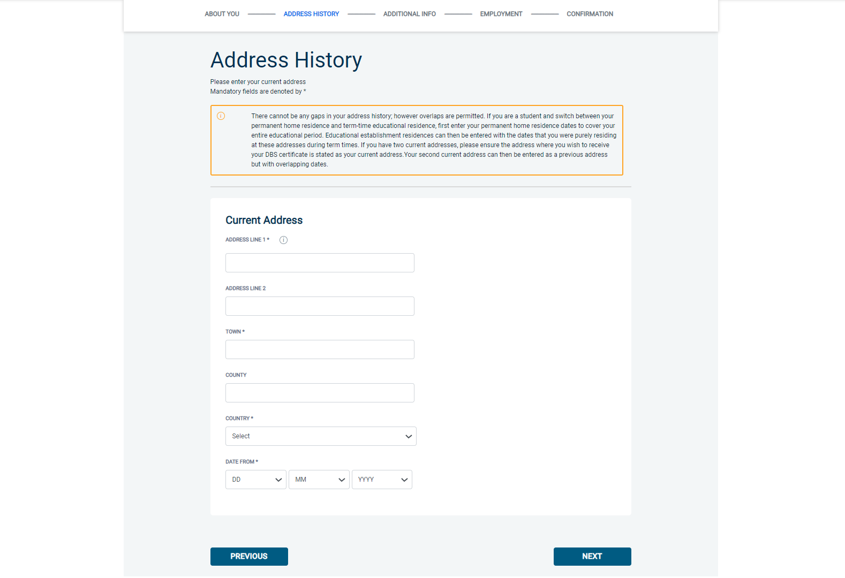
Once you have completed this section click ‘Next’.

Section 3 – Additional Info

Place of Birth
Please enter details of your place of birth.

Nationality / Current Nationality
Please enter your Nationality at birth and your current Nationality, even if this hasn’t changed since birth.

Changed Surname
If you have changed your surname, please provide your birth surname and the year you changed it. Please ensure that where names change, they run in date order and with no gaps.

Receive Paper Certificate
The DBS will automatically issue you an electronic certificate upon completion of your basic disclosure check. If you also require a paper copy of your certificate, please state ‘Yes’ to this question. Please then supply the address that you would like your paper certificate to be sent to.

Certificate Access
You can grant the Registered Organisation processing your application, or a 3rd party (e.g. your employer), access to your electronic certificate upon completion of check automatically within the application. Please note, if you are granting a 3rd party access to your certificate, the email address you supply that can access your certificate must have a registered DBS portal account.

Other Names
Please provide details of any other names used at any time during your lifetime and the dates during which the names were used. Please enter each previous name (forename, middle name(s) and surname) using the 'Add Name' button below. If you have used any aliases, e.g. William known as Bill, please also supply these details.
Failure to supply any additional information may cause your application to be delayed.

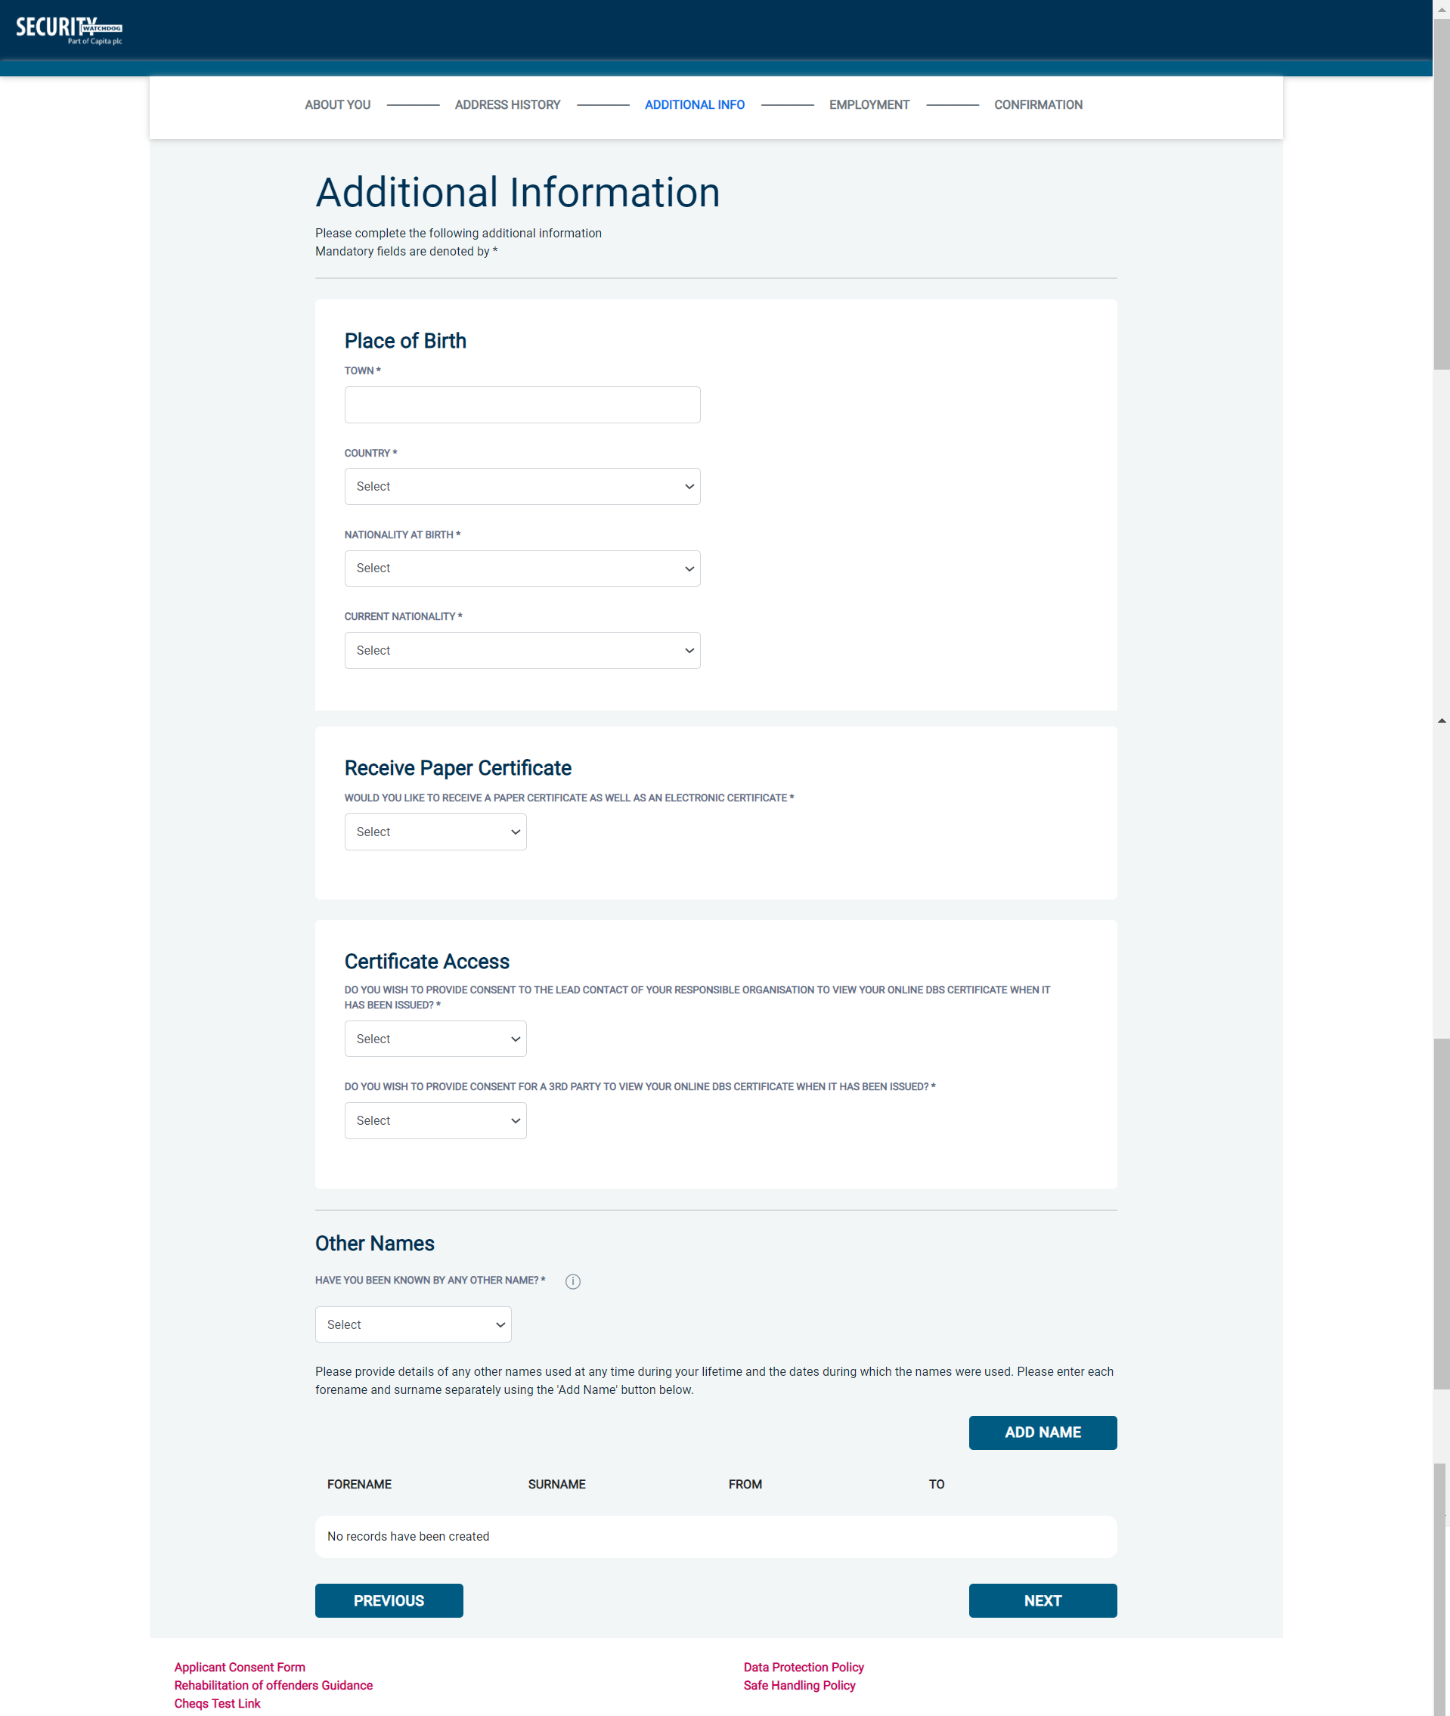

Once you have completed this section click ‘Next’.

Section 4 – Employment Details

Purpose of Check
You are required to enter from the drop-down list provided, what the purpose of this basic check is (Employment, Personal Interest or Other.) If the purpose of the check is employment, further questions will be required. If ‘Other’ is stated, you will be required to enter what the purpose is.

Position Applied For
Please insert the correct job role as supplied to you by your current/new employer. No abbreviations are permissible, e.g. Admin Asst should read Administrative Assistant. If you are a volunteer do not enter just volunteer, please enter in which capacity your job role is, e.g. Coach.
Failure to enter the correct job role may cause your application to be delayed.

Name of Employment Sector
Please select from the drop-down list provided, the most appropriate employment sector that your application relates to.

Employer Name
This has been defaulted to the organisation you are applying through and should not be amended.
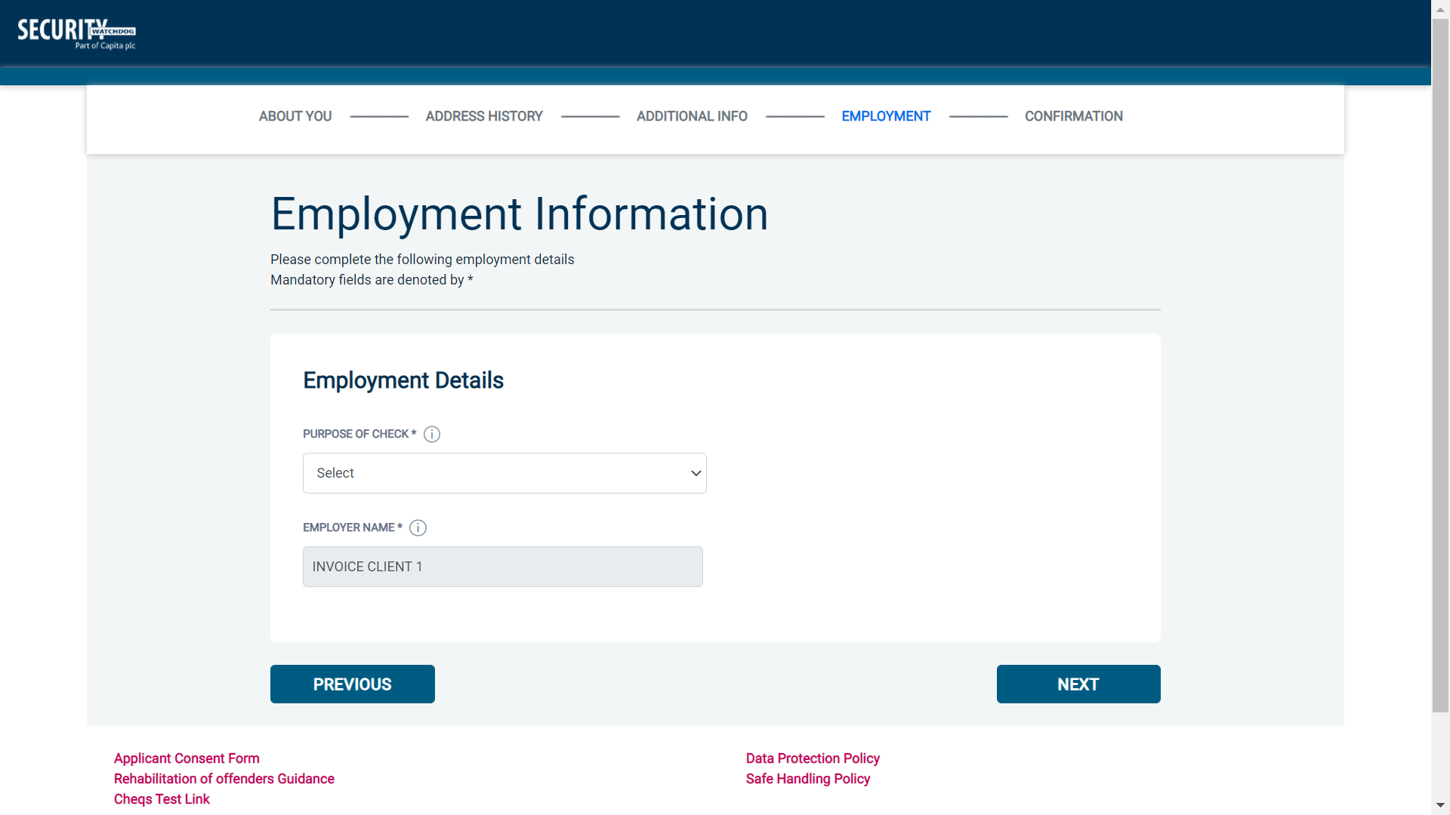

Once you have completed this section click ‘Next’.

Section 5 – Confirmation and Consent

Now please read through your application to ensure that there are no omissions/errors before you submit your application. If you wish to edit a section of your application click on ‘edit’ next to the section of the form that requires changes.
At the end of the application please make sure that you complete the Applicant Consent section.

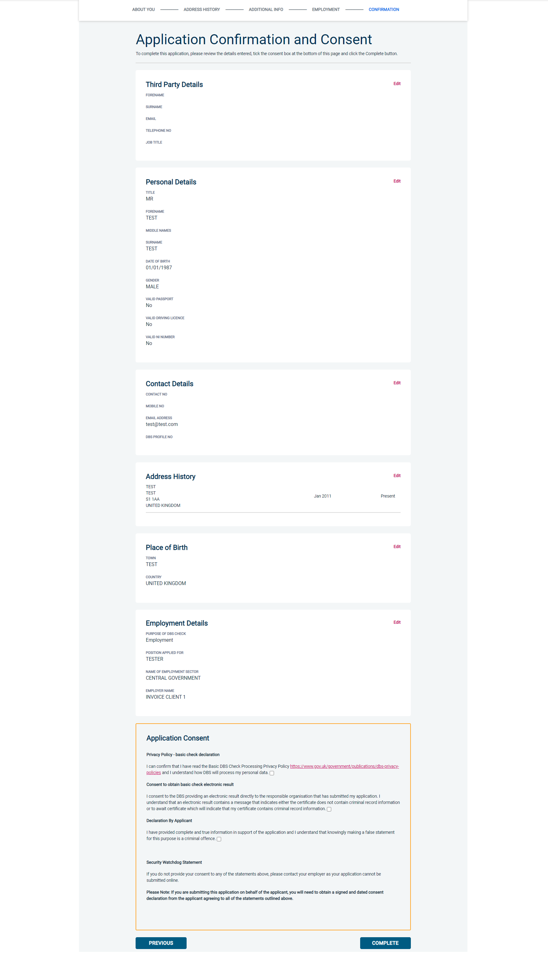
Now click ‘Complete’.

Complete Application

You have now completed your application form and you will be given a submission reference number. Please make a note of this number for reference purposes. You will receive a confirmation email containing these details to the email address supplied on the application form.
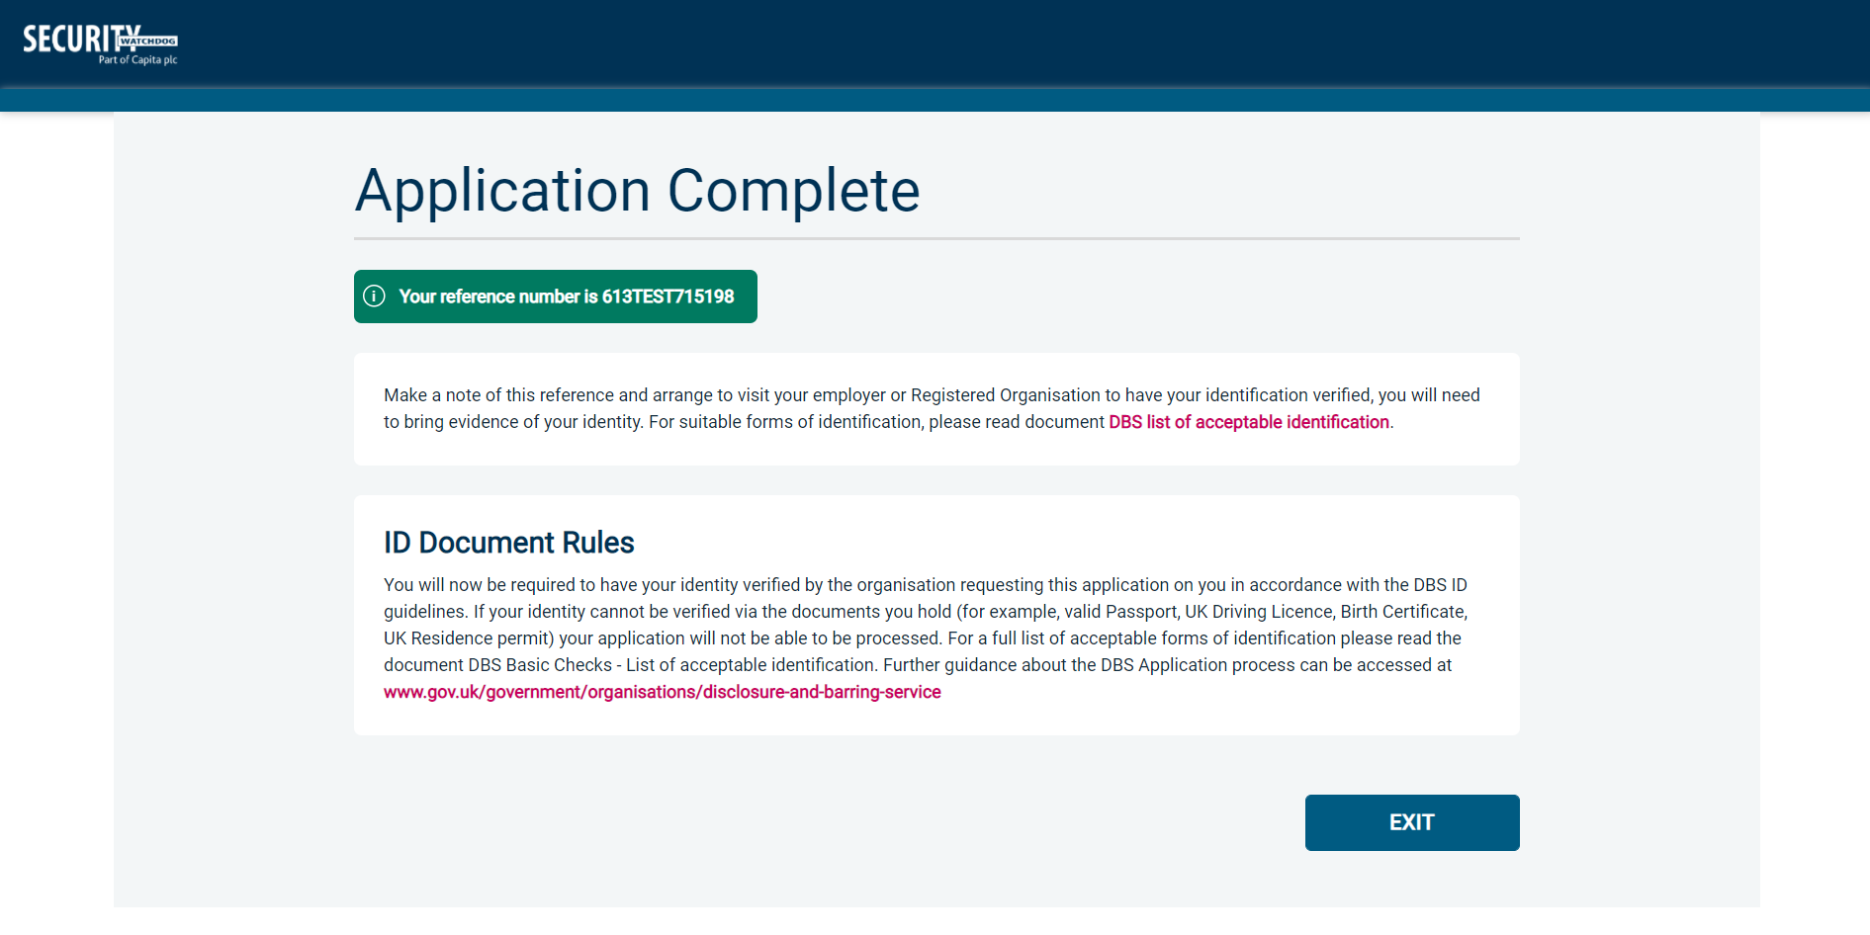

Your application form will be processed by your employer once they have verified your identity. Please see below for guidance on identity verification.

Next step - identity verification
In line with the DBS code of practice all applicants requiring a DBS check must have their identity verified.

How do I have my identity verified?
Please provide original identification to your Company’s Nominated Person (usually Recruitment or HR Manager) and provide identification as listed in the acceptable ID table (see table below). Your application form will be processed by your employer once they have verified your identity, and then sent onto the DBS.

Tracking the progress of your application with the DBS
Once your application has been received at the DBS and is assigned a DBS Application Reference number you will receive a second email detailing this information. This email will include details and links to the DBS website to enable you to track the progress of your application from the moment the disclosure process commences.

CONTACT DETAILS
Please contact your HR Team/Recruiting Manager if you have any queries regarding the DBS application process. If you experience any technical issues with the online system, please contact Care Check on 0333 777 8575. Alternatively, you can contact us by e-mail at info@carecheck.co.uk

Route 1 – For all applicants except paid non-EEA nationals
(2 documents to be seen)

1 document from Group 1.
1 further document from Group 1, 2a or 2b

Combination of documents must confirm name, DOB & current address.

If unable to satisfy Route 1, proceed to Route 2.

DBS Basic Checks - List of Acceptable Identification

Route 2 – For all applicants except paid non-UK nationals
(3 documents to be seen)

1 document from Group 2a.
2 further documents from Group 2a or 2b.

Combination of documents must confirm name, DOB & current address.

If unable to satisfy Route 2, basic check cannot be submitted.

Route 1 – For all applicants except paid non-UK nationals
(2 documents to be seen)

1 document from Group 1.
1 further document from Group 1, 2a or 2b

Combination of documents must confirm name, DOB & current address.

If unable to satisfy Route 1, proceed to Route 2.
Route 1a – For paid non-UK nationals only
(2 documents to be seen)

1 document from Group 1a.
1 further document from Group 1, 2a or 2b

Combination of documents must confirm name, DOB & current address.

If unable to satisfy Route 1a, basic check cannot be submitted.

Group 1
Primary Identity Documents
- Current valid Passport
- Biometric Residence Permit (UK)
- Current Driving Licence – photo card (UK / Isle of Man / Channel Islands) (Full or Provisional)
- Birth Certificate (UK / Isle of Man / Channel Islands) (Issued within 12 months of birth)
Full or short form acceptable including those issued by UK authorities overseas, such as Embassies, High Commissions & HM Forces. (Photocopies are not acceptable)
- Adoption Certificate (UK / Channel Islands)

Group 1a
Primary Identity Documents for non-UK nationals
- A current passport or passport card showing that the holder is a national of the Republic of Ireland.
- A current document issued by the Home Office to a family member of an EEA or Swiss citizen, and which indicates that the holder is permitted to stay in the United Kingdom indefinitely.
- A current Biometric Immigration Document (Biometric Residence Permit) issued by the Home Office to the holder indicating that the person named is allowed to stay indefinitely in the UK or has no time limit on their stay in the UK.
- Online evidence of immigration status. Either via the View and Prove service or using the BRP or BRC online service. Issued by the Home Office to the employer or prospective employer, which indicates that the named person may stay in the UK and is permitted to do the work in question. Must be valid. Note: this includes the EUSS digital status confirmation.
- A current passport endorsed to show that the holder is exempt from immigration control, is allowed to stay indefinitely in the UK, has the right of abode in the UK, or has no time limit on their stay in the UK.
- A current Immigration Status Document issued by the Home Office to the holder with an endorsement indicating that the named person is allowed to stay indefinitely in the UK or has no time limit on their stay in the UK, together with an official document giving the person’s permanent National Insurance number and their name issued by a government agency or a previous employer.
- A current passport endorsed to show that the holder is allowed to stay in the UK and is currently allowed to do the type of work in question.
- A current Biometric Immigration Document (Biometric Residence Permit) issued by the Home Office to the holder which indicates that the named person can currently stay in the UK and is allowed to do the work in question.
- A current document issued by the Home Office to a family member of an EEA or Swiss citizen, and which indicates that the holder is permitted to stay in the United Kingdom for a time limited period and to do the type of work in question.
- A frontier worker permit issued under regulation 8 of the Citizens’ Rights (Frontier Workers) (EU Exit) Regulations 2020.
- A current Immigration Status Document containing a photograph issued by the Home Office to the holder with a valid endorsement indicating that the named person may stay in the UK, and is allowed to do the type of work in question, together with an official document giving the person’s permanent National Insurance number and their name issued by a government agency or a previous employer.
- A document issued by the Home Office showing that the holder has made an application for leave to enter or remain under Appendix EU to the immigration rules on or before 30 June 2021 together with a Positive Verification Notice from the Home Office Employer Checking Service.
- An Application Registration Card issued by the Home Office stating that the holder is permitted to take the employment in question, together with a Positive Verification Notice from the Home Office Employer Checking Service.
- A Positive Verification Notice issued by the Home Office Employer Checking Service to the employer or prospective employer, which indicates that the named person may stay in the UK and is permitted to do the work in question.

Group 2a
Trusted Government Documents
- Current Driving Licence – photo card only (All Countries except Group 1) (Full or Provisional)
- Current Driving Licence – paper version (UK / Isle of Man / Channel Islands) (Full or Provisional)
- Birth Certificate (UK / Isle of Man / Channel Islands) (Issued after the time of birth)
- Marriage / Civil Partnership Certificate (UK / Channel Islands)
- HM Forces ID Card (UK)
- Fire Arms Licence (UK / Isle of Man / Channel Islands)
- Immigration document, work permit or VISA (Issued outside of UK) (Valid only for roles whereby applicant is living and working outside of UK.)

Group 2b
Financial & Social History Documents
- Mortgage Statement (UK) **
- Bank/Building Society Statement (UK / Channel Islands) *
Monzo statements or statements printed from the internet are not acceptable
- Bank/Building Society Account Opening Confirmation Letter (UK) *
- Credit Card Statement (UK) *
- Financial Statement e.g. pension, endowment, ISA (UK) **
- P45/P60 Statement (UK / Channel Islands) **
- Council Tax Statement (UK / Channel Islands) **
- Utility Bill (UK) - Not Mobile Phone *
- Benefit Statement (UK) e.g. Child Allowance, Pension *
- Document from Central/ Local Government/ Government Agency/ Local Authority (UK / Channel Islands) *
e.g. DWP, Employment Service, HMRC, Job Centre, Social Security
- EEA National ID Card – must be valid
- Cards carrying the PASS accreditation logo (UK / Isle of Man / Channel Islands) – must be valid
- Irish Passport Card – must be valid (Cannot be used with an Irish Passport)
- Letter from Head Teacher or College Principal (16-19 year olds in full time education in the UK)
- Non-UK Bank/Building Society Statement *
Branch must be located in the country in which the applicant lives and works
- Letter of Sponsorship from future employer
Non-UK only – valid only for applicants residing outside UK at time of application

Please note if a document in the List of Valid Identity Documents is:
- Denoted with * - issued in the last 3 months
- Denoted with ** - issued in the last 12 months

