Basic DS Online Disclosure Guide (eBulkPlus)

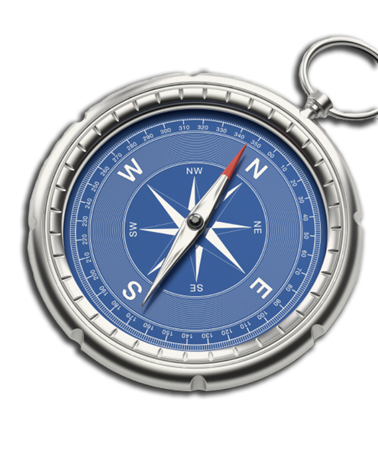
ID Checker Guidance Notes

Contents
ID checker guidance notes 3
Logging onto the system 3
Section A – How to login 3
Section B – How to verify ID 6
Disclosure Scotland List of Acceptable Identification 9

ID checker guidance notes

The eBulkPlus online basic Disclosure Scotland (DS) checks can be completed by accessing the internet from any device that has this facility. This includes a smart phone, tablet, laptop or PC. It is supported on the latest versions of all modern browsers; however, we do not recommend access via Internet Explorer as this browser is unsupported both by our technology and soon by Microsoft also.

Logging onto the system

You have been granted access to eBulkPlus in the role of an ID Checker. An ID Checker can view all applications created under the organisation or specific division they have been created under. The ID Checker can stipulate what ID has been seen in relation to an applicant. The ID Checker will then need to advise an Applicant Manager or Countersignatory (where applicable) within their organisation or division to approve the application for countersigning.

Section A – How to login

Please enter the following address into your web browser:
www.carecheck.co.uk
When you arrive at this page please click on ‘Manage Your DBS Checks’
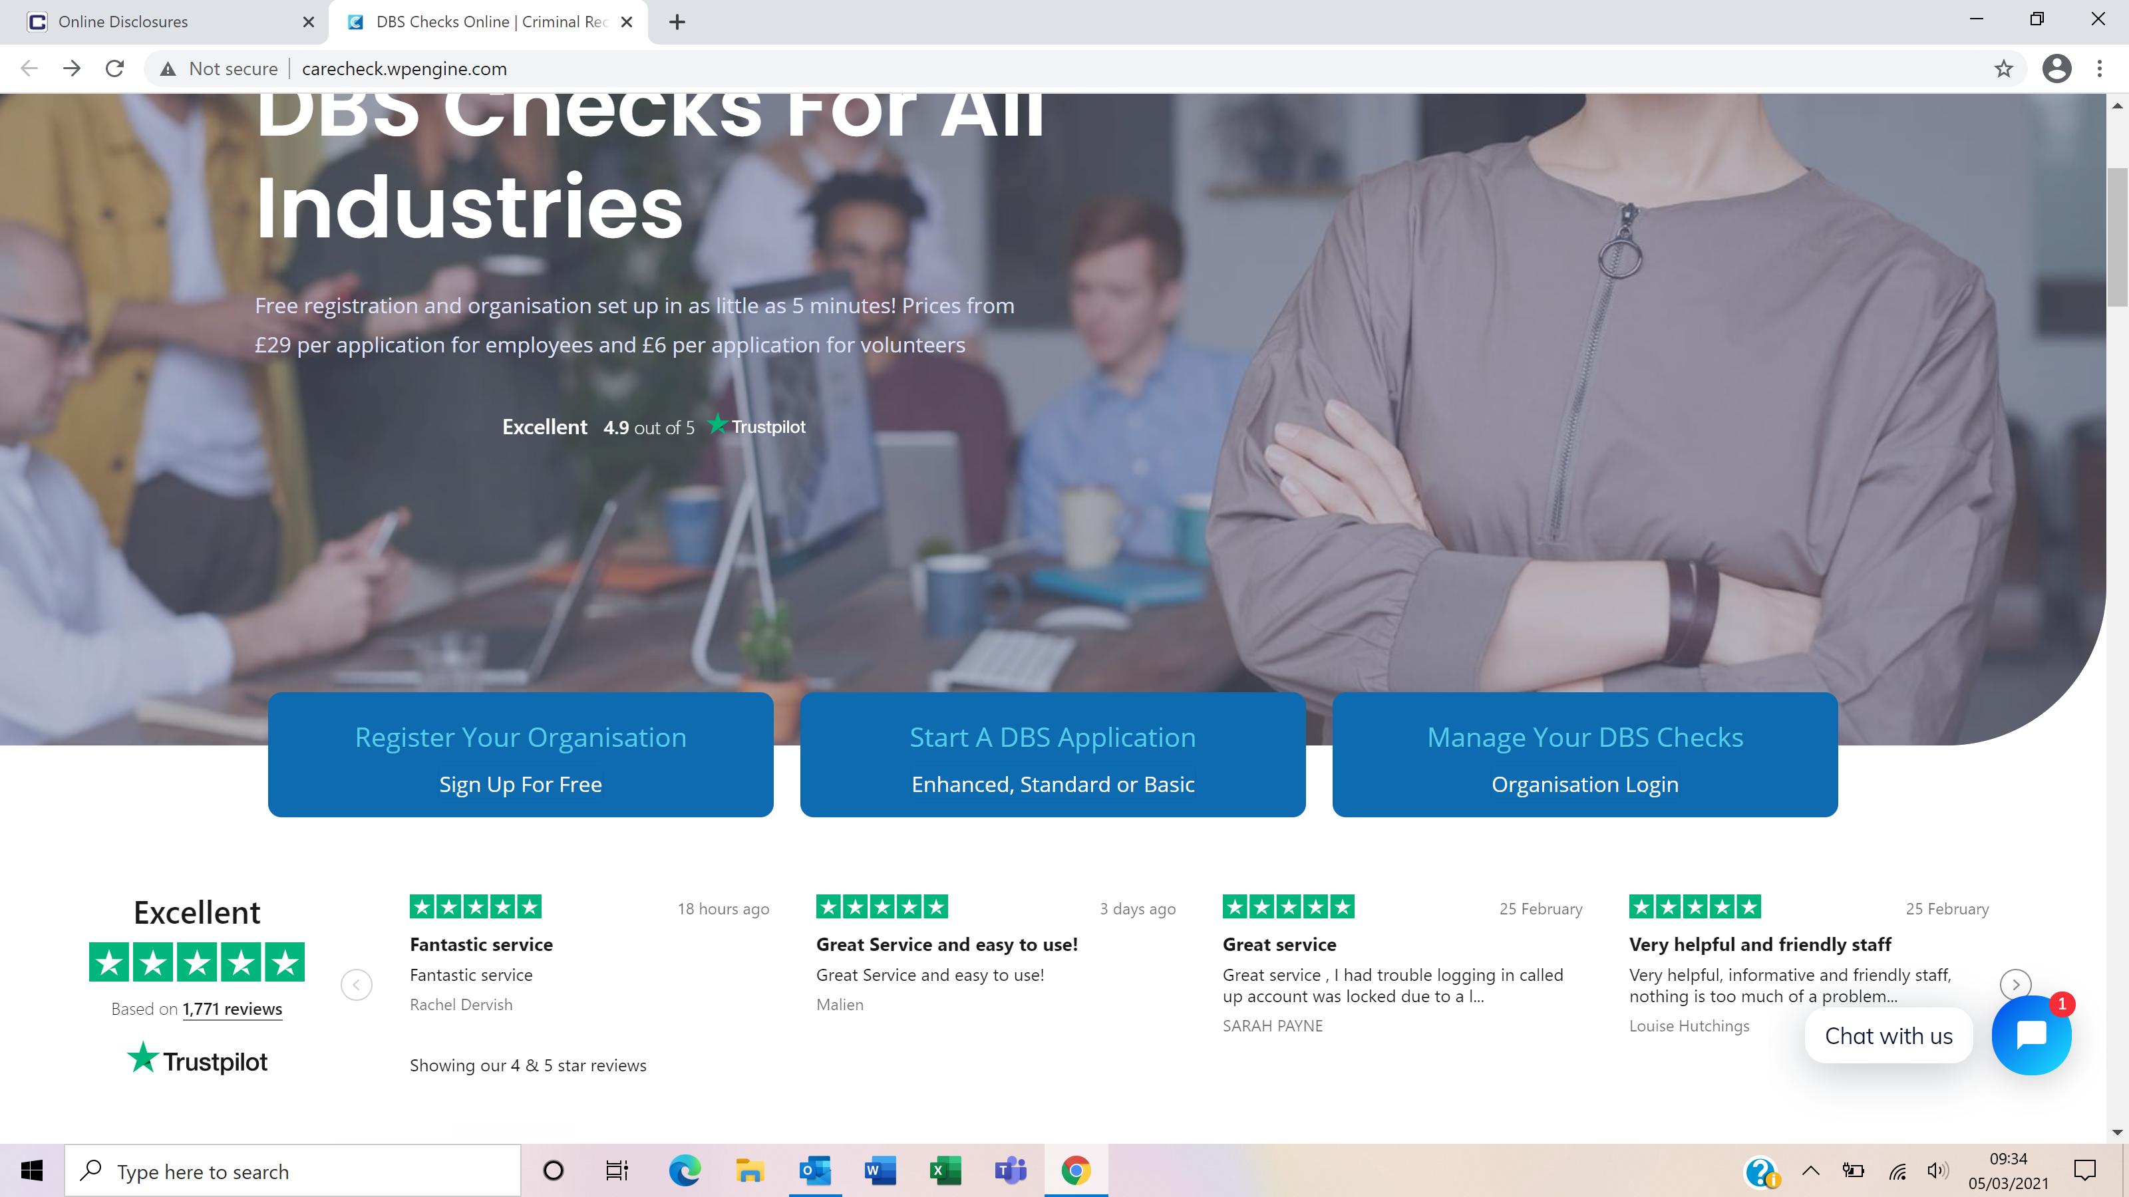
You will now be on the main login page, which shows three boxes. NB *Please note at this stage of the process, your login details are case sensitive.
- Click on ‘Application Management’ - this will take you to the start of the application process.
- Enter your company Organisation Reference - this will have been supplied to you in an automated email.
- Enter your Username.
- Enter your Date of Birth (for first initial login please ensure you enter the default date of birth 01 Jan 1998. Failure to do so will deny you access to the system).

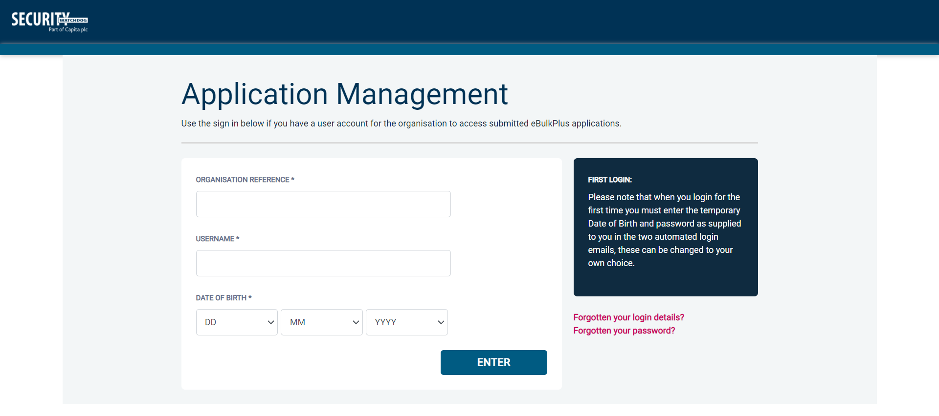
Screen Shot 1
- Once you have completed this section click ‘Enter’.
- Enter your password (this will be supplied to you in an automated email) – see screen shot 2.
If you have difficulty gaining access to the system please contact XXX on XXX, however, please ensure the first time you login that you have not been denied access because of entering your own date of birth. The first time you login you must enter the temporary default date of birth 01 Jan 1998.
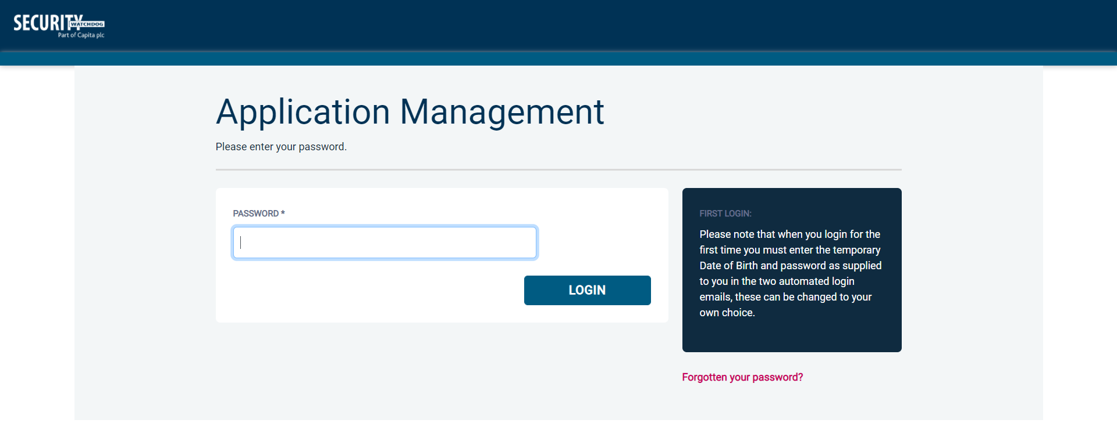
Screen Shot 2
- Please note, after initial login you will be required to set your own password and enter your own date of birth for future login purposes.
- Please re-enter into the ‘Current Password’ field the temporary password you received in your initial email and then create your own unique password – see screen shot 3 below.
- The password you create must be between 8 & 30 characters containing at least one upper case letter, one lower case letter, one special character and at least one number.
- Please then enter a date of birth of your choice for future login purposes.
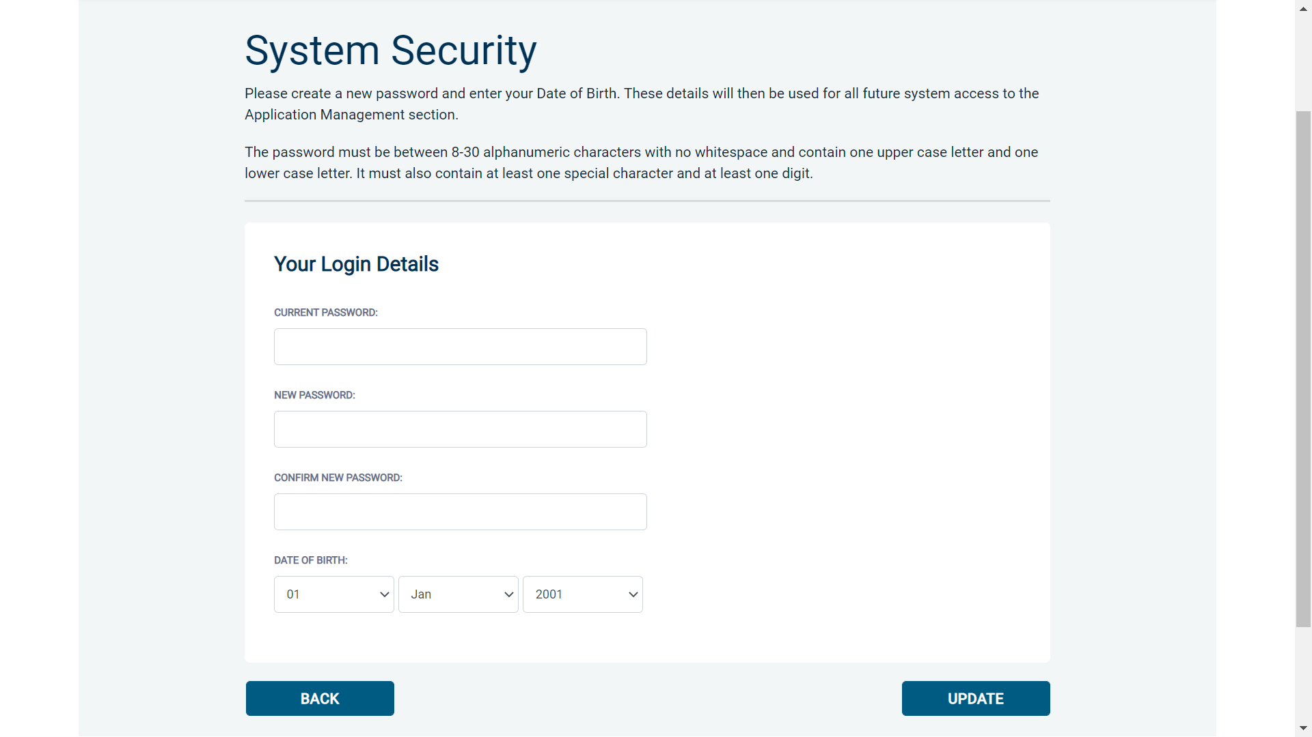
Screen Shot 3
- Please then click ‘Update’

- If you have successfully created your own password, you will now be able to enter the system by clicking the ‘Click here to enter System’ icon in the green box (please note you do not need to re-enter your password details once the green box has appeared).
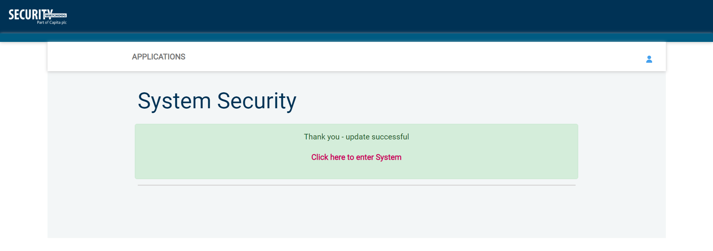
Screen Shot 4
- This will now take you to the eBulkPlus homepage containing a list of ‘Applications for ID Checking’. Please note the list may contain both DBS and Disclosure Scotland applications. DBS applications are marked with ‘DBS’ and Disclosure Scotland applications are marked with ‘DS’.

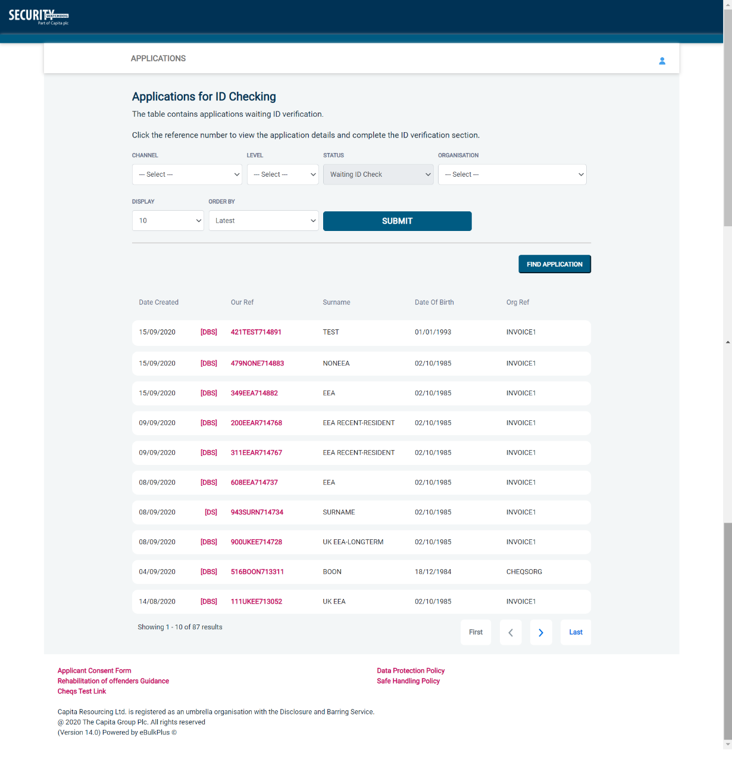
Screen Shot 5

Section B – How to verify ID

Step 1 - On the Applications page, click on the relevant applicant’s reference number to open the application form (see screen shot 6 below).

Screen Shot 6

Step 2 - You will now see two tabs (overview and application), and you will need to check the applicant’s completed form (screen shot 7 & 8 below).

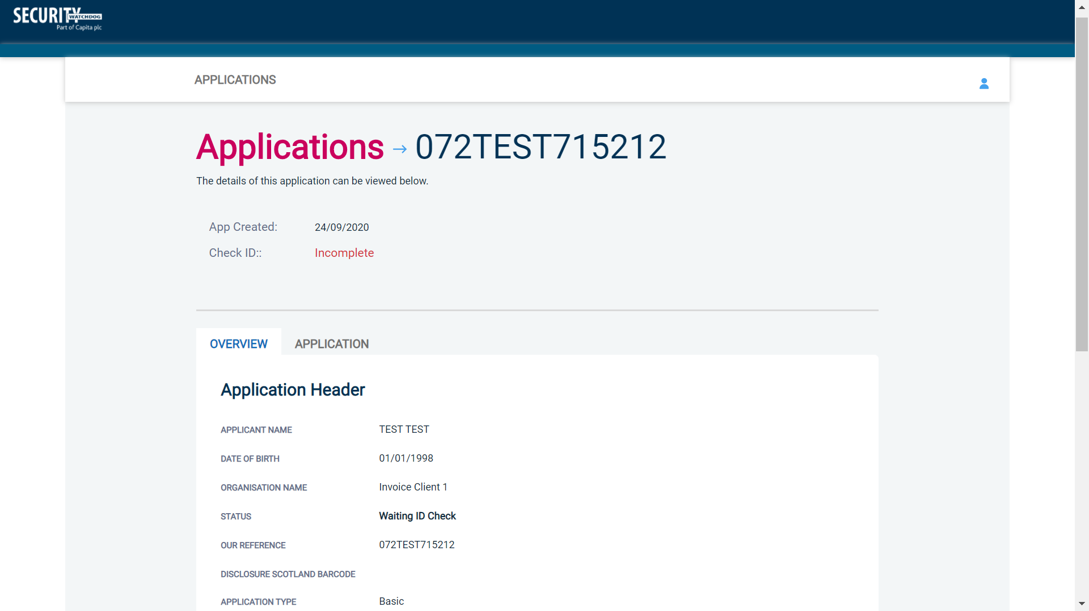
Screen Shot 7
Step 3 - To view the application details entered by the applicant, click on the ‘Application’ tab. Here you can see the entire application submitted by the applicant. This can be used to ensure the correct job role has been entered and to verify any ID given by the applicant in a previous surname or previous address (see screen shot 8).
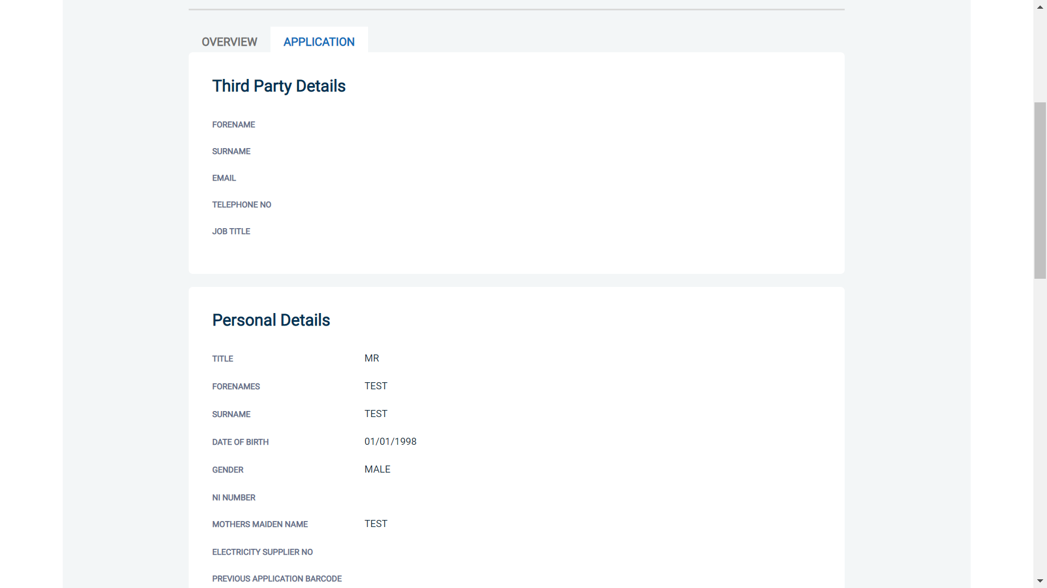
Screen Shot 8

Step 4 – Verifying ID

- You will notice a box at the top of the screen, which highlights if the ID has been verified or not (see screen shot 7 above), with a section completion date. It will say in red ‘Incomplete’ if the section has not been completed. If there is a date present, it means that this action has been completed and will show the date that this was carried out.
- To complete the ID verification section click on ‘Complete ID Check’ (see screen shot 7 above). Access to this section is located in two places – at the top of the screen or on the overview of the actual form itself. You will now be on the ID screen (see screen shot 8 below).
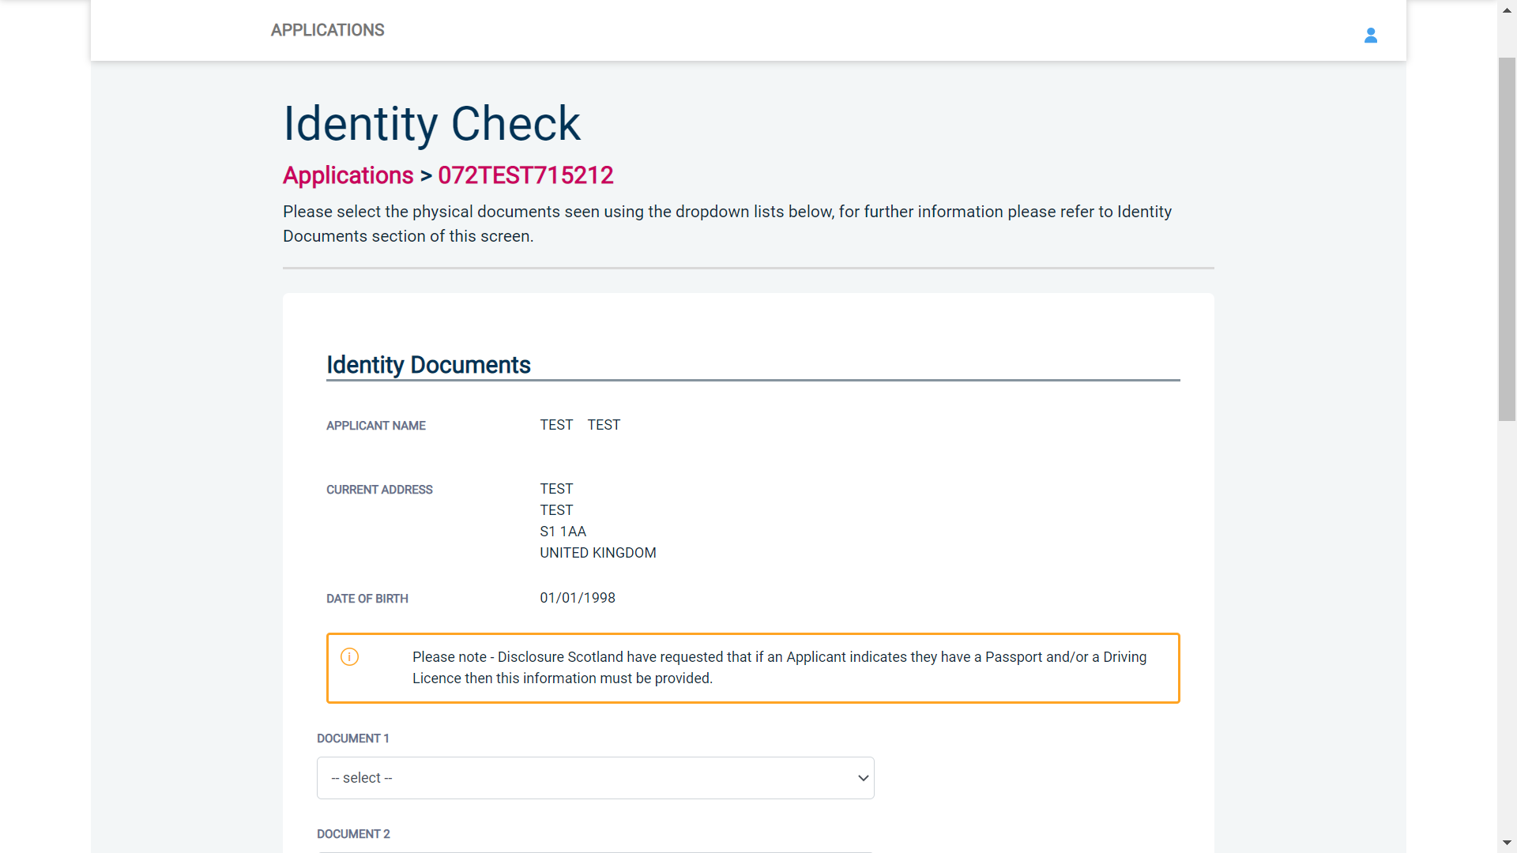
Screen Shot 9

- Please select the ID that the applicant has provided for you from the drop down boxes. Guidance notes can be found at the end of this document and are in accordance with Disclosure Scotland Code of Practice. Please ensure at all times that you follow the ID checking rules e.g. do not accept a bank statement if it is more than 12 months old, and do not accept an out of date passport.
- Ensure that you confirm from the drop down boxes that you have verified a document showing the applicant’s address, and also that you have verified their date of birth.
- If a Cost Code or Personnel Number is required to be assigned to the specific application, this can be entered in the Cost Code / Personnel Number field.
- Finally click ‘Save’ and then click the ‘Return to Application’ icon in the green box located at the top of the screen.
Once you have fully completed the applicant’s identity verification, you will then need to liaise with your appointed Applicant Managers/Countersignatories for the application to be approved. Please note, until the application has been approved, the application will not be able to be forwarded to Disclosure Scotland for processing.

ALL USERS – PLEASE LOG OFF AT THE END OF YOUR SESSION. IF A SESSION IS INACTIVE FOR MORE THAN TEN MINUTES YOU WILL BE AUTOMATICALLY LOGGED OFF FOR SECURITY REASONS.

CONTACT DETAILS
If you experience any technical issues with the online system, please contact Care Check on 0333 777 8575. Lines open 9.00am-5.30pm Monday to Friday. Alternatively you can contact us by e-mail at info@carecheck.co.uk

Disclosure Scotland List of Acceptable Identification

Can you produce any document from Group 1?

NO
YES

3 documents
to be seen
One document from Group 1 plus any two others from Group 1 or 2
5 documents
to be seen

Five documents from Group 2

Document check complete

Group 1
Primary Identity Documents
- Current valid Passport (any nationality)
- Current UK Driving Licence – photo card or paper (England/Wales/Northern Ireland/Isle of Man) (Full or Provisional)
- Original UK Birth Certificate (Issued within 12 months of date of birth)
Full or short form acceptable including those issued by UK authorities overseas, such as Embassies, High Commissions & HM Forces.
- Adoption Certificate (UK)
- Valid photo identity card (EU countries only)
- UK Firearms licence
- HM Forces ID card (UK)
Group 2  Issued whenever | Issued within last 3 months | Issued within last 12 months
- Non-original UK Birth Certificate (Issued after 12 months of date of birth, full or short form)  - Marriage / Civil Partnership Certificate  - P45/P60 Statement  - Utility Bill (electricity, gas, water, telephone – including mobile phone contract/bill)  - Valid TV licence  - Credit card statement  - Store card statement  - Mortgage statement  - Valid insurance certificate  - Certificate of British nationality  - Asylum Registration Card  - Valid vehicle registration document  - Court summons  - Valid NHS card  - Court Claim Form  - National insurance number card  - Examination certificate (e.g. GCSE, NVQ)  - Child benefit book | - Personal correspondence or a document from a Government Department  - Mail order catalogue statement  - Addressed payslip  - Letter from a Head Teacher | - British work permit/visa  - Bank or Building Society Document  - Financial statement e.g. pension, endowment, ISA

